Mind Mapping: An Interactive Approach to Syllabus Review

Few college teaching tools are more ubiquitous than the course syllabus. Many institutions of higher education require that all faculty provide one to their students for every course. These documents serve many purposes, but they are most commonly viewed as a communication device to convey information about the professor, the course itself, as well as grading and other policies (Doolittle & Siudzinski, 2010). Interestingly, research has shown that the document often includes the information faculty members want to see, rather than what students would like to see on the syllabus (Doolittle & Siudzinski, 2010). Some argue that syllabi are course contracts, laying out the rights and responsibilities of each party—faculty and students (Matejka & Kurke, 1994), although that view has not held up in the courts (Kaufmann, 2015). Syllabi also function as course plans, listing the topics to be covered, assignments and their due dates. Finally the document can also serve as a cognitive map of the intellectual journey the class will be taking during the semester (Matejka & Kurke, 1994).
Review the “to-do” list of nearly any management professor for the first day of class, and you are likely to see “go over the syllabus” somewhere on the agenda. Traditionally that entails the professor standing in front of the classroom, highlighting key aspects of the syllabus such as required materials, major assignments and exams. Some faculty members use syllabus quizzes (see for example, Glascoff, 1984; Raymark & Connor-Greene, 2002) to ensure that students pay adequate attention. Many of these approaches, however, are somewhat ineffective, as students are often unable to recall key course information that is clearly included in the syllabus. For example, Smith & Razzouk (1993), in a study of 152 students enrolled in advanced undergraduate marketing classes at a major southwestern state university, found 30.9% of surveyed students could not recall any course objectives, and 14.5% could not recall how many exams were to be given.
Despite the above findings, the syllabus remains a critical tool for student success (Becker & Calhoon, 1999). Given the issues with current approaches, what other tactics besides quizzes can faculty members use to improve recall and generate energy in the typical undergraduate classroom? Two concepts inspired the work presented here. First, the conceptualization of the syllabus as a cognitive map for courses seems to lend itself to the idea of using a mind map approach. Second, research has found that mind mapping is a good technique to “improve factual recall from written material” (Farrand, Hussain, & Hennessy, 2002: 427). With that in mind, we decided to test the efficacy of an exercise in which small student teams created a mind map of the course syllabus during the first day of class in an undergraduate management elective.
Mind mapping, a technique developed and trademarked by Tony Buzan, “can be used to make teaching and learning more stimulating, enjoyable and effective” (Buzan and Buzan, 1993: 221). It has been used in educational fields as diverse as nursing (Rosciano, 2015) and medicine (Edwards & Cooper, 2010), science (Dhindsa, Makarimi-Kasim, & Anderson, 2011), foreign language instruction (Wilson, Copeland-Solas, & Guthrie-Dixon, 2016), engineering (Dixon & Lammi, 2014), and education research methods (Murtonen, 2015). The approach has been used in business education contexts as well, including: economics (Budd, 2004), marketing (Eriksson & Hauer, 2004) and accounting ethics (Guo, 2014). Its flexibility means it can be used at any educational level, from grammar school (e.g., Merchie & Van Keer, 2016) to executive education (Mento & Jones, 1999) and every level in between.
The only supplies needed for mind mapping are a large, unlined writing surface, such as flip-chart paper or white board, and some colorful fine point markers. While other colorful writing implements can be used, such as colored pencils or even crayons, the markers result in a stronger, more visible line. Alternatively, there are several mind mapping software packages, such as Mindjet and XMind, and some of them are even free, like Coggle. However, there are some advantages to drawing mind maps by hand (Tucker, Armstrong, & Massad, 2010) especially when group interaction in a classroom setting is desired..
The mind mapping process is driven by a few simple rules (see Exhibit 1). To create a map, start in the center of the page. Draw a picture or symbol that captures the central idea you are mapping. From that center point, draw curved lines radiating outward, each line representing a category of concepts related to the central idea. Keep dividing the key concepts into related sub-concepts, branching out in a radial fashion and using a different color for each line. Label each branch and sub-branch with one key word that captures the gist of the concept. Wherever possible, include illustrations. If some of the outer concepts are related to others on a different branch, connect them with a curved line.
What results is a diagram of the central idea and its related concepts (see Exhibit 2 for an example). It is ironic that completed mind maps often resemble stylized drawings of the anatomy of a brain cell, i.e., a neuron and its dendrites (see Exhibit 3). For more information about constructing Mind Maps, see: https://www.youtube.com/watch?v=MlabrWv25qQ.
In the next section of this paper, we explain how this mind mapping technique was used to review the syllabus in an undergraduate management elective course. Step by step instructions including a debriefing approach are described. The subsequent section describes the student’s anonymous, qualitative reactions to the exercise. Also in that section, we assess the students’ retention of key syllabus items, as measured by a surprise “pop” quiz. The results are compared to a control group, in which the instructor used the more traditional syllabus review method. We conclude with a section on limitations and next steps.

Instructions for Running and Debriefing the Exercise
The first step in the exercise was to review the instructions on creating a mind map as described above. Given the visual nature of the concept, it helps to show students multiple examples. Two sources of illustrative mind maps are http://www.biggerplate.com/top-10-mindmaps and http://www.tonybuzan.com/gallery/mind-maps/. Alternatively, you can curate a portfolio of samples by googling “Mind Map Examples.” For this class the instructor included some examples that were very artistic, and others that were more basic, so that everyone could see that you don’t need to be a talented illustrator to use the technique successfully.
Next, the instructor randomly assigned the class of 30 students into small sets of 3 classmates per group. They were told to introduce themselves to each other, and then pick one person to come up to the front of the room for supplies. Each team was given 3 printed copies of the syllabus (one per person), one large sheet of flip chart paper, and a handful of colorful felt-tip markers (each team had 5 or 6 different colors). They were then given about 20 minutes to draw a mind map of the syllabus.
To debrief the exercise, the completed mind maps were hung up around the room. Each team was asked to nominate one person from the group to explain their mind map to the rest of the class. After the first presentation, subsequent presenters were asked to just highlight what was different about their map to minimize duplication. Some variations included alternative approaches to organizing the radial branches, including more or less detail, and highlighting different pieces of information. After all the teams presented, they were asked if anyone noticed anything important from the syllabus that was still missing. The instructor then opened the floor to general questions, and re-emphasized any key points. The review of the completed mind maps took an additional 15-20 minutes.
The control group was an undergraduate section of Principles of Management. In that class, the syllabus was reviewed in a more traditional, conversational manner. The instructor for that class (not the same instructor as the experimental group) provided students with a copy of the syllabus, and then verbally walked the students through each section (objectives, competencies, standards, assignments, etc.). The important points were covered and any questions the students had were answered. It was a straightforward review, partially a presentation from the instructor and partially a discussion with the students. This approach took approximately 35-40 minutes, which is similar to the amount of time it took for the experimental class to complete the mind map approach. The similarity in amount of time it took each class to review the syllabus reduces concerns that any differences found between the mind map class and the control class will be an artifact of time spent reviewing the syllabus.
As of the first day of class, when both the experimental and the control group syllabi reviews occurred, neither instructor intended to study the results of their syllabus review method. Therefore, neither did anything out of the ordinary or emphasized any particular items. In other words, they did not “teach to the test.”

Mind Mapping Syllabus Review Assessment
After the co-authors determined that a study of the efficacy of the mind mapping approach would be a worthwhile endeavor, we designed a short quiz that would apply in both of our courses. We opted to use one, universal instrument to reduce confounding factors. The intent was to measure whether or not the methods used to review the syllabus had any impact on the students’ retention of key information.
Questions included those assessing retention of information pertinent to students, such as the number of exams and the types of assignments, as well as information deemed important by the faculty members, namely the school’s mission statement and the respective course’s learning objectives. Among the questions on the assessment were whether or not students chose their project groups, whether or not attendance was taken each class, and the business school’s mission statement. Students were also asked to indicate the graded assignments in the course by checking the appropriate ones from a list of 10 possibilities. The final question asked students to describe the learning objectives for the course. With the exception of the question on learning objectives, all items were scored dichotomously (1 = correct/positive response, 0 = incorrect/negative response). See Appendix 1 for a copy of the quiz.
Both courses meet twice a week for 75 minutes on Tuesdays and Thursdays. On the 4th class session, after the add-drop period closed, both instructors administered the unannounced assessment (i.e., a “pop” quiz). Therefore students did not review the syllabus or prepare for the quiz in any way. After the quiz, students were told that their quiz score would not count towards their grade. We did not announce this prior to the assessment to ensure that students took it seriously, a problem noted in prior research on syllabus quizzes (Raymark & Connor-Greene, 2002). Students were told that their names would not be associated with any responses, and that scores would only be reported in the aggregate.
After the quiz was completed, the students were sent an anonymous survey, so that we could capture some qualitative data regarding student’s attitudes toward the syllabus review approaches. Once it was confirmed that they were in class on the first day, the only question on the survey was to describe how they felt about the syllabus review portion of the class.
In general, students were very satisfied with the instructor’s traditional approach. For example, one student said: “[the instructor] … reviewed the syllabus really well and thoroughly on the first day.” Another shared, “…the professor adequately reviewed the syllabus by reading the necessary information expressed directly in the text, as well as providing further explanations in some areas that required clarification or specific details.” The only negative comment was focused on the length of the review, not the method: “…it should've been shorter and focused more on the grades and expectations of the professor.”
The qualitative remarks regarding the experimental, mind mapping condition were overall positive, but there were a few dissenting voices, after all, as one student noted, “It was different.” Most students, like this one, really felt the approach was useful: “[it was] effective getting students to understand how various components of the syllabus come together.” Another respondent agreed, “It was interactive which helped more focus on it, but I think it would have been best to draw a mind map of the "important dates" in class, since most of the syllabus is [standard operating procedure].” One student said “The mind map actually forces the student to look over the syllabus and dissect it. If the professor just discusses it, some kids just ignore it because it's not captivating their attention.” However, a few students were a bit more skeptical: “Using a mind map was very interesting. I am not sure whether it worked or not, but it was fun.” Lastly, a few students were not buying it, and would have preferred that the professor just “Go over it the usual way.” And “It wasn't much more engaging than a typical read-over.”
The quantitative results of the syllabus quiz yielded interesting results. Table 1 presents means, standard deviations, and t-test results for the variables in the study. There were a number of items where there were no statistically significant differences between the control group and the experimental group, namely, the question regarding the format of the course reading materials, the number of exams, attendance policy, academic integrity policy and school mission. However, overall the difference in total student scores between the experimental and the control groups were statistically significant, with the experimental approach resulting in higher overall quiz scores (t₍₆₀₎ = 5.02, p < .01) than control group.
On some items, the control group scored higher. In particular, students in the experimental group incorrectly indicated that the course included a service learning project and a peer evaluation assignment, as a result, the control group scored statistically significantly higher on this item (t₍₆₀₎ = -2.17, p < .05). However, roughly a quarter of the students in the experimental group had the instructor for a previous class in which there was a major service learning project that included peer evaluation. It is possible that some of the students were confusing the classes. Since we combined all responses for question 8, which asked students to correctly identify graded assignments, into one global measure (Total score for graded assignments), we have provided scores for each individual item from question 8 in Table 2. This was done in an effort to provide a fuller picture of participant responses.
The control group also scored statistically significantly higher on question 10, which measured the reason why students are not permitted to step out of class for a few minutes during a session (t₍₆₀₎ = -2.56, p < .05). The instructor in the control group spent some considerable time discussing professional behavior and how the class was a good opportunity to practice. In the experimental group there was only one line on the syllabus stating that students should not step out of class because it is disruptive to the students and professor. One student group in the experimental condition did say that stepping out of class was not allowed on their mind map review in front of the class, but did not include why it was not permitted and the instructor did not emphasize why stepping out was inappropriate either.
In addition to the above mentioned findings for total score on the survey, the two most compelling findings related to recall of learning objectives and correct identification of graded assignments. Student recall of learning objectives was scored on the following scale: 0 for omitted or wrong; 1 = one element of the learning objectives correctly identified, 2 = a few learning objectives correctly identified, and 3 = most of learning objectives correctly identified.
Given the nature of the quiz, we did not expect the students to quote verbatim from the syllabus, rather we were looking for their ability to articulate the gist of the learning goal. Each instructor graded his/her own class’s quizzes, after jointly reviewing some samples to ensure our expectations were calibrated. The result was that the mind mapping class outperformed the control class on recall of learning objectives (t₍₆₀₎ = 7.56, p < .01). Twenty-six percent of the students in the control group, like 30.9% of the students in Smith & Razzouk's (1993) study, could not identify any course learning objectives (i.e., they scored a zero for question 11). However, all students in the experimental group were able to articulate at least one course goal. Nearly all were able to describe at least two.
A similar finding was observed correct identification of graded class assignments. Summed scores for assignments correctly identified were totaled and a comparison between the two classes was conducted. The mind mapping class was more effective at correctly identifying graded assignments (t₍₆₀₎ = 2.04, p < .05). Taken together, these findings suggest that the mind mapping approach had a positive effect on student recall of learning objectives and graded assignments.

Discussion and Conclusion
Numerous settings (educational, corporate, non-profit, etc.) all have a vested interest in finding ways to help people successfully encode and recall information. The educational and organizational benefits are substantial, as are the benefits to individuals who experience better encoding and recollection of information. Results from the current study suggest mind mapping may be a promising way to help individuals and organizations retain and recall more information.
While some results did not show meaningful differences between the mind map group and the control group, there were findings that showed the potential value of mind mapping. The most notable finding is the one for course objectives. The mind map group outperformed the control group on recall of learning objectives by a wide margin. This is a very encouraging finding, as it suggests a higher-order concept, like learning objectives, was recalled more effectively by those who completed the mind map method. Also of note is the difference in correct identification of graded assignments. While there were some mixed results for this section of the survey, the overall finding is that students who participated in the mind map scored higher at identifying which assignments were a part of their course. Having students who have a strengthened grasp of course learning objectives and an increased knowledge of the assignments they must complete is a desirable outcome in any learning setting (e.g., K-12 education, college, corporate training).
Taking an even broader approach, the combined scores (across all survey items) showed higher performance for the mind map group. This suggests that when we simply consider overall recall (as defined by cumulating scores on all survey items) that mind mapping has a positive impact on information recall. Again, regardless of setting, an increased understanding of the content under discussion is a desirable outcome.

Study Limitations and Future Research
The current study, like all studies, has its limitations. The current study is limited to the two classes that participated in the study. While the sample size (N = 62) was suitable to conduct our analyses (Cohen, 1977), its value is limited in drawing wide generalizations to how the effective the method would be in other settings. Additional research utilizing other classrooms, and ideally other learning environments (K-12, organizational training) should be conducted to determine the efficacy of our findings.
One additional limitation is that our study was focused on the effect of mind mapping and did not consider the cognitive processes taking place that led to the increased recall demonstrated by the students in the mind mapping group. Future research should examine the cognitive processes (what takes place in the mind during the mind mapping process) that allows for the improved encoding and recall of information.

Exercise Demonstration at ELA
If this exercise is selected for an ELA session, the participants, like the students, will be randomly assigned to small groups of approximate 3 people each. After explaining mind mapping and reviewing some examples, the author(s) will distribute copies of a typical management syllabus, as well as flip chart paper and markers. ELA participants will be given about 15 minutes to draw a mind map of the syllabus. Similar to the students, each group will be asked to nominate someone to explain their map. After presenting the maps, we will discuss the strengths and weaknesses of the approach, and brainstorm ideas on how to both improve the process, and apply it to other contexts.

References
Becker, A. H., & Calhoon, S. K. 1999. What Introductory Psychology Students Attend to on a Course Syllabus. Teaching of Psychology, 26(1): 6.
Budd, J. W. 2004. Mind Maps as Classroom Exercises. The Journal of Economic Education, (1): 35.
Cohen, J. (1977). Statistical power analysis for the behavioral sciences. New York: Academic
Press Inc.
Dhindsa, H. S., Makarimi-Kasim, & Anderson, O. R. 2011. Constructivist-Visual Mind Map Teaching Approach and the Quality of Students’ Cognitive Structures. Journal of Science Education and Technology, 20(2): 186–200.
Dixon, R. A., & Lammi, M. 2014. Cognitive Mapping Techniques: Implications for Research in Engineering and Technology Education. Journal of Technology Education, 25(2): 2–17.
Doolittle, P. E., & Siudzinski, R. A. 2010. Recommended Syllabus Components: What Do Higher Education Faculty Include in Their Syllabi? Journal on Excellence in College Teaching, 21(3): 29–61.
Edwards, S., & Cooper, N. 2010. Mind mapping as a teaching resource. Clinical Teacher, 7(4): 236–239.
Eriksson, L. T., & Hauer, A. M. 2004. Mind Map Marketing: A Creative Approach in Developing Marketing Skills. Journal of Marketing Education, 26(2): 174–187.
Farrand P, Hussain F, & Hennessy E. 2002. The efficacy of the `mind map’ study technique. Medical Education, 36(5): 426–431.
Glascoff, D. W. 1984. The Syllabus Quiz: A Multipurpose Strategy. Journal of Marketing Education, 6(3): 46.
Guo, X. 2014. Incorporating Mind Maps into Teaching and Learning in Higher Education: My Experience as an International University Lecturer. Accounting Education, 23(3): 258–261.
Kaufmann, K. D. 2015. A Legal Analysis and Contrarian View of the Syllabus-as-Contract Perspective. Journal on Excellence in College Teaching, 26(2): 177–197.
Matejka, K., & Kurke, L. B. 1994. Designing a Great Syllabus. College Teaching, 42(3): 115–17.
Mento, A. J., & Jones, R. M. 1999. Mind mapping in executive education: applications and outcomes. Journal of Management Development, 18(4): 390.
Merchie, E., & Van Keer, H. 2016. Empirical study: Mind mapping as a meta-learning strategy: Stimulating pre-adolescents’ text-learning strategies and performance? Contemporary Educational Psychology, 46: 128–147.
Murtonen, M. 2015. University students’ understanding of the concepts empirical, theoretical, qualitative and quantitative research. Teaching in Higher Education, 20(7): 684–698.
Raymark, P. H., & Connor-Greene, P. A. 2002. The Syllabus Quiz. Teaching of Psychology, 29(4): 286–288.
Rosciano, A. 2015. The effectiveness of mind mapping as an active learning strategy among associate degree nursing students. Teaching & Learning in Nursing, 10(2): 93–99.
Smith, M. F., & Razzouk, N. Y. 1993. Improving Classroom Communication: The Case of the Course Syllabus. Journal of Education for Business, 68(4): 215–221.
Tucker, J. M., Armstrong, G. R., & Massad, V. J. 2010. Profiling a Mind Map User: A Descriptive Appraisal. Journal of Instructional Pedagogies, 2. http://ezproxy.shu.edu/login?url=http://search.ebscohost.com/login.aspx?direct=true&db=eric&AN=EJ1056389&site=eds-live.
Wilson, K., Copeland-Solas, E., & Guthrie-Dixon, N. 2016. A Preliminary Study on the Use of Mind Mapping as a Visual-Learning Strategy in General Education Science Classes for Arabic Speakers in the United Arab Emirates. Journal of the Scholarship of Teaching and Learning, 16(1): 31–52.

Exhibit 1 - Steps to Making a Mind Map
Source: http://www.tonybuzan.com/about/mind-mapping/
- Start in the CENTRE of a blank page turned sideways. Why? Because starting in the centre gives your Brain freedom to spread out in all directions and to express itself more freely and naturally.
- Use an IMAGE or PICTURE for your central idea. Why? Because an image is worth a thousand words and helps you use your Imagination. A central image is more interesting, keeps you focussed, helps you concentrate, and gives your Brain more of a buzz!
- Use COLOURS throughout. Why? Because colours are as exciting to your Brain as are images. Colour adds extra vibrancy and life to your Mind Map, adds tremendous energy to your Creative Thinking, and is fun!
- CONNECT your MAIN BRANCHES to the central image and connect your second- and third-level branches to the first and second levels, etc. Why? Because your Brain works by association. It likes to link two (or three, or four) things together. If you connect the branches, you will understand and remember a lot more easily.
- Make your branches CURVED rather than straight-lined. Why? Because having nothing but straight lines is boring to your Brain.
- Use ONE KEY WORD PER LINE. Why? Because single key words give your Mind Map more power and flexibility.
- Use IMAGES throughout. Why? Because each image, like the central image, is also worth a thousand words. So if you have only 10 images in your Mind Map, it’s already the equal of 10,000 words of notes!

Exhibit 2 – Example of a Mind Map
Source: http://www.tonybuzan.com/about/mind-mapping/

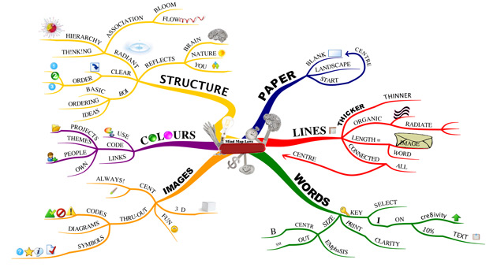

Exhibit 3 – The anatomy of a multipolar neuron

Source: https://en.wikipedia.org/wiki/Neuron

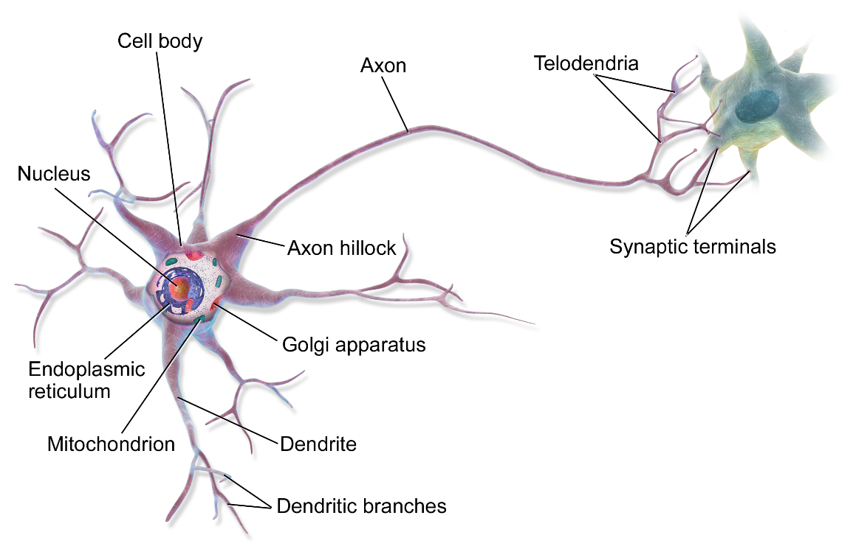

Table 1: Means, Standard Deviations, and t-test Results
Item | Mean Mind Map | Mean Control | SD Mind Map | SD Control | t-testª
Present first day of class | 1 | 1 | 0 | 0 | N/A
Number and type of exams | .82 | .91 | .39 | .29 | -1.05
Type of textbook or required readings | 1 | .97 | 0 | .17 | .91
Way in which students are assigned to groups | .82 | .91 | .39 | .29 | -1.05
How to make up work when absent | 1 | .41 | 0 | .50 | 6.22**
Attendance policy | 1 | 1 | 0 | 0 | N/A
Mission of Business School | .57 | .65 | .50 | .49 | -.60
Academic integrity violation consequences | .61 | .47 | .50 | .51 | 1.07
Leaving during class policy | .57 | .85 | .50 | .36 | -2.56*
Learning objectives | 2.14 | .94 | .53 | .69 | 7.56**
Total score for graded assignments | 8.89 | 8.18 | 1.40 | 1.34 | 2.04*
Total score | 18.43 | 16.29 | 1.62 | 1.73 | 4.99**
N = 62, *p <.05, **p<.01, ªdf = 60,
Note: Independent samples t-tests were conducted for all items with the exception of Total score for graded assignments and Total score, where summary independent samples t-test was conducted.

Table 2: Means, Standard Deviations, and t-test Results for Question 8: Correct Identification of Graded Assignments
Item | Mean Mind Map | Mean Control | SD Mind Map | SD Control | t-testª
Self-selected assignment | 1 | 1 | 0 | 0 | N/A
BCG Matrix presentation | .82 | .94 | .39 | .24 | -1.49
Reading quizzes | 1 | .91 | 0 | .29 | 1.62
Team challenge presentation | .93 | .41 | .26 | .50 | 4.94**
Service learning project | .75 | .94 | .44 | .24 | -2.17*
Statistical project on controlling | .86 | .53 | .36 | .51 | 2.88**
Graded cases | .89 | .85 | .32 | .36 | .46
Attendance and class participation | 1 | .71 | 0 | .46 | 3.36**
Exams | .96 | 1 | .19 | 0 | -1.10
Peer evaluation assignment | .68 | .88 | .48 | .33 | -1.99^{b}
N = 62, *p <.05, **p<.01, ªdf = 60 ^{b}p = .05,
Note: Independent samples t-tests were conducted for all items.

Appendix 1 – Unannounced Syllabus Quiz
- I was:
  - Absent on the first day of class when the syllabus was reviewed
  - Present on the first day of class when the syllabus was reviewed
- In this class:
  - There are three exams
  - There are two exams and a cumulative final
- The textbook:
  - There is no textbook for this course, but there are required readings
  - Can be purchased at the bookstore or online retailers
- For the group project:
  - You can choose your own group
  - Groups will be assigned by the instructor
- If you are absent:
  - Check the lecture notes posted in Blackboard after class
  - Get the notes from a classmate, because the professor does not post lecture notes
- Attendance
  - No formal attendance is taken at class meetings
  - The professor takes attendance at every class
- The mission of the Stillman School of Business includes:
  - “To advance the world's prosperity”
  - “to create ideas that deepen and advance our understanding of management”
  - “Transforming concepts into practice”
  - “Transform Lives Through Knowledge Creation & Sharing”
- The graded assignments in this class include (check ALL that apply):
  - _____ Self-selected assignment f. _____ Statistical project on controlling
  - _____ BCG Matrix presentation g. _____ Graded cases
  - _____ Reading quizzes h. _____ Attendance and class participation
  - _____ Team challenge presentation i. _____ Exams
  - _____ Service learning project j. _____ Peer evaluation assignment

- In this course, any violations of academic integrity:
  - Result in an automatic failure for the course
  - Result in either a zero for the assignment or failure of the course depending on the severity of the infraction.
- Stepping out of class for a few minutes:
  - Is not permitted in nonemergency cases because it is disruptive
  - Is not permitted in nonemergency cases because it is not professional
- What are the learning objectives for this course?
_____________________________________________________________________________________
_____________________________________________________________________________________
_____________________________________________________________________________________
_____________________________________________________________________________________
_____________________________________________________________________________________
_____________________________________________________________________________________
_____________________________________________________________________________________
_____________________________________________________________________________________

