MR. CHOCOLATE AND THE EFFECTUAL ENTREPRENEUR:
A LIFE CYCLE STORY

ABSTRACT
This is a story of an entrepreneur and his journey to find a scalable business. It is based on real life, and moves step by step through the entrepreneurial process. At every stage in the life cycle of this journey, you will be asked what you think our entrepreneur should do. As the story unfolds, you’ll learn about the concept of effectuation, a process by which our entrepreneur discovers what to do next by just starting with what he’s got, trying, and failing, and trying again until something sticks. You’ll help him identify the challenges and resources he could consider as he moves from ideation through intention to prototype, pilot, results, then profitability, hopefully becoming market established. What lessons did he learn, and what do you think about his chances for eventual success? This series of “compact cases” can be used in any introductory entrepreneurship or marketing class.

INTRODUCTION – AN ENTREPRENEURIAL MINDSET
Once upon a time there was a man named Michael who liked to try new things. He started a newspaper route when he was 10, but stopped it when the newspapers had to be delivered later in the day, because it interfered with his school schedule. He went to college to major in finance because he had found he liked making money, which was fine until he took his first advanced finance course and discovered he hated it. Michael really liked his professor, though, and asked for advice. The professor said to find something that matched his skill sets but also made him happy, or at least gave him satisfaction. Michael was a personable guy who liked physical activity – he had started a lawn care business during the summer to pay for his college expenses – and he had taken an acting class as an elective, so he decided to switch to become a communications/theatre major. This he loved.
One semester when he had a part time job working at a grocery store stocking shelves in the evenings, he decided to learn to juggle – apples and oranges, you know – and discovered he was good at that as well. Michael kept practicing and one day happened to watch the 1986 movie Labyrinth with David Bowie. In it he saw Bowie’s character juggling crystal balls, and decided he could not only learn how to get a sphere to “float” but he could teach others how to do that as well. A new business was born.
When Michael graduated from college, he started Sphere Play, a business where he demonstrated how to do “contact” juggling with spheres, offering free lessons and then selling the ball (sphere) plus instructions at fairs and renaissance festivals around the country. He and his new wife had a great time traveling and “playing” with both kids and adults for several years, hiring college students to demonstrate as well, interacting with thousands of customers. Having built up enough of a base, they decided to display at toy shows to try to find some wholesale clients.
At one of those trade shows their product caught the attention of the As-Seen-On-TV folks, who felt Sphere Play would be perfect for that distribution channel. After several weeks of back and forth negotiation, Michael was excited, until the phone calls just stopped. He was unable to get any response, and wondered what had happened. Oh well, he thought, until, watching TV one evening he saw an infomercial for the Fushigi Ball, a direct copy of his product! Michael had been out maneuvered. Taking what remained of his Sphere Play inventory and storing it in his attic, Michael and his wife sat down to decide what might be next.

QUESTIONS AT THIS POINT:
- Based on what you know of the entrepreneurial mindset, what characteristics did Michael seem to have that made him “entrepreneurial”?
- Do you think he identified a product that “solved a problem” for a group of customers? If so, what solution did he provide and why do you think he was successful?
- What do you think of his initial sales and distribution method? What might have been the pros and cons of the Sphere Play sales and distribution model?
- Is there anything he could have done differently to prevent what happened?

ADDRESSING REAL LIFE ISSUES
Although Michael and his wife had successfully developed and marketed a playful solution for people’s need to learn a skill that could entertain and impress others, bringing joy to all involved, their solution was not able to be protected from aggressive competitors. There was no potential for a patent – you can’t “protect” a ball or the craft of juggling, since both are already in the public domain – but Michael had learned something from the Sphere Play business experience. Unfortunately, he now needed to make money.
Taking what he knew about running a business, and knowing he was a good salesman, he went to work for a growing company out of New Hampshire, yogibo. Yogibo sold “everybody friendly” bean bag furniture, body rolls, pillows and inspiring accessories. Yogibo promised to transform any building into a “truly awesome and personalized relaxation zone”; encouraging all to "be more cozy, play, and chill", inside and out. Given this mission and message, Michael felt he was a natural at this business, and yogibo must have thought so too, because they gave him the opportunity, and responsibility, for developing sales outlets throughout the entire greater New York area. Michael was successful once again.
Over the years, as this company grew, things became more stable, but also more “corporatized”. For Michael, the fun had gone out of it all. He discovered he was a great boss, especially as long as he was free to be innovative and imaginative, but he was a terrible employee. He decided to leave, on good terms, with a much more substantial financial cushion, and started a brief business selling “fun” environments that he could install at kids parties and events. He provided “bounce houses” and even incorporated the yogibo furniture, but this didn’t last long. He realized he needed a business with more substance to it, something that was unique enough to withstand competition, or something with a built-in “secret sauce” for success.
Figuring he might find something, perhaps a well-supported franchise opportunity in the amusement and entertainment business, he went to a trade show in New York to check out what was available. He walked around the huge Javits Center for a whole day and found nothing that interested him. Traveling back to his home in Connecticut on the train, he reflected on what he’d seen, and what he might be able to report back to his wife. It was October 27, 2015 and Michael’s 45th birthday, and he was feeling a little discouraged that he hadn’t yet accomplished what he set out to do. The only thing that stood out for him was the fact that lots of booths had given out some sort of chocolate treat as a favor. He liked chocolate – doesn’t everybody? – and wondered if there was a business idea there…

QUESTIONS AT THIS POINT:
- What do you think Michael learned from his “failure” with Sphere Play?
- Did it surprise you that Michael didn’t last at his “corporate” job? Why or why not? What risks did he take in leaving? Would you have left this job?
- When Michael realized he needed a business with some “substance” to it, what do you think he meant by that? What might be the characteristics of such a business; what characteristics might appeal to him?
- If you had the same experience as Michael did at the trade show, would this have been a triggering event for you? What business ideas might you have, based on what you know?

STARTING WITH WHAT YOU’VE GOT
When Michael returned home from the trade show, and realized the only thing that stood out for him was the fact that chocolate treats were offered almost everywhere, he decided to do some research. He found out the chocolate industry was a $22B market. This was a large market, but also very saturated. How could he find a unique angle, that “secret sauce” that he knew was necessary in order to capture some market share? Even though it might be difficult, the thought was sweet that even with a .5% share he could be looking at over $100K in revenue.
As he shared his thoughts with his wife Jennifer, she reminded him that she had an allergy to soy, a main ingredient in most consumer chocolates, so anything they did would have to be soy-free so she could eat it. This raised other questions about the commodity – what about the “fair trade” in chocolate, given that some cacao production is done using unfair or unappealing labor practices? What about other allergies or health issues, including production of chocolates in factories that also included nuts or genetically-modified ingredients? They would have to do careful research into the raw materials and the production facilities if they wanted to produce something based on the values they held. They realized they would have to fully identify those values before they proceeded.
In addition, Michael was still sensitive to competition, and wanted to create a business that took an opportunity to solve a customer’s problems in such a way that this solution was better than anything else available, and was something the customer was willing to pay for. What might that be, in chocolate? As he and Jennifer brainstormed ideas, he recalled a friend of his mentioning the new technology that was becoming available in 3D modeling and laser engraving – there was a growing “hobby” market for this equipment. Michael wondered if chocolate could become a raw material for computer-aided machining? Weird, perhaps, but certainly different!
When he mentioned this to Jennifer, she remembered reading that the local “hackerspace” had just gotten a laser for members to try. Michael and Jennifer looked at each other and said “laser-engraved chocolate – sounds crazy, but why not?!” Several days later Michael showed up at the Hackerspace with some Hersey’s basic chocolate bars and asked to talk to the person in charge. This person, when he found out that the goal was to see if the laser would work on chocolate, said “why not, let’s try!” They did, and it worked… sort of…more experimentation was necessary, but the initial results were definitely promising. Now, what might this engraved chocolate business become?

QUESTIONS AT THIS POINT:
- Why was it important for Michael to do research at this point? What did he find out that was useful, and what other research might be important to do?
- When starting a business, Dr. Saras Sarasvathy suggests a method called “effectuation” that, as she says “suggests you start with who you are, what you know, and whom you know to come up with very doable venture ideas”. In what way was Michael practicing “effectuation”? What do you think was his intention?
- How important might an identification of core values and finding the most useful stakeholders be in Michael and Jennifer’s quest for a successful business? What evidence do you see that they’ve begun to do this? What core values do you think they hold?
- Since we now know that chocolate can be engraved on a laser, what should Michael do with this knowledge? What kind of engraving do you think he should pursue?

THE PRINCIPLE OF AFFORDABLE LOSS
It should come as no surprise by now that Michael and Jennifer were committed to co-creating something new, something based on the values they held, but something that could be unique, and solve someone’s problems. It would also help if it were fun to do! So what could they create that was fun, value-based, solved someone’s problems and could make money? They decided to laser engrave the chocolate with a message – provide the customer with a blank “page” to write on, using chocolate stationary to compose a meaningful message to someone they cared about, someone who also liked chocolate. Based on their previous experience, Michael and Jennifer knew they needed a memorable and unique name for this business, one that could convert to a web domain name that wasn’t already taken, one that could broadcast the nature of the brand and its value proposition. They chose the name Noteworthy Chocolates.
Now that they had the idea, they needed to seek further advice and truly research the feasibility of this “noteworthy” concept. They needed to do some actual customer outreach and see if this would really appeal to what they thought was their ideal target audience: people who cared enough about someone to send them a personalized message engraved in chocolate.
Luckily Michael had access to the laser and the other members of the Hackerspace who were willing to help with any technical issues that might arise. The other challenge was finding a supplier of soy-free, nut-free, gluten-free and non-GMO chocolate, a supplier who also believed in fair trade. They found such a vendor in California, Guittard Chocolate Company, a 150 year old family business with a commitment to honorable sourcing and expert crafting of milk, white and dark chocolate. Over the next three months, Michael tinkered with the settings on the laser, testing the capabilities of the equipment and the properties of the chocolate until he had a product that looked both elegant and edible.
The first “customers” were friends and family, and Michael and Jennifer got sometimes tearful thanks from the surprised recipients of the thoughtful, personalized chocolate gifts. Understanding that the engraved chocolate “gift cards” were so beautiful that it seemed a shame to destroy the message by eating it, they also provided the message printed on high quality paper stationary, so it could be preserved. In addition, they paid attention to the packaging, creating a “clam shell” box out of biodegradable paper, engraving the box with a personalized “To:” “From:” label and tying it up with a signature lavender ribbon.
Figure 1: Noteworthy Chocolates Product and Packaging
Their initial price for the 6x8 inch “letter” size chocolate note was $60. They also envisioned a 3.5 inch round medallion, to be used for special “favors” such as wedding seating placement cards or employee appreciation tokens, a 5 inch square and a 6 inch square. Customers could choose from a variety of templates and fonts optimized to look good in chocolate. The programmable laser made it easy to produce anything the customer wanted to say, and a special “picture” could be produced from certain types of digitized images.
Now that they had a working prototype, and had pilot tested their market, Michael and Jennifer needed to launch their new venture. They needed to identify the resources, establish an operational plan, identify marketing channels and get ready to actually sell their product, but in order to do this, they needed money. They knew they needed a facility that would pass the state health code as a commercial kitchen, and they knew they needed equipment to “temper” the chocolate, molds to use to set the chocolate, and a laser of their own to do the engraving. They also needed a web site to process orders and collect money, and social media accounts to let people know about this new business. They had savings from Michael’s yogibo days, but this would only go so far. The laser they wanted could set them back over $5000. They were willing to stake everything they had, but this might not be enough. Where could they go to get the needed funds?
One of Dr. Saras Sarasvathy’s points about entrepreneurs who practice effectuation is they understand they should “invest no more than they can afford to lose and invite stakeholders to support the project in a way that ensures they are really committed. The goal is to co-create rather than predict the future.” In the spirit of this belief, Michael and Jennifer decided to mount a Kickstarter campaign, asking interested backers to fund the $27,000 it would take to get started. As they explained on the Kickstarter site, “so far, everything has been improvised, so we're excited for what we can do with more space and professional equipment. With your backing, we will create a certified kitchen and laser lab, purchase lasers and other equipment, order professional chocolate molds, develop the website, and then make and send all the yummy rewards!”
They had improvised by using Mason jar lids and sandwich containers for the molds, working at their kitchen table to temper the chocolate and in the Hackerspace to do the engraving. To create this $27,000 campaign, they enlisted the help of the folks who had been attracted to their vision, who had eaten the prototype failures and cheered the successes – this crew of friends from the Hackerspace was tapped to shoot the promotional videos, create an initial website, spread the word via social media, and host the Kickstarter launch party. Between April 14th and May 15th 2016 they attracted 390 backers and raised $28,450. They were now ready to launch their new business.
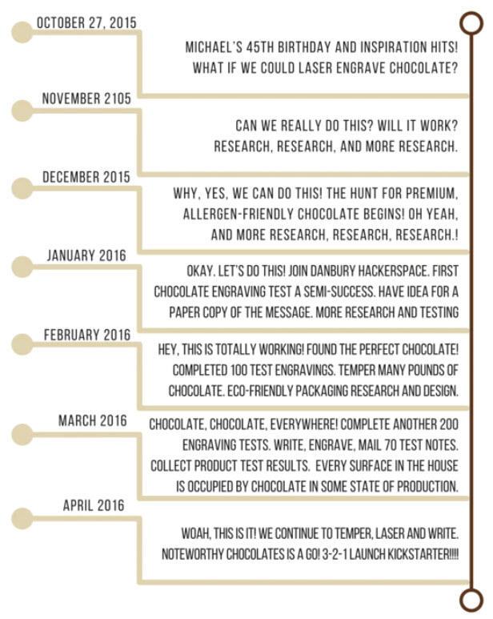
Figure 2: Noteworthy Chocolates Pre-Kickstarter Timeline
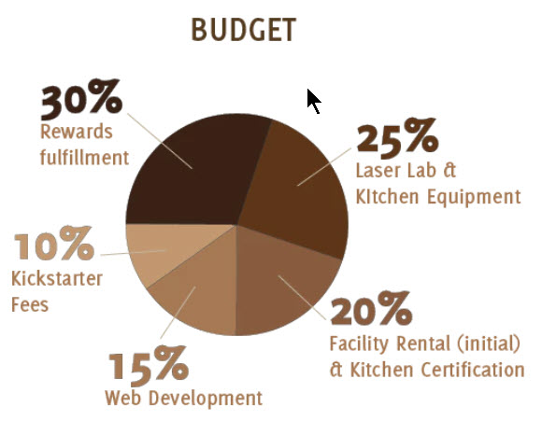
Figure 3: Noteworthy Chocolate’s Kickstarter "Ask" Budget

QUESTIONS AT THIS POINT:
- Visit the Noteworthy Chocolates Kickstarter campaign at https://www.kickstarter.com/projects/noteworthychocolates/noteworthy-chocolates-your-message-engraved-in-cho What do you think of their campaign? Would you have become a backer? Why or why not?
- Visit the Noteworthy Chocolates website at https://www.noteworthychocolates.com/ What do you think about the Noteworthy Chocolates concept? Would you purchase such a gift? Do you think Michael and Jennifer did enough research to validate their proposed market? Do you see any potential flaws in their process so far?
- Dr. Saras Sarasvathy talks about an “expanding cycle of resources” that accompany stakeholder commitments, leading the entrepreneur to acquire new means to achieve new goals. These new goals can sometimes create constraints on future possibilities, requiring other new goals and resources that might require reconfigurations, or “pivots” into new products, new markets or new partners. See the following graphic from the Society for Effectual Action:
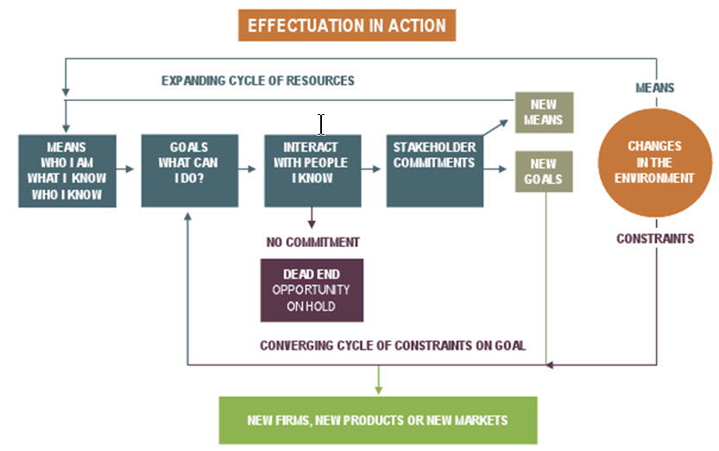
Who might be the key stakeholders Michael and Jennifer might need to interact with as they develop this business further?
- What do you think might happen to Noteworthy Chocolates as they begin producing results? Might pivots be necessary?

PRODUCING RESULTS, EXPERT ADVICE, PROTECTION, AND PIVOTS
Michael had set out to do something unique, something that had a “secret sauce” that couldn’t be easily copied. He was betting on people’s desire to do personalized gifting, and that they would love to see their name engraved into chocolate. He had researched market trends and knew that the personalized gift market was growing, driven by people’s interest in something meaningful and memorable. He had also researched the edible gift market, and had studied the founders of Edible Arrangements, who began their fresh fruit arrangement design business in East Haven Connecticut in 1999. Edible Arrangements was a private company, but had grown via franchising, with over 1200 stores and reportedly over $400M in revenue.
Michael also knew that the chocolate confectionary market was facing some challenges from declining margins due to high raw material prices and declining demand in some geographic areas. If he could create a new market category where the personalized gift market, the edible gift market and the chocolate market met, he would have reached a sweet spot. He was betting on his ability to convince people he was on to something. However, remembering what had happened with Sphere Play, he also knew he needed protection.
Working with a patent attorney, Michael filed a provisional patent to protect his process. He was unable to patent the manufacture of chocolate, nor was he able to get any protection for the laser engraving mechanism, but he was successful in isolating the laser settings and temperatures used to imprint his message into the chocolate. As far as he knew, he was the first to do this, and the months of trial and error at the Hackerspace had resulted in a unique process that no one else had yet to discover.
Going into 2017 Michael had his approval from the CT Health Department and the FDA, had purchased a laser, moved into a commercial location and was producing chocolate stationary to order, but business was not as strong as he had hoped. He and Jennifer sat down and ran the numbers and decided that if they did not meet their goals for Valentine’s Day 2017, they would shutter the business. Luckily for them they had a great Valentine’s Day, and continued to grow the business, but realized they needed some help, some more expert advice.
Press about Michael’s accomplishments had started to accumulate, and Noteworthy Chocolates was invited to become a participant in a Connecticut accelerator, reSET. Mentors from that organization and from the CT Small Business Development Center (CTSBDC) helped Michael and Jennifer refine their marketing strategy and make decisions based on data. They also engaged in more customer research via networking and trade show appearances. What they found was that word-of-mouth was strong, and the business-to-business market was more interested than they first thought.
Going into 2018 the product mix had shifted, with the medallions and special business-card-sized “impressions” becoming very popular with business clients. Along with the “favors’ for weddings, parties and business events, this component of their business was now producing 65% of Noteworthy Chocolates revenue. The personalized chocolate messages delivered as notes, cards and letters for landmark celebrations, anniversary, birthday and holiday gifts was still popular, but not as much, representing 35% of revenue. However, for both segments of the business, the customer reorder rate was 25%. This was a very good sign. The customer mix was further broken down into 35% small business and professional services, 43% personal and weddings, 14% non-governmental organizations and schools, and 8% corporate. Although this was different from their initial expectations, the diversity and potential for growth into new categories, with new product configurations, was promising.
Noteworthy Chocolates was poised to grow, but the next stage would be difficult without additional resources. Michael and Jennifer needed some help, employees to produce, pack and ship product, an expanded website, targeted social media and more robust print marketing materials, and, if business continued to grow, another laser. They needed some outside money. Reluctant to dilute ownership, Michael did not want outside investors, at least not just yet, and banks were reluctant to lend to a new startup without significant collateral. Luckily, he was able to connect with the Community Economic Development Fund, an entity that provides loans to Connecticut small businesses primarily in low-to-moderate income communities, who are not able to obtain traditional bank financing. With that financial cushion, he and Jennifer could truly plan for what might be next.

QUESTIONS AT THIS POINT:
- What do you think of Michael and Jennifer’s decision to shutter the business in 2017 if they didn’t hit their Valentine’s Day revenue goal? Would you have been willing to shut down if it was your business? Why or why not?
- Given that it is hard for startup businesses without collateral to get bank loans, would you have pursued equity investment, venture or angel capital? What are the pros and cons of this decision to dilute equity? Do you agree with Michael’s decision not to do this?
- Given the market analysis Michael did, the outlook for the edible gift, personalization and chocolate markets, do you think he’s correct that he’s carved out a sweet spot? What analysis would you do to confirm his conclusions?
- What should Michael and Jennifer do to grow their business to the next level? Choices include ramping up nationally and processing online orders from wherever they originate, or establishing Noteworthy Chocolates as a franchise opportunity, similar to Edible Arrangements. Which option do you recommend, and why?

CLOSING COMMENTS FROM MICHAEL AND JENNIFER
When interviewed by Nan Price of Innovation Destination Hartford, Michael had this to say:
The advice I would offer is to learn to look at things sideways. Because you don’t get a good view of things if you’re looking from any one direction. You have to look at things from different angles and perspectives. You get a better picture of what the problem is, and it allows you to be more creative solution provider… As for advice received: Focus on what you do best and what makes you or your company special. Really identify what that is and nail that first. That’s the most important thing you can do. Everything else kind of follows from that… I think when you’re starting something new you must be adaptable to what you think is going to happen and the reality of what happens. You can’t just think: If you build it they will come…you have to pay attention [to what people care about].
Jennifer added:
The quality and sustainability have been a driving core value for us. The packaging for our gift boxes is 99% biodegradable. The gourmet chocolate is made by Guittard. It’s fair trade certified and allergen-free. We love chocolate and we want everyone to be able to enjoy it as much as we do… [As far as advice?] I would say just start. Don’t try for perfect. Just do what you can when you can. Keep learning along the way and building on what you learn… we’ve been able to see how people experience the chocolate and we’ve been able to adjust along the way. And, now that we’ve felt these things out and figured out what people respond to, we can go to the next step.
What might that “next step” be? Follow along and see what Michael and Jennifer do next. Will they be content with an established market position, or will they decide to grown and deal with disruption as it comes? What might their ultimate exit strategy be? Remember, Michael is someone who always likes to try new things. Perhaps there’s another new business, another startup in their future? Who knows? Let’s see!

NOTES FOR INSTRUCTORS
This series of case discussions is meant to accompany a course based on Dr. Saras Sarasvathy’s concept of entrepreneurial effectuation. See the references list for possible texts and readings to support this discussion. It’s also designed to help students appreciate how entrepreneurial businesses follow a life cycle. It may be helpful to refer to a model of development, a graphical depiction of a process that has checkpoints along the way, so progress can be noted, adjustments made as necessary, and all can learn and grow.
Everyone is on a journey. Individuals and organizations both follow an organic developmental cycle that proceeds from birth through growth to maturity and eventually decline and death (Hanks, 1990; Quinn & Cameron, 1983). In the case of organizations, a “rebirth” is possible, a reversion to an earlier stage of development, so the process can begin again, hopefully having integrated what’s been learned, and the organization can achieve different outcomes, at greater levels of effectiveness.
As Quinn and Cameron (1983) note, evaluation of organizational success in one stage of development may require different criteria than that used at another stage, and the transitions from one stage to the next may encounter resistance, requiring intervention in order to make the process less “painful”. In addition, the resources and processes needed to facilitate these transitions and address challenges as they occur may not exist within the organization, necessitating external support or other facilitative mechanisms that can best help the organization reconfigure itself and continue to grow.
This need to seek help may cause an early decline and death if the organization’s leadership does not recognize or accept the reality of life stage transitions. Successful entrepreneurs are especially vulnerable to this “trap”, for to them the organization’s current success belies the need to think in terms of stages, and they may fail to see the need for reconfiguration, even as the organization grows in size and complexity (Galbraith, 1982). Both organizations (or institutions) and individuals are prone to this blind spot – we don’t know what we don’t know – so appropriate and timely help may be needed as decision points are reached and transitions need to be made.
INSERT FIGURE 3: The Entrepreneurial Arc

At its essence, entrepreneurship is about pursuing opportunities, creating something out of something else that results in something different, and verifying, through research, that this innovative approach is solving a problem or fulfilling a need that people are willing to pay for. And it’s in this payment, or economic exchange of value, where the business piece comes in. No activity will be sustainable without the circular flow of economic activity that keeps things moving from supplier to consumer.
So the Entrepreneurial ARC describes a life-cycle approach to this whole process, and it’s called “entrepreneurial” because it takes action on an identified opportunity and assumes the risk of developing an organization or identifying resources that can be used to grow or profit from this activity. However, just like any organic or growth activity, there is also inevitable decline and death, which must be anticipated in the beginning, so it can be planned for, and an intervention can be activated at the appropriate time to re-configure or re-vitalize things. At that point, the activity or enterprise can begin again, but is now informed by what it learned, so the subsequent “arc” continues its upward spiral. Whatever that ends up being, it’s important that the outcome be sustainable or, at the very least, provide a foundation for further development.
For students, it’s important for them to have opportunities to explore, to evaluate what they’re learning in the context of what the future might bring, and then see the pivot points where they can make changes if needed. The entrepreneurial mindset helps students navigate these transitions, regardless of whether they’re in a startup or a corporate environment. Especially around career choices it helps them to think strategically about how their actions might affect events in the future, so they can plan ahead; think holistically about how their job might fit into a larger picture, how their skills might need to mesh with skills at the department or organizational level; develop intellectual honesty in their decisions, being able to edit their own thought processes and realize when things just aren’t “right”; know where to look for the specialized knowledge they need in order to move from plan to action.
As Dr. Saras Sarasvathy says, sometimes you have to just start with what you have, identify existing resources, then ask three questions: who am I (what are my values, what do I care about), what do I know (what am I good at, and what am I not so good at), and WHO do I know (can I find a partner who values what I value and has skills that complement mine). This gets you on your way.
But then it’s important to recognize how basic management works, that one starts with a plan, a goal, then organizes the resources necessary to achieve that goal, starts operating, but then immediately activates a control function to monitor performance toward the goal. It’s very unlikely that one will achieve that goal completely, which is where the “pivot” comes in. Adjustments are always necessary. Once you’ve done something, you’re never completely done doing it! But the idea is to achieve progress never the less. It should be an upward spiral, continuous improvement, and this applies almost everywhere, which is why the entrepreneurial arc should be able to appeal to almost all stakeholders.

ENDNOTES

This case is based on first hand interviews and archived information, plus publically available and library-based materials. Michael Sauvageau of Noteworthy Chocolates has given permission to use his story for the purposes of student learning. It is not intended to provide commentary on or evaluation of the effectiveness or appropriateness of any party’s handling of the situation described.
See the crystal ball in the movie, actually juggled by Michael Moschen, at https://www.youtube.com/watch?v=0UWNWVIhFdY
See the fushigi gravity ball infomercial here https://www.youtube.com/watch?v=myIR__htBgc
See https://www.yogibo.com/about/
See https://www.statista.com/topics/1638/chocolate-industry/
See Sarasvathy, S. 2012.“Everyone Should Learn the Entrepreneurial Method”, Harvard Business Review, March 15, 2012, https://hbr.org/2012/03/everyone-should-learn-the-entr#
See https://www.guittard.com/
Sarasvathy, 2012, op. cit.
See https://www.kickstarter.com/projects/noteworthychocolates/noteworthy-chocolates-your-message-engraved-in-cho
From https://blogs.hope.edu/center-for-faithful-leadership/uncategorized/sarasvathy-effectuation-entrepreneur/
https://www.inc.com/profile/edible-arrangements-international
Yu, D. 2017. “Four big trends in chocolate for 2017: Cargill identifies growth drivers”, confectionerynews.com. https://www.confectionerynews.com/Article/2016/12/15/4-key-chocolate-and-cocoa-trends-for-2017-Cargill
See https://www.cedf.com/
Price, N. 2018. “CT Startup Finds Success with Laser Engraved Chocolate”, Innovation Destination Hartford, https://www.innovationhartford.com/tag/reset-accelerator/ REFERENCES Galbraith, J. 1982. The Stages of Growth. Journal of Business Strategy, 3(1): 70-79. Hanks, S. H. 1990. The Organizational Life Cycle: Integrating Content and Process. Journal of Small Business Strategy, 1(1): 1-12. Quinn, R. E., & Cameron, K. 1983. Organizational Life Cycles and Shifting Criteria of Effectiveness: Some Preliminary Evidence. Management Science, 29(1): 33-51. Read, S., Sarasvathy, S., Dew, N., Wiltbank, R., & Ohlsson, A.-V. 2011. Effectual Entrepreneurship. New York, NY: Routledge. Sarasvathy, S. D. 2001. Causation and effectuation: Toward a theoretical shift from economic inevitability to entrepreneurial contingency. Academy of Management Review, 26(2): 243-263. Sarasvathy, S D. 2008. Effectuation: Elements of Entrepreneurial Expertise. Northampton, MA: Edward Elgar. Sarasvathy, S. 2012. Everyone should learn the entrepreneurial method. Harvard Business Review, https://hbr.org/2012/03/everyone-should-learn-the-entr (March 15, 2012). Sarasvathy, S. 2015. AoM Entrepreneurship Division Live Webinar with Saras Sarasvathy, Academy of Management, https://www.youtube.com/watch?v=pbFP-ZzRRtM. Figure 3: The Entrepreneurial Arc

