Purpose
The aim of this exercise is to draw attention to the number of conflicts and similar stressful situations experienced by class members in one week and use delegates within the groups to come up with reasonable solutions for each conflict.
Objectives:
- Define conflict
- Identify the 5 stages of conflict resolution and apply them to communication exchanges
- Distinguish between content/task and relationship conflicts
- Apply the model of conflict resolution to more effectively managing conflict through a group exercise and activity
- Assess the impact of trigger words
- Compare and contrast assertive/collaborative communication with passive and aggressive communication.
Instructions
After defining conflict, students will recall three conflicts they have experienced in the past three days and receive some solutions from others. This exercise encourages participants to apply the conflict resolution/problem solving model and to identify negotiation strategies.
Conflict Sheet
Please fill in the table with three conflicts that you or other members of your group were involved in (i.e., in the last three days). Reach consensus on three examples of conflicts and fill in the chart below.
What does conflict mean to you? Prior to completing the exercise below define, conflict.
______________________________________________________________________________________________________________________________________________________________
Subject of the Conflict | People Involved | What happened? | Trigger Word | Define this Conflict
Example:  Washing dishes | My partner and I were involved in this conflict. | My partner accused me of being untidy by saying:  “You always leave a pile of dirty dishes in the sink for days” | Always | Relationship
1:

2:

3:

Covey said, “Seek first to understand and then to be understood.”
Conflict/Problem Solving Model
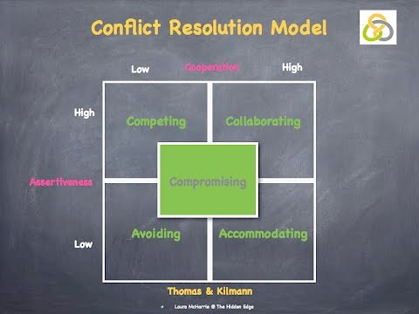
Review: Negotiating/Bargaining/Conflict Resolution Styles
- A = Competing
- B = Collaborating
- C = Compromising
- D = Avoiding
- E = Accommodating

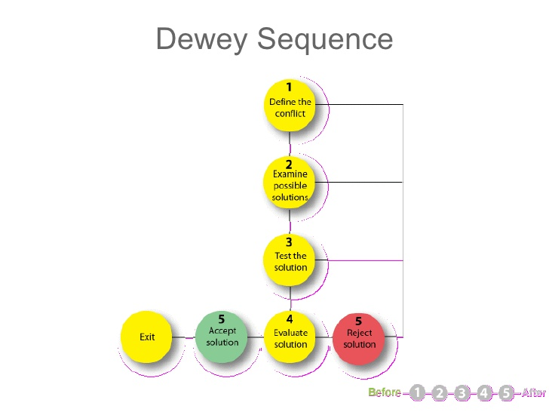

Discussion Questions/Debriefing
1). How did recalling a conflict make you feel?
2). How do you define the conflict?
3). Could you have handled that situation differently?
4). What was the trigger word that made you feel you were in a conflicting situation?
5). What conflict resolution or negotiation strategies did you use?
6). How helpful were other’s suggestions?
7). What conflict resolution strategies or negotiation strategies were used by the delegates?
8). Could you use the new suggestions to resolve your conflict or prevent them from happening?
9). What can you do as a leader to promote a healthy attitude toward conflict within your team?

