CAPITAL STRUCTURE DECISIONS AND NEW VENTURE SURVIVAL

ABSTRACT
We investigate the relationship between debt and equity financing of new ventures and their survival using the Kauffman Foundation’s longitudinal data on 4,928 U.S. startups. We find that surviving firms initially rely upon internal debt and equity to fund their ventures, then shift their financing structures to rely more heavily upon external debt. Among companies that survive longest, external debt is used more heavily than external equity. We posit that even though information asymmetry dissipates over time with demonstrated performance, the heavier use of external debt may be related to business owners not wanting to relinquish control over their businesses.

Keywords: New venture survival, internal and external finance, pecking order theory

INTRODUCTION
Entrepreneurship literature has demonstrated that starting and growing a small business requires some help both from external sources as well as internal sources of funding (George, 2005; Pissarides, 1999). Many firms finance their business activities systematically and strategically through a combination of equity and debt funding types (Modigliani and Miller, 1958). Various factors such as agency costs, information asymmetry, market interactions and control can influence a firm’s financing decisions and capital structure (Harris and Raviv, 1991). Firm capital financing has been researched from the perspective of the funding type (debt vs equity) as well as the source of funding (internal vs external) (Jensen and Meckling, 1976). Some researchers have claimed that strategic management and managerial choice plays a role in determining a firm’s capital structure (Barton and Gordon, 1987; Chaganti, et al., 1995). However smaller firms have a different set of debt and equity financing choices available to them due to information asymmetry and lack of historical financial statement information (Ang,1991; Myers and Majluf, 1984).
Growth of most small firms is constrained by internal funding (Carpenter and Petersen, 2002). Therefore, many startups rely heavily on external funding to finance their growth and development (Robb and Robinson, 2012). Access to external funding has been linked to higher likelihood of growth and survival (Musso and Schiavo, 2008). When small startups are expected to grow faster, outside equity is especially likely to be tapped in order to provide the startups with access to resources they could not otherwise afford with their internal funding alone (Carpenter and Petersen, 2002). High growth startups, in particular, have been observed to benefit most when external equity is present in the firm’s capital structure (Hechavarría, Matthews and Reynolds, 2016). Once small firms seek external funding, the initial form of funding is debt financing to avoid the transaction costs associated with equity investment and to retain control of the firm (Hechevarría, Matthews, Reynolds, 2005). Many entrepreneurs have a hard time giving up control and shares of their ventures, which is required for equity financing (Eddleston et al., 2014; Winton and Yerramilli, 2008).
Drawing from the pecking order theory from the finance discipline, we note that the firms prefer internal funding over external, but when they do require external funding, they tend to use debt over equity because it is more easily accessible (Frank and Goyal, 2003; Meyers, 1984; Robb and Robinson, 2012). The problems as well as the costs related to information asymmetry in equity financing make it the least preferred type of funding. Information asymmetry occurs when management knows the firm's value and potential, while external investors can only rely upon objective, rational observations of the firm to decide whether or not to issue funding (Meyers and Majluf, 1984). Firms’ decisions to seek additional funding from outside of the firm can be driven by internal financial deficit (Shyam-Sunder and Myers, 1999).
According to Frank and Goyal (2003) while the pecking order theory is not strongly supported in larger firms, they did observe support for the pecking order for those firms in their earlier years. Frank and Goyal (2003) also noted that over time, the support for the pecking order declines as equity financing becomes more important, however their sample population consisted entirely of publicly traded firms. When we examine smaller firms, more specifically startups, some of the prevalent forms of financing are bank debt, personal equity and trade credit respectively (Robb and Robinson, 2012). According to Robb and Robinson (2012), bank debt is a popular choice among entrepreneurs partly because of how readily available bank debt is to borrowers. However, it is difficult to attribute this phenomenon to traditional pecking order theory since it may not be a preference or a choice issue (Robb and Robinson, 2012).
However, the extant research has overlooked the changing sequence of the capital structure of the startups affecting the survival of the new ventures. The intent of the current study is to examine these research areas in relation to the likelihood of the new venture survival. Are the new ventures that select internal funding more likely to survive when compared to the other new ventures that choose external funding financing or vice versa? Another key interest of our study is to see if new ventures maintain a sequence of financing options such as external debt and equity attributing to their survival rate.
In this study, we reviewed the capital structure of the new ventures exploring the variations associated with the new venture’s growth. Inferring from the extant literature, we positioned the current research following and building on Berger’s theorizing of the growth cycle in addition to the pecking order theory (Myers and Majluf, 1984). We presented some empirical evidence from the Kauffman Firm Survey (KFS). The firms observed in this study are more reflective of the earlier years, prior to the issuance of publicly traded company stock. Our findings have demonstrated a very interesting process story, presenting how the small startups’ usage of funding vary as they grow. Our descriptive statistics validate the evolution of the capital structure of the new ventures. Similar to Frank and Goyal’s 2003 study, as small businesses sprout, they rely heavily on the external debt (Robb and Robinson, 2012). However, once they grow and prosper, they are able to generate the needed funding internally lowering the debt and equity. Our descriptive statistics reveal this change over time as an increase in the startups’ assets, exhibiting a similar pattern to the standard pecking order theory (Myers and Majluf, 1984).
CONCEPTUAL FRAMEWORK
Difference Between Small and Large Firms
Lacking publicly traded securities, small firms have different set of characteristics affecting their financial management options when compared to large firms (Ang, 1991). Large firms are usually more diversified, have better reputation in debt markets with lower information costs when borrowing, predicting higher amounts of debt in their capital structure (Frank and Goyal, 2003). On the other hand, small firms are also less likely to have large, diversified portfolios, bearing a greater level of risk to the owners’ personal assets in order to be able to get a loan (Ang, 1991). Especially in the new ventures, the uncertainty of new business development, coupled with unstructured financial information make it difficult for investors and lenders to evaluate the risk of lending to or investing in fledgling companies (Berger and Udell, 1998). This information asymmetry can drive up the transaction cost for small business owners (Berger and Udell, 1998). When the small businesses first begin to consider financing through external funding, to eliminate potential agency problems associated with the information asymmetry, monitoring mechanisms must be put in place to satisfy their lenders leading to higher transaction costs for the new firm (Ang, 1991). Other kinds of problems small businesses face include having limited leverage with their external networks, credibility and lack of financial information (Ang, 1991). Berger and Udell (1998) have also examined how small business’ capital structure varies over time through the financial growth cycle paradigm. It is beneficial to note that the different stages of the new venture have different requirements. The sources and types of financing vary as the firm age and size change over time (Berger and Udell, 1998).
Financing Options for New Ventures and Capital Structure
When we look at the challenges the new ventures encounter, financing has been recognized as a major challenge in the entrepreneurship discipline (Ebben and Johnson, 2006). In order to overcome the challenge of financing, entrepreneurs have various options. Initially, entrepreneurs mostly rely on personal resources followed by funding from friends and family (Berger and Udell, 2003). Debt financing and equity capital comes in later stages (Berger and Udell, 2003).
The information asymmetry associated with: a) the uncertainty of new business development, and b) the unstructured financial information makes it difficult for investors and lenders to evaluate the risk of lending or investing as well as driving up the transaction cost for small business owners (Berger and Udell, 1998). Unable to meet the required criteria for equity investments, most entrepreneurs draw on debt financing (Eddleston et al., 2014). At these initial stages of the new venture, debt financing is conducted through commercial banks and trade credit; while the primary sources of equity financing are owners and family members (Berger and Udell, 1998). Interestingly, this sequence of financing options is consistent with the Standard pecking order theory (Myers and Majluf, 1984). Myers (1984) proposed that firms prefer internal finance due to adverse selection. High growth firms with large financing needs are likely to have higher debt ratio because of manager’s unwillingness to issue equity (Myers, 1984). Thus, according to the pecking order theory, firms prefer internal funding followed by debt and equity.
One of the main assumptions based on the resource-based view in addition to the pecking order theory is that new ventures do not want to pass up on a positive Net Present Value (NPV) project. Consequently, the new venture needs new resources as they take on new projects and exhaust their previous resources. According to the pecking order theory (Myers and Majluf, 1984), under normal operating conditions, internal funding which in our case Retained Earnings should be used for all of the positive NPV projects unless it is inadequate, then debt will be issued. No equity is issued for it poses severe adverse selection problems. Thus, the pecking order proposed by Myers and Majluf (1984) predicts the sequence of internal cash, then accrual of debt and after that, the use of outside equity. However, according to Frank and Goyal (2003) small firms do not follow the pecking order for they have different needs. Frank and Goyal (2003) have empirically tested the pecking order theory on publicly traded U.S. firms and found that, as small firms grew, there was less support for the pecking order theory. Using a smaller sample of new businesses, Atherton (2009) found the pecking order theory of finance to partially explain the financing decisions of new firms.
According to the descriptive statistics gathered from our dataset, we identify three types of internal funding in the new ventures. Since the internal cash generated from business operations are not enough, the new ventures are financed by internal debt and internal equity initially. Owners’ access to funding from local banks, friends and families make up the majority of the internal funding in our dataset. This is similar to the findings of Ang’s (1991) as well as Berger and Udell’s (1998 and 2003) papers stating that financing sources for the startup stage comes from owners, friends and families since the cost of financing is very low at this stage (Ang, 1991).
HYPOTHESES DEVELOPMENT
Taking a resource-based view, we note that as the new venture’s resources are exhausted, the need for additional resources drives the new venture to seek out additional funding. The new ventures seek out possibilities of various types (debt versus equity) and various sources (internal versus external) of funding (Jensen and Meckling, 1976). The type and source of funding the new ventures receive (referring to external/internal and debt/equity) can affect the new venture’s likelihood of survival since financing the new venture is one of the main issues entrepreneurs face (Ebben and Johnson, 2006).
When a small startup considers funding at initial stages, since the internal cash generated from business operations is either not achieved or not enough to function, the founders’ personal resources are followed by funding from friends and family (Berger and Udell, 2003). In the current study, we categorize these as the internal funding. Assuming that the new venture’s internal cash from business operations is neither achieved nor enough to function, the ease of access and the lower costs are two important aspects associated with internal funding making internal debt and internal equity more favorable for the startup correspondingly. Although we cannot argue that this occurrence is by preference or choice, it presents a similar pattern to the pecking order theory (Frank and Goyal, 2003; Meyers, 1984; Robb and Robinson, 2012) demonstrating that internal funding is favored. However, lacking some outsider competencies may have a negative impact on the new venture. Therefore, we hypothesize that;
H1A) There is a negative relationship between the total amount of internal funding and the new venture survival.

It is established in the entrepreneurship literature that external competencies associated with outsiders can come in various forms. Some of these external competencies are funding in the form of debt or equity, knowledge, guidance and expertise helping the new venture prosper (Gilbert et al., 2006). These external competencies are considered beneficial for the small startup (Gilbert et al.,2006). Optimal amount of outside assistance is helpful for the new venture. External funding sources such as venture capitalists and banks are considered significant predictors of new venture growth (Lee et al., 2001). Government aid can boost new venture’s growth (Dahlqvist, Davidsson, and Wiklund, 2000). Findings from Chrisman et al. (2005) showed that assistance of Small Business Development Center had significant impact on various types of growth in new ventures. Thus, we hypothesize that;
H1B) There is a positive relationship between the total amount of external funding and the new venture survival.

When we examine the sequence of financing in the new ventures, drawing from the Transaction Cost Economics (Williamson, 1981) and Agency Theory (Eisenhardt, 1989), the costs associated with the information asymmetry between the insiders and outsiders create an optimal balance (Robb and Robinson, 2012) generating various types and sources of financing such as external debt, external equity, internal debt and internal equity. Since we cannot argue that this optimal balance of financing is a preference or a choice rather than an accessibility issue for the new venture, we posit that it is merely a similarity to the pecking order theory. However, Robb and Robinson’s work (2014) as well as Berger and Udell’s work (2003) lay the foundations for proposing a possible portfolio of financing in addition to financing sequence for predicting higher likelihood of the new venture survival in the small firms.
Applying the pecking order theory to our early stage new ventures, we predict that the new ventures will use debt financing initially and then followed by equity financing in later stages. We have established that new ventures at initial stages receive funding from friends and family in addition to the owners’ personal resources (Ang 1991; Berger and Udell, 1998 and 2003). Thus, when considering later stages, the focus is mainly on the external debt and external equity. Based on the pecking order theory, these new ventures are likely to have a higher external debt to external equity ratio in their early years after the internal funding is exhausted. However, we predict lower external debt to external equity ratio as these new ventures prosper and enjoy equity funding in later stages. Hence, we propose the sequence of financing choices selected can impact the survival of the new firm.
H2) New ventures that have higher external debt to external equity ratio are more likely to survive when compared to new ventures that have lower debt to equity ratios.

METHODOLOGY
Data
This study uses the most recent, publicly-available dataset from the Kauffman Firm Survey (KFS), which is arguably the largest longitudinal panel dataset of new small businesses in the United States. The cohort of 4,928 high-tech, medium-tech and no-tech firms founded in 2004 in the U.S. that participated in the survey were tracked annually, from 2004 to 2011. The total number of observations is 10,893. Detailed information is included on firm characteristics, owner characteristics, financial structure, and other performance measures from 2004 to 2011.
Prior studies that have used the Kauffman Firm Survey data have examined such topics as gender differences (Coleman and Robb, 2009) and capital structure decisions (Robb and Robinson, 2012). This study extends the work conducted by Robb and Robinson by taking a closer look at the pecking order theory referenced in their study and exploring in greater depth the pattern of capital structure preferred by those firms that survive.
------------------------------------
Insert Table 1 about here
------------------------------------

Procedure
Survival analysis has been performed on the dataset to examine the relationship between the survival of the new venture and the different types and sources of financing. In addition to this, three cross sections of the dataset have been analyzed using logistic regressions for survival at 1, 3 and 7 year marks for the new ventures in the dataset.
Measures
Our dependent variable throughout various analyses is the new venture survival. The independent variables are total amount of outside equity, outside debt, inside equity and inside debt. These independent variables are standardized and normalized in our study. We categorized total amount of outside equity as the equity associated with venture capitalists, business angels, other companies and government. Total amount of outside debt consisted of business credit cards, personal and business loans from banks, other non-bank lenders (individuals as well as other companies) and government. Total amount of inside equity is categorized as equity associated with the operating owners, spouses and family. Total amount of inside debt consisted of personal credit cards, business and personal loans from family and spouses, business loans from employees, other personal loans and debt. Consistent with prior studies using the KFS dataset in their research (Coleman and Robb, 2009; Robb and Robinson, 2012), we control for gender, owners’ hours worked, owners’ work experience, owners’ prior startup experience, number of owners, profit-loss and credit risk.
------------------------------------
Insert Table 2 about here
------------------------------------

When we examine the trends in our dataset, as shown in Figure 1, the startups grow and they seem to lower the amount of equity financing both internally and externally. If this may be perceived as a matter of preference or choice then, our descriptive statistics are showing that as startups, these new ventures are not following the similar pattern of the pecking order theory since they have higher internal and external equity. As we have reviewed previously, pecking order theory states that the costs associated with equity makes this form of funding the least preferred (Myers and Majluf, 1984). However, as these new ventures grow, they lower their equity internally and externally as seen in Figure 1.
------------------------------------
Insert Figure 1 about here
------------------------------------

Noticing this trend in our dataset, we examined the mean value of assets since we assume that the assets are the indicator for internal cash generation for the new venture based on the previous literature. The descriptive statistics of our dataset as presented in Figure 2, have revealed that there is a constant increase of the mean value of assets showing similarities to the pecking order theory. Between Figure 1 and 2, the descriptive statistics of our study presents an interesting story demonstrating the change in types and sources of financing in these new ventures over time.
------------------------------------
Insert Figure 2 about here
------------------------------------

RESULTS
Examining the various logistic regression analyses run at the first, third and seventh year marks, we note that our first hypothesis H1A is supported. We predict that there would be a negative relationship between the internal funding and the survival of the new venture. At 0.05 significance level, the internal funding maintained a statistically significant negative coefficient (-0.23 in 2004; -0.11 in 2007; -0.12 in 2011) throughout three logistic regressions. It is noticeable that after the third year the coefficient seems to be stabilized.
------------------------------------
Insert Table 3a about here
------------------------------------

However, for our second hypothesis H1B, we found partial support. External funding seemed to be significant only for the seventh year (2011) in the analyses.
Our last hypothesis H2 was supported as well. At 0.05 significance level, the external debt to external equity ratio is statistically significant. When we examine the external debt to external equity ratio, the increasing coefficient (0.57 in 2004, 1.83 in 2007 and 1.92 in 2011) demonstrates that as this ratio is declining the likelihood of survival increases. So as the external equity is increased or as the external debt decreases, the new venture is more likely to survive.
------------------------------------
Insert Tables 3b and 4 about here
------------------------------------

Also a thorough examination of the results of the survival analyses has revealed that H2 is supported. In Table 4 we see that companies with a higher external debt to equity ratio have a higher chance to survive (hazard ratio = 0.48, p<.001). To further examine H2, we split the sample into high versus low external debt to equity ratios based on the mean and make the comparison between the survival of companies with high versus low external debt to equity ratios (see Figure 5). Figure 5 demonstrates that among the surviving companies, the proportion of those with the lower external debt to equity ratios becomes smaller over time.
------------------------------------
Insert Figure 5 about here
------------------------------------

DISCUSSION
The various types of analyses conducted in this study have demonstrated that, though easily accessed by many entrepreneurs in initial stages (Ang, 1991; Berger andUdell, 1998 and 2003), internal funding – whether it be debt or equity – is a negative predictor of new venture survival. Thus, lacking the external competencies (Gilbert et al., 2006) provided by outsiders such as knowledge, expertise, guidance in addition to monetary resources affect the new venture’s survival in negative way.
External funding is a little more complex. Based on the literature, we recognize that there have been various studies showing that external funding is beneficial for new venture growth (Chrisman et al., 2005; Dahlqvist, Davidsson, and Wiklund, 2000; Lee et al., 2001). Thus, we wanted to take it a step closer and relate new venture survival to external funding and found partial support.
Although we acknowledge that this is not a matter of choice or preference, once new ventures grow out of their initial stages, they try to follow the pecking order in order to improve their chances of survival.
Another aspect of the current study was the credit risk associated with the new venture. Our analyses have demonstrated that at 5 percent level, the credit risk has been statistically very significant (p=0) for the new venture survival. The higher the credit risk associated with the new venture, the lesser the likelihood of survival of the new venture. Another finding was at third and seventh year marks, profitability of the new venture was significant. However, this can be considered as a rational expectation when we examine concepts such as survival, performance, and growth.
CONCLUSION
Our study contributes to the literature of new venture survival. Internal financing associated with friends and families may be more accessible, but it is not beneficial for the new venture survival. We also recognize that external financing is more complicated and requires just the right amount of assistance.
Based on the similarities of patterns, as the new ventures grow, they try to follow the proposed sequence of the pecking order theory. Although we note that initially the new ventures mostly pursue external debt, this is not a matter of choice or a preference but a matter of accessibility. It also contradicts the tenets of pecking order theory. However, once the new venture gets out of the initial stages and generates enough amount of cash from business operations, it uses that cash to operate rather than seek additional resources from inside and outside.

REFERENCES
Ang, J. S. (1991). Small business uniqueness and the theory of financial management. The Journal of Entrepreneurial Finance, 1(1), 1.

Atherton, A. (2009). Rational Actors, Knowledgeable Agents Extending Pecking Order Considerations of New Venture Financing to Incorporate Founder Experience, Knowledge and Networks. International Small Business Journal, 27(4), 470-495.

Barton, S. L., & Gordon, P. I. (1987). Corporate strategy: Useful perspective for the study of capital structure? Academy of Management Review, 12(1), 67-75.

Berger, A. N., & Udell, G. F. (2003). Small business and debt finance. In Handbook of Entrepreneurship Research (pp. 299-328). Springer US.

Berger, A. N., & Udell, G. F. (1998). The economics of small business finance: The roles of private equity and debt markets in the financial growth cycle. Journal of Banking & Finance, 22(6), 613-673.

Carpenter, R. E., & Petersen, B. C. (2002). Is the growth of small firms constrained by internal finance? Review of Economics & Statistics, 84(2), 298-309.

Chaganti, R., DeCarolis, D., & Deeds, D. (1995). Predictors of capital structure in small ventures. Entrepreneurship Theory and Practice, 20, 7-18.

Chrisman, J. J., Chua, J. H., & Sharma, P. (2005). Trends and directions in the development of a strategic management theory of the family firm. Entrepreneurship theory and practice, 29(5), 555-576.

Coleman, S., & Robb, A. (2009). A comparison of new firm financing by gender: evidence from the Kauffman Firm Survey data. Small Business Economics, 33(4), 397.

Dahlqvist, J., Davidsson, P., & Wiklund, J. (2000). Initial conditions as predictors of new venture performance: A replication and extension of the Cooper et al. study. Enterprise and Innovation Management Studies, 1(1), 1-17.

Ebben, J., & Johnson, A. (2006). Bootstrapping in small firms: An empirical analysis of change over time. Journal of Business Venturing, 21(6), 851-865.

Eddleston, K. A., Ladge, J. J., Mitteness, C., & Balachandra, L. (2014). Do you see what I see? Signaling effects of gender and firm characteristics on financing entrepreneurial ventures. Entrepreneurship Theory and Practice.

Eisenhardt, K. M. (1989). Agency theory: An assessment and review. Academy of management review, 14(1), 57-74.

Frank, M. Z., & Goyal, V. K. (2003). Testing the pecking order theory of capital structure. Journal of financial economics, 67(2), 217-248.

George, G. (2005). Slack resources and the performance of privately held firms. Academy of Management Journal, 48(4), 661-676.

Gilbert, B. A., McDougall, P. P., & Audretsch, D. B. (2006). New venture growth: A review and extension. Journal of management, 32(6), 926-950.

Harris, M., & Raviv, A. (1991). The theory of capital structure. The Journal of Finance, 46(1), 297-355.

Hechavarría, D. M., Matthews, C. H., & Reynolds, P. D. (2016). Does start-up financing influence start-up speed? Evidence from the panel study of entrepreneurial dynamics. Small Business Economics, 46(1), 137-167.

Jensen, M. C., & Meckling, W. H. (1976). Theory of the firm: Managerial behavior, agency costs and ownership structure. Journal of financial economics, 3(4), 305-360.

Lee, C., Lee, K., & Pennings, J. M. (2001). Internal capabilities, external networks, and performance: a study on technology‐based ventures. Strategic management journal, 22(6‐7), 615-640.

Musso, P., & Schiavo, S. (2008). The impact of financial constraints on firm survival and growth. Journal of Evolutionary Economics, 18(2), 135-149.

Pissarides, F. (1999). Is lack of funds the main obstacle to growth? EBRD's experience with small-and medium-sized businesses in Central and Eastern Europe. Journal of Business Venturing, 14(5), 519-539.

Robb, A. M., & Robinson, D. T. (2012). The capital structure decisions of new firms. Review of Financial Studies, hhs072.

Myers, S. C. (1984). The capital structure puzzle. The Journal of Finance, 39(3), 574-592.

Myers, S. C., & Majluf, N. S. (1984). Corporate financing and investment decisions when firms have information that investors do not have. Journal of Financial Economics, 13(2), 187-221. doi:http://dx.doi.org/10.1016/0304-405X (84)90023-0

Frank, M. Z., & Goyal, V. K. (2003). Testing the pecking order theory of capital structure. Journal of Financial Economics, 67(2), 217-248.

Shyam-Sunder, L., & Myers, S. C. (1999). Testing static tradeoff against pecking order models of capital structure. Journal of Financial Economics, 51(2), 219-244.

Williamson, O. E. (1981). The economics of organization: The transaction cost approach. American Journal of Sociology, 548-577.

Winton, A., & Yerramilli, V. (2008). Entrepreneurial finance: Banks versus venture capital. Journal of Financial Economics, 88(1), 51-79.

Table 1. Descriptive Statistics & Pairwise Correlations

 | Mean | SD | 1 | 2 | 3 | 4 | 5 | 6 | 7 | 8 | 9 | 10 | 11 | 12 | 13
1. Outside Equity | $12,189.57 | $106,846.60 | 1.00
2. Outside Debt | 46,377.00 | 189,032.50 | 0.18* | 1.00
3. Inside Equity | 26,534.29 | 108,126.30 | 0.25* | 0.23* | 1.00
4. Inside Debt | 8,301.96 | 55,942.61 | 0.08* | 0.24* | 0.12* | 1.00
5.External Debt to Equity Ratio | 4.15 | 1.28 | -0.06* | -0.01 | -0.05* | -0.01 | 1.00
6. Female | 0.18 | 0.38 | 0.03* | -0.04* | -0.03* | -0.01 | 0.01 | 1.00
7. Owner Hours Worked | 40.38 | 20.16 | 0.08* | 0.10* | 0.13* | 0.07* | 0.02* | -0.07* | 1.00
8. Owner Work Experience | 13.64 | 10.68 | 0.04* | 0.02* | 0.02* | 0.00 | 0.08* | -0.09* | 0.08* | 1.00
9. Owner Prior Startups | 0.90 | 1.57 | 0.08* | 0.09* | 0.12* | 0.05* | 0.01 | -0.07* | 0.01 | 0.09* | 1.00
10. Multiple Owners | 1.98 | 4.81 | 0.44* | 0.15* | 0.14* | 0.10* | -0.03* | -0.03* | 0.07* | 0.03* | 0.11* | 1.00
11. Credit Risk | 3.05 | 0.92 | -0.03* | -0.04* | -0.01 | -0.03* | -0.10* | 0.02* | -0.03* | -0.07* | -0.02* | -0.04* | 1.00
12. Profit or Loss | $33,716.05 | $206,220.00 | 0.06* | 0.16* | 0.10* | 0.06* | 0.08* | -0.08* | 0.36* | 0.09* | 0.09* | 0.13* | -0.18* | 1.00
13. # of Employees | 2.96 | 6.11 | 0.18* | 0.29* | 0.15* | 0.09* | 0.04* | -0.06* | 0.22* | 0.06* | 0.10* | 0.20* | -0.08* | 0.37* | 1.00
Notes: n=19,961 observations.
Asterisks denote correlations at a significance level of .05 or better.
ª Mean and Std Deviations of Debt & Equity variables 1-4 and Profit/Loss are shown in total dollar amount.
The log of Profit/Loss was used in correlation calculations.

Table 2. Summary of Financing Source Means for 2004, 2007 & 2011

Funding Source Categories | 2004 Means | 2007 Means | 2011 Means
Outside Equity | $12,122.45 | $11,007.10 | $8,264.82
Venture capital investments | 2,727.64 | 2,270.33 | 1,117.28
Other equity investments | 279.71 | 321.04 | 339.30
Government equity investments | 974.92 | 828.82 | 803.33
Other companies’ investments | 2,738.45 | 2,390.02 | 2,015.57
Angel investors | 5,401.74 | 5,196.90 | 3,989.35
Outside Debt | $46,126.48 | $46,211.66 | $44,511.92
Personal bank loans | 14,985.12 | 14,652.26 | 14,434.14
Business credit card balances | 3,892.02 | 4,128.65 | 4,249.49
Other debt sources | 644.11 | 579.51 | 431.77
Other owners’ loans | 1,859.10 | 1,886.27 | 1,714.13
Other individuals’ loans | 564.20 | 544.47 | 508.09
Nonbank business loans | 3,376.50 | 3,123.82 | 2,730.37
Government loans | 1,717.47 | 1,789.37 | 1,654.09
Other business loans | 715.80 | 718.55 | 762.39
Bank loans | 16,357.54 | 16,923.89 | 16,129.39
Personal bank loan by other owners | 1,741.63 | 1,615.75 | 1,633.73
Business credit card balances, other owners | 272.98 | 249.12 | 264.32
Inside Equity | $25,937.46 | $24,176.42 | $21,133.04
Owners’ equity | 24,162.17 | 22,614.41 | 19,838.59
Spouses’ equity | 397.33 | 299.26 | 214.76
Parents’ equity | 1,377.95 | 1,262.75 | 1,079.69
Inside Debt | $8,379.27 | $8,026.45 | $7,730.84
Business loans by owner | 1,859.10 | 1,886.27 | 1,714.13
Business loans by family | 1,808.45 | 1,615.29 | 1,660.11
Business loans by employees | 120.23 | 135.72 | 128.11
Personal credit card balances, owner | 3,904.24 | 3,838.39 | $3,699.69
Personal loans from other owners | 102.88 | 118.35 | 36.50
Personal loans, other owners’ other sources | 52.73 | 15.44 | 14.34
Personal loans from family | 233.33 | 183.50 | 221.19
Personal credit card balances, other owners | 298.32 | 233.49 | 256.77
Total Mean Financial Capital | $92,565.65 | $89,421.63 | $81,640.62

Table 3a. Logistic Regression Comparisons of Surviving Firm Capital Structures
at Startup in 2004, in 2007 and in 2011

Capital Structure and Control Variables | 2004 Base Year | 2007 Survivors | 2011 Survivors
Outside Equity, mean standardized | -0.14 | -0.07 | -0.09
 | (0.1) | (0.05) | (0.05)
Outside Debt, mean standardized | 0.07 | 0.07 | 0.02
 | (0.12) | (0.04) | (0.03)
Inside Equity, mean standardized | -0.3*** | -0.13** | -0.15***
 | (0.07) | (0.04) | (0.04)
Inside Debt, mean standardized | 1.05 | 0.05 | 0
 | (0.7) | (0.04) | (0.03)
External Debt to Equity Ratio | 0.57*** | 1.83*** | 1.92***
 | (0.08) | (0.06) | (0.03)
Female | -0.25 | 0.06 | -0.03
 | (0.26) | (0.11) | (0.1)
Owner Hours Worked | 0 | -0.01*** | 0
 | (0.01) | (0) | (0)
Owner Work Experience | 0.01 | 0 | 0.01**
 | (0.01) | (0) | (0)
Owner Prior Startups | -0.1 | -0.03 | 0.02
 | (0.06) | (0.03) | (0.02)
Multiple Owners | 0.18 | 0.03 | -0.02
 | (0.15) | (0.02) | (0.01)
Credit Risk | -0.43*** | -0.34*** | -0.26***
 | (0.12) | (0.05) | (0.04)
Relative Profit or Loss | 0.03 | 0.01 | 0.06**
 | (0.06) | (0.02) | (0.02)
Number of Employees | 0.06 | 0.01 | 0
 | (0.03) | (0.01) | (0.01)
Constant | 3.56*** | -2.59*** | -6.98***
 | (0.78) | (0.3) | (0.28)
Observations | 10,893 | 10,893 | 10,893
Log likelihood | -484.69 | -1987.17 | -2937.75
Pseudo R2 | 0.10 | 0.47 | 0.56
LR chi2(13) | 111.28 | 3485.65 | 7434.66
Prob > chi2 | 0.00 | 0.00 | 0.00
Robust standard errors are reported in parentheses.
*p<.10
**p<.05
***p<.01

Table 3b. Logistic Regression Comparisons of Surviving Firm Internal and
External Finance in 2004, in 2007 and in 2011

Capital Structure and Control Variables | 2004 Base Year | 2007 Survivors | 2011 Survivors
Outside Finance, mean standardized | 0.02 | 0.04 | 0
 | (0.13) | (0.04) | (0.04)
Inside Finance, mean standardized | -0.2** | -0.07 | -0.14***
 | (0.07) | (0.04) | (0.04)
External Debt to Equity Ratio | 0.57*** | 1.83*** | 1.92***
 | (0.08) | (0.06) | (0.03)
Female | -0.25 | 0.06 | -0.03
 | (0.26) | (0.11) | (0.1)
Owner Hours Worked | 0 | -0.01*** | 0
 | (0.01) | (0) | (0)
Owner Work Experience | 0.01 | 0 | 0.01**
 | (0.01) | (0) | (0)
Owner Prior Startups | -0.11 | -0.03 | 0.02
 | (0.06) | (0.03) | (0.02)
Multiple Owners | 0.15 | 0.02 | -0.02
 | (0.14) | (0.02) | (0.01)
Credit Risk | -0.43*** | -0.34*** | -0.27***
 | (0.12) | (0.04) | (0.04)
Relative Profit or Loss | 0.03 | 0.01 | 0.06**
 | (0.06) | (0.02) | (0.02)
Number of Employees | 0.05 | 0.01 | 0
 | (0.03) | (0.01) | (0.01)
Constant | 3.6*** | -2.56*** | -6.97***
 | (0.78) | (0.3) | (0.28)
Observations | 10,893 | 10,893 | 10,893
Log likelihood | -491.12 | -1992.73 | -2941.41
Pseudo R2 | 0.09 | 0.47 | 0.56
LR chi2(11) | 98.42 | 3474.52 | 7427.34
Prob > chi2 | 0.00 | 0.00 | 0.00
Robust standard errors are reported in parentheses.
*p<.10
**p<.05
***p<.01

Table 4. Results of Cox regression for Overall Survival with Internal / External Debt & Equity Financing

 | Hazard Ratio | Std. Err. | z | P>z | [95% Conf. Interval]
Outside Equity, mean standardized | 1.02 | 0.05 | 0.39 | 0.69 | 0.92-1.13
Outside Debt, mean standardized | 0.97 | 0.04 | -0.81 | 0.42 | 0.90-1.04
Inside Equity, mean standardized | 1.02 | 0.03 | 0.52 | 0.60 | 0.95-1.08
Inside Debt, mean standardized | 0.95 | 0.05 | -1.01 | 0.31 | 0.86-1.05
External Debt to Equity Ratio | 0.48 | 0.02 | -20.49 | 0.00 | 0.45-0.52
Female | 1.05 | 0.10 | 0.45 | 0.66 | 0.86-1.27
Owner Hours Worked | 1.00 | 0.00 | -0.76 | 0.45 | 0.99-1.00
Owner Work Experience | 0.99 | 0.00 | -1.56 | 0.12 | 0.99-1.00
Owner Prior Startups | 1.03 | 0.03 | 1.40 | 0.16 | 0.99-1.09
Multiple Owners | 0.94 | 0.04 | -1.37 | 0.17 | 0.87-1.03
Credit Risk | 1.09 | 0.06 | 1.66 | 0.10 | 0.98-1.21
Profit or Loss | 0.98 | 0.02 | -1.11 | 0.27 | 0.93-1.02
Number of Employees | 1.00 | 0.01 | 0.14 | 0.89 | 0.98-1.02
Cox regression -- Breslow method for ties; subjects =2,880; observations = 9,327; failures = 685; Time at risk = 9327; LR chi2(13) = 574.09
Log likelihood = -4641.43; Prob > chi2 = 0.00
Table 5. Closure rates from 2004 to 2011 based on level of External Debt to Equity Ratio

Startups with a Lower Debt to Equity Ratio, n=2339
Time Interval | Beginning Totals | Closures | Discontinued Survey | Survival | Std. Error | [95% Conf. Int.]
2004-2005 | 2339 | 426 | 110 | 0.81 | 0.01 | 0.80-0.83
2005-2006 | 1803 | 511 | 123 | 0.57 | 0.01 | 0.55-0.60
2006-2007 | 1169 | 314 | 75 | 0.42 | 0.01 | 0.39-0.44
2007-2008 | 780 | 152 | 78 | 0.33 | 0.01 | 0.31-0.35
2008-2009 | 550 | 101 | 21 | 0.27 | 0.01 | 0.25-0.29
2009-2010 | 428 | 149 | 88 | 0.16 | 0.01 | 0.15-0.18
2010-2011 | 191 | 92 | 99 | 0.06 | 0.01 | 0.04-0.07
Startups with a Higher Debt to Equity Ratio, n=2362
Interval | Beg. Total | Closures | Discontinued Survey | Survival | Std. Error | [95% Conf. Int.]
2004-2005 | 2362 | 20 | 20 | 0.99 | 0.00 | 0.99-0.99
2005-2006 | 2322 | 38 | 101 | 0.97 | 0.00 | 0.97-0.98
2006-2007 | 2183 | 42 | 58 | 0.96 | 0.00 | 0.95-0.96
2007-2008 | 2083 | 56 | 30 | 0.93 | 0.01 | 0.92-0.94
2008-2009 | 1997 | 113 | 197 | 0.87 | 0.01 | 0.86-0.89
2009-2010 | 1687 | 0 | 68 | 0.87 | 0.01 | 0.86-0.89
2010-2011 | 1619 | 0 | 121 | 0.87 | 0.01 | 0.86-0.89
2011-2012 | 1498 | 0 | 1498 | 0.87 | 0.01 | 0.86-0.89

Figure 1. Capital structure finance of startups from 2004-2011

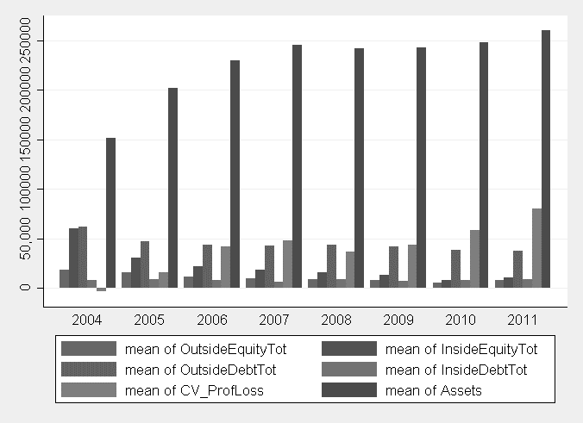

Figure 2. Average capital structure financing distributions of startups in 2004

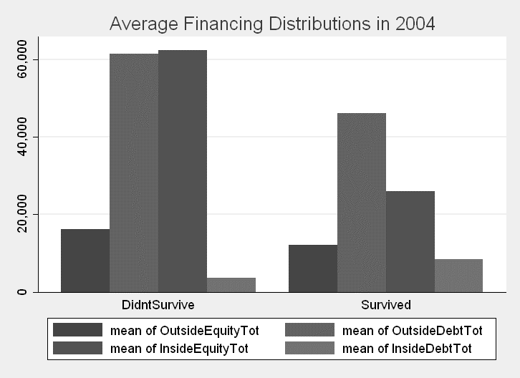

Figure 3. Average capital structure financing distributions of startups in 2007

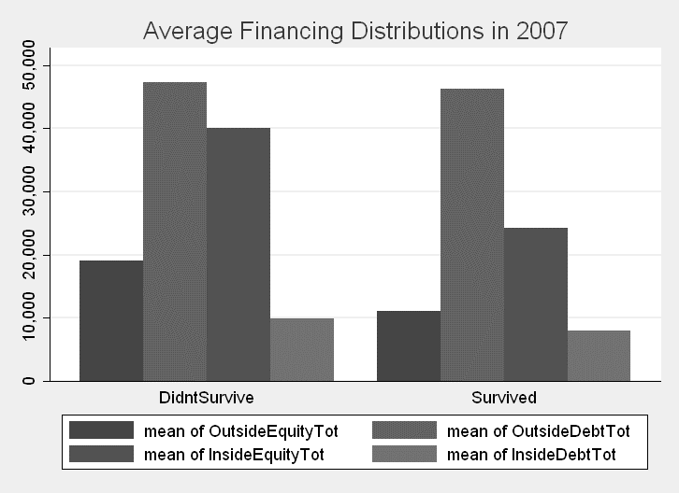

Figure 4. Average capital structure financing distributions of startups in 2011

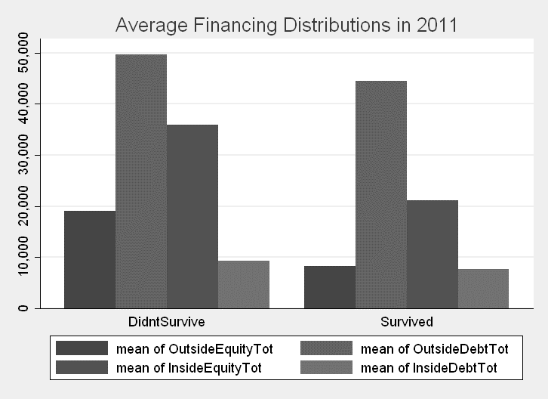

Figure 5. Proportion of Surviving Companies – Comparison by Lower and Higher Levels of External Debt to External Equity Ratios

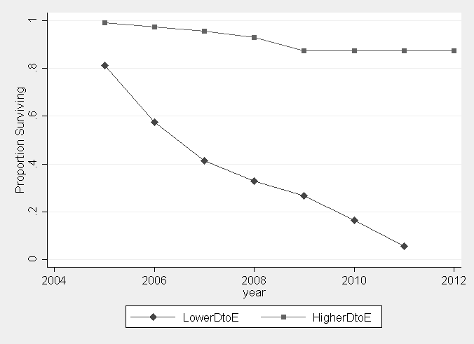

Data included herein are derived from the Kauffman Firm Survey. Any opinions, findings, and conclusions or recommendations expressed in this material are those of the author(s) and do not necessarily reflect the views of the Ewing Marion Kauffman Foundation. For additional details on the Kauffman Firm Survey, visit[1] http://www1.kauffman.org/kfs/.

