Using the card game San Juan to teach Strategy Concepts: An Experiential Learning Activity (Single Session)

Abstract:
We used an existing, award-winning cooperative card game to help students in an undergraduate Strategy class learn about role selection and path dependence, an important element of competitive positioning. The card game San Juan focuses on the importance of dynamic competitive conditions, role selection, and path dependence. What a player does to win depends in part on what the other people playing do as well. We provide an explanation of the game, with particular emphasis on the importance of role selection and path dependence, along with suggestions for how to debrief it. The exercise provides an opportunity for students to understand implications of choosing to do one thing instead of another, based on what your competitors are (or are not) doing.

The typical Strategy course, especially for undergraduates, consists of lectures and case studies in which concepts and theories are conveyed (Boyer, 1990, Stewart-Wingfield & Black, 2005). Both of these components are essential (Tas, 1988), and yet neither one provides students with adequate practical knowledge regarding the process of strategic decision making. Lectures allow primarily passive learning (Hanford, 2015). Case studies, for their part, are constrained by the time and scope requirements of the academic environment. They cannot feasibly be large enough to exhibit many of the phenomena occurring in real-world strategic decision making processes.
Active learning is a broadly inclusive term, used to describe several models of instruction that hold learners responsible for their own learning, and an approach often used to supplement lectures and case studies. Proponents of active learning describe a process in which students engage in “doing things and thinking about what they are doing” in the classroom (Bonwell & Eison, 1991, p. 2). Active learning includes creating small-group discussions within larger classes, incorporating survey instruments, quizzes, and student self-assessment exercises into the course (Padlet, Qualtrics, Top Hat, or something else), taking field trips, and using simulations, debates, games, and role plays (Bonwell & Eison, 1991; Sarason & Banbury, 2004). Active learning provides many key benefits, particularly useful in Strategy courses: students are engaged in activities such as reading, discussing, and writing; student motivation is increased; students can receive immediate feedback; and students may engage in higher-order thinking, such as analysis, synthesis, and evaluation (Bonwell and Eison, 1991). Research has shown a significant improvement in class-specific learning outcomes for Active versus Passive Teaching Styles (Ebert-May et al., 1997, Norbert et al, 2009).

That said, it is often difficult to get undergraduates away from the self-consciousness associated with role-plays and simulations. To address this problem in an undergraduate Strategy course, we use an existing card game designed to teach some process issues that are not sufficiently highlighted by lectures and case studies, nor addressed by role-plays or simulations. We begin by describing five benefits of using card games in the class. We then summarize the rules of the card game San Juan, explain how to play the game in groups of 4, with special attention to the concepts of role selection and path-dependence, and provide a debrief for the exercise.

Session Learning goals
- Show faculty how to use card games in support of key strategy concepts, such as role selection and path dependence
- Enable faculty to learn this game well enough to play it in their classes

Benefits of using a card game (by “game," we are referring to learning through play, active engagement and fun).

First, students learn through the process of playing the game. By playing a game, students may be able to understand a new concept or idea, take on a different perspective, or experiment with different options or variables. For example, the card game San Juan focuses on the importance of dynamic competitive conditions, role selection, and path dependence. What a player does depends in part on what the other people playing do as well. The core of any role selection game is figuring out how to exploit the roles better than one’s opponents. Different choices make it easier (or not) to get the most out of roles other people have selected, and take the role for which others desperately needed the privilege. Accomplishing this can be subtle.

Second, games provide a context for engaging practice. We know students need a lot of practice to internalize important concepts. However, for the practice to be meaningful, students must be engaged (and let’s be honest, countless textbook exercises are not always engaging!). Through playing the game, students willingly use the concepts, repeatedly gaining much-needed practice. For example, each round one player receives a tile indicating that they go first in the round. This tile rotates each turn. So each player gets a chance to pick first, several times during the game, and thus occasionally sees firsthand the benefit of having first-mover advantage.

Third, through games, students can learn a variety of important skills. There are countless skills that students can develop through game playing such as critical thinking skills, creativity, teamwork, and good sportsmanship. Students gain insight into themselves and it also enables them to learn a lot about each other.

Fourth, while playing games, students develop a variety of connections with the content and can form positive memories of learning. The fun, silly or interesting moments tend to stand out in students’ memories, and enable them to latch on to the topics we are studying. A positive emotional connection can facilitate learning (Pekrun, 2006). Furthermore, many games feature a variety of different stimuli; some students might remember the words from playing certain combinations of cards, others remember reading the cards, and still other students remember watching classmates make tactical choices in support of their chosen strategy. Games can provide a variety of sensory experiences for students.

Finally, games grab students’ attention and actively engage them. Student motivation and active class participation are factors that significantly influence achieving learning objectives. Because students really enjoy playing games, it is a good way to focus their attention. They get to be themselves, without the self-consciousness that can accompany role-plays, and get to try something that seems less artificial than a simulation.

Game Summary/Instructions
San Juan comes with a deck of 110 building cards, 5 role tiles, 1 Governor tile, and 5 trading house tiles. The point of the game is to earn points by building buildings in a fictionalized colonial San Juan. The game ends when one player has built 12 buildings. There are 30 different buildings, most of which just let you draw more cards, or pay fewer cards in various situations. The building cards are shuffled, and each player receives 4 cards. Each player also starts with 1 Production facility – an Indigo Plant - from the building cards in front of them. Figure 1 shows sample building cards.
Figure 1: Sample Building Cards
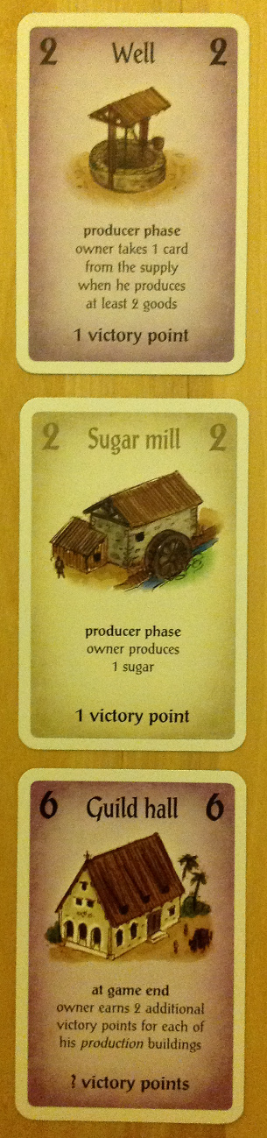

The 5 role tiles are laid out for the players to select, and the 5 trading house tiles are shuffled and placed face down. One player receives the Governor tile, indicating that they go first in the round. This tile rotates each turn. On their turn, players will select a role. They will perform that role with an added benefit (do something for cheaper, pick an additional card, produce one more good, trade one more good, etc.). All the other players will perform the same role, without the extra privilege. Once every player has selected a role, the current Governor passes the Governor tile to his left, and the next round starts. Figure 2 shows the game roles.

Figure 2: Game Roles
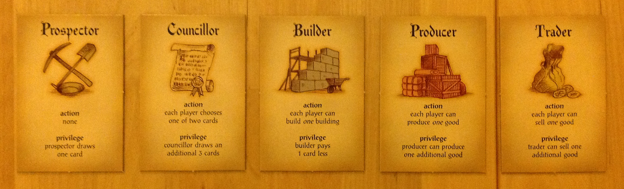

The simple goal of building 12 buildings to end the game helps new players stay focused, instead of constantly asking "What should I do now?" The deck is not overly complicated; as stated earlier, the different buildings mostly let you draw more cards, or pay fewer cards in various situations. Everything in San Juan is in plain sight. The roles spell out what they do. The building cards say what they do, and when they do it – which role activates their benefit. The play area starts out very simply, with just a single production card out – the Indigo Plant mentioned earlier. Players have a chance to learn the game as they go, focusing on just the cards in their hand.
The game is a cycle of building up a hand, then building a card from it and discarding some or all of the rest of one’s cards to pay for it. San Juan adds some strategy by keeping divergent paths limited. Production, trade, and building are all heavily linked. For example, if a player fails to find the single Guild Hall card, which rewards strong production, she might still be able to play the City Hall card, which rewards city buildings, to decent effect. San Juan also provides a wonderful sense of continuity in the card play. Maintaining a consistent hand of cards, even a hand that rapidly cycles, is great.
Benefitting from other people's roles is less pronounced than in other role selection games. Many of the buildings explicitly duplicate the privilege of many roles. Additionally, the produce and trade cycle is somewhat limited by the fact that you cannot produce more than one good per production plant. The hand limit of 7 cards also caps the effectiveness of certain approaches.
Fundamentally, the dilemmas in San Juan revolve around two facets. First, how does a player take the most beneficial roles from opponents? The role selection aspect is constantly putting students in the position of doing what is best for themselves, or trying to take away what is best for someone else. If players are really good, they might be able to have it both ways. They can take someone else's best role, and force them to take one that is still good enough for others. The dilemmas in San Juan are easier to assess than other games, since students can plainly see, thanks to the cards, how well positioned a player is for any role. If they have no goods to trade, it's obvious at a glance. If their production plants are all full, everyone can see that as well. If they have a small hand of cards and won't be able to build much, everyone knows immediately.
The second facet is path dependence in the form of card management, or which cards are you willing to discard in order to get one into play? Students find themselves with a hand full of great cards. Then they must choose. Do they play the best card, but pay (discard) all the others to get it out? Or do they play a slightly worse card, just to hold onto one of the really good ones? Knowing which cards to keep, and which cards to spend, makes or breaks a game. It's especially difficult early in the game. The clock is ticking and players have to start building. It can be very painful to discard one of the powerful 6 cost buildings, only to never see one again the rest of the game. The value of certain cards, when in the game they are most valuable, and knowing how difficult it can be to get a card back once you've spent (discarded) it, are lessons usually learned the hard way.

Timing
We will spend the first 5-10 minutes creating groups of 4 players and describing the rules. Then groups will play the game for approximately 30 minutes, and we will spend the remainder debriefing.

Handouts/props
The debrief sheet is included as Appendix 1. instructions are included as Appendix 2. Copies of the instructions will be available to participants. The only other props required are multiple game sets, which we will bring. The room must be large enough for players to sit around tables to play the card games.
References
Bonwell, C., & Eison, J. (1991). Active learning: Creating excitement in the classroom, ASHEERIC Higher Education Report No. 1. Washington, DC: The George Washington University, School of Education and Higher Education.
Ebert-May, D., Brewer, C., & Allred, S. (1997). Innovation in large lectures—Teaching for active learning. Bioscience, 47, 601–607.
Hanford, E. (2015). Rethinking the Way College Students Are Taught. Retrieved September 21, 2015, from http://americanradioworks.publicradio.org/features/tomorrows-college/lectures/rethinking-teaching.htm
Michel, N., Cater, J. J., & Varela, O. (2009). Active versus passive teaching styles: An empirical study of student learning outcomes. Human Resource Development Quarterly, 20(4), 397–418. https://doi.org/10.1002/hrdq.20025
Pekrun, R. (2006). The control-value theory of achievement emotions: Assumptions, corollaries, and implications for educational research and practice. Educational psychology review, 18(4), 315-341.
Stewart-Wingfield, S., & Black, G. S. (2005). Active versus passive course designs: The impact on student outcomes. Journal of Education for Business, 81, 119–125.
Tas, R. F. (1988). Teaching future managers. Cornell Hotel and Restaurant Administration Quarterly, 29(2), 41. Retrieved from https://gold.worcester.edu/login?

Appendix 1: San Juan debrief sheet

Name:
Others in your group:
Your Score:
Others’ scores:

Questions:
- Who won? What was their strategy? Did they focus on city buildings, production buildings, special cards?

- What was your strategy? Was it successful? Why or why not?

- Of the 5 role cards, which gives the selector the best outcome? Why?

- Which is the most equal? Why?

- Who played the most powerful cards, in your opinion? What made them the most powerful?

- If you were going to describe this game to someone else, what are three things you think are key to doing well (if not winning)?

