The Trials and Tribulations of MPH Inc.*

Mayank Jaiswal, Assistant Professor, Department of Management, Rider University, Lawrenceville, NJ email: Mjaiswal@rider.edu, and
Robert Maxwell, Founder, MPH Inc.

Corresponding author:
Mayank Jaiswal, Assistant Professor, Department of Management, Rider University, Lawrenceville, NJ, 08648, email: mjaiswal@rider.edu

*This is an abridged version of the case submitted for presentation at the Annual Meetings of the Eastern Academy of Management, Providence, R.I. May 2018

It was 6 in the evening in mid May 2010, Robert Maxwell, CEO of MPH Electronics was sipping his usual evening tea at his desk. Evenings were a good time to think since most workers would have left for the day and Robert could think in peace rather than fight fires as is the norm in any small or medium enterprise. MPH was founded in 1988 by Robert and two passive investors, and was in the business of electrical/electronic sub contract manufacturing for its clients in the New England area.
Robert had just received the final quarter and annual financials from his CPA, he knew that things were not going well but was not prepared for the shock that the numbers seem to be delivering. MPH had its first ever annual loss in 2008 and ever since the losses seemed to be increasing every quarter, the total loss for 2010 (May, 2009 to April, 2010) stood at close to $260,000 per the auditor’s reports. Robert felt some hard choices had to be made, he had been retrenching staff for the past two years but now a decision had to be made, should he keep the doors open or throw in the towel. He was turning 68 in June and another year of such losses would wipe out a significant portion of his retirement fund, but MPH had been his ‘baby’. He had nurtured it with hard work and perseverance for the past 22 years. He was also worried about Mark, his son who had just joined him after leaving his job in the US Customs Department. Mark and his wife were planning on settling down and starting a family. His reverie was broken by the ringing of his cellphone, it was his wife “Hi Rob, come home quick or else we will again miss the opening act of Romeo and Juliet”. Robert realized it was 7 and time to head home, he surely did not want to miss the opening act as the young actors performing in it were the talk of the town.

ELECTRICAL/ELECTRONICS SUB CONTRACT MANUFACTURING (SCM) INDUSTRY
Large computer corporations involved in conceptualization, design and manufacture of complex computer systems usually have core competencies in R&D and design rather than manufacturing. They prefer to “farm out” the mundane job of assembly of computers to sub-contractors which are usually more efficient and cheaper. Initially computer companies manufactured the computers in-house but over time around the late 1970s they started farming out the non-core activity of manufacturing to SCMs.
The business model was very well suited for the big computer manufacturers since it offloads the resource drain of personnel and operations to a third party. The SCMs whose core competence is manufacturing are able to complete the job at much lower costs and overheads. It also allowed the computer manufactures to solely focus on their core competence, and reduced attention diverting activities.

MPH INC.
Robert approached Amp for reviving the gas connector business but they were not interested, the capital outlay required to start a gas connector business was significant and he could not have started it on his own. Thus, he moved on to search for other business ideas.
Robert realized that he had manufacturing and quality control experience, had done sales and was entrepreneurial by nature. He was able to continue the relationship (from his Culver Sterns days) with Stratus Corporation, who wanted assembly of computer parts to be done by sub-contractors. The company would provide blue prints and bill of materials, sub-contractors would bid for the work and whichever firm won fulfilled the order. MPH was able to land Stratus and then EMC (now Dell) as its clients. The clients were involved in supplying complex computer systems to agencies requiring high levels of computing power for example the National Security Agency, NASA etc. Each computer could be as expensive as $1 Mn and MPH or similar sub-contractors accounted for a very small portion of the selling price (approximately 1% of the selling price for each computer).
Robert had developed a robust pipeline of customers, after all Robert commented in a recent interview “ ………. the business is essentially a customer list …….”. The fact that Robert was an innovative and high performing salesman did help. MPH’s sales peaked at around $4.5 Mn in 2003, and hovered above the $1.5 Mn mark till 2008, refer Exhibit 1 below.

Exhibit 1: Timeline of Revenues MPH Inc.

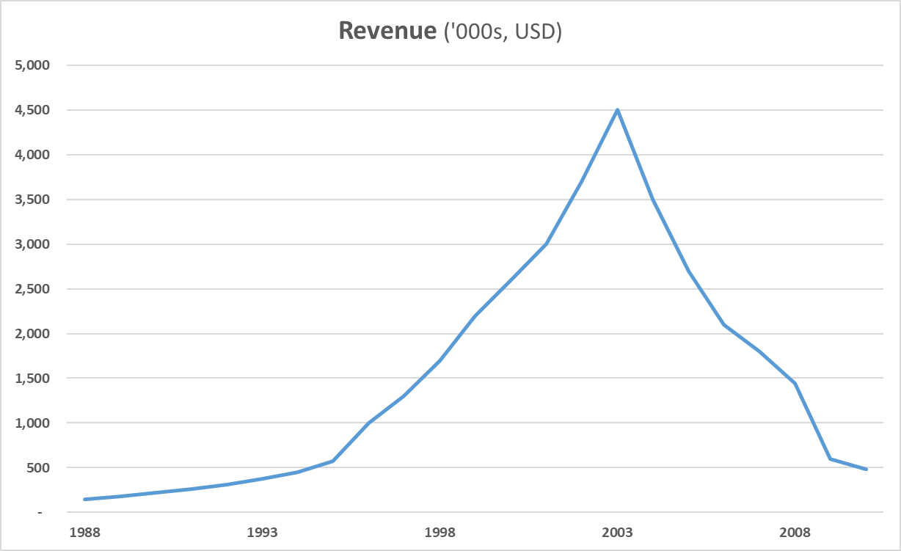
ISO Certification in 1995 (Revenues jump from ~$600k to ~$1 Mn
1996 – 2003: Stratus opens facility in
Ireland leads to significant
increase in business
2003 – 2008: EMC separation over
the years and diversification into medical customers.
Contracts moving to China and tough to find replacement contracts.

CURRENT DECISION:
The losses had been mounting for the past two years, refer key financials Exhibit 3, Robert felt that the time to act had come. He faced a few options:
Keep the business going, persevere and try to find new clients. But finding clients was a 6 - 12 month process, a sub-contractor had to deliver small orders, develop a relationship and keep getting bigger orders over time as it gained the trust of the client.

Another option was to merge with or get acquired by a competitor in the area, but to what end? The move to China was an industry wide phenomenon and his competitors were struggling and some had already exited. A merger would most probably compound the losses if anything

What if MPH changed the model and became…...

Robert knew these were tough choices. The decision was multifaceted. It not only involved financial considerations but also emotional and personal criteria as well. Which was increasing the complexity and intricacy of the decision at hand ………..

