Building and Leading a Cultural Enterprise. Martin Guitar and C. F. Martin IV in 2018

DRAFT VERSION OF JAN 16 2018 FOR SUBMISSION TO EASTERN ACADEMY OF MANAGEMENT

Background

Martin Guitar -- more formally, C. F. Martin & Co., Inc. -- is a globally-known manufacturer of guitars and guitar strings, located in Nazareth, Pennsylvania, a small town in the Lehigh Valley of Eastern Pennsylvania. In 2016, Martin Guitar had $124 million in revenue, 1,110 employees in Nazareth and Mexico, a highly regarded brand name, and a profound influence on American and global music dating back to the mid-19th century.

Since 1986, Martin Guitar has been led by sixth-generation C. F. Martin IV (Chris). The musical instrument marketplace is always evolving as tastes and technologies bubble up. Manufacturing technology has had to adapt. Old competitors have fallen, and new ones have emerged. With assistance from his customers, his Board, and the Martin Guitar labor force, Chris faces the latest examples of a continuing series of challenges that he has navigated.

Martin Guitar History (1833-1986)

Martin Guitar’s status in 2018 is the result of vigorous competition and growth for more than 180 years. Founded by German immigrant Christian Frederick Martin Sr. in New York City, C.F. Martin & Co. built its first guitar in 1833. The company began as a one-man operation, but by the time Martin Guitar relocated to North Street in Nazareth in 1859, it was thriving and employed over a dozen craftsmen. The key to Martin’s early success was through an X-bracing technique he developed that gives Martin guitars their distinct tone, and is still utilized in their construction today. The company product line developed with the times, producing mandolins and ukuleles in the early twentieth century, but its most popular innovation came in 1916 with a new style of guitar called the dreadnought. This design is today the company’s most popular, and a favorite among musicians worldwide. In addition, nearly every major acoustic guitar company has a model based on the original Martin design. In the 1920s, the company was exceedingly profitable, especially with its ukuleles. However, the Great Depression took a toll on demand for instruments. Thus, President Frank Herbert Martin, and his most loyal employee, his son, Christian Frederick Martin III needed to figure out a way to see the company through these difficult times.

Seeing sales plummeting, Martin III realized they needed a much more robust development campaign to keep the company afloat. These ideas ranged from producing violins to creating wooden jewelry, but Martin knew the company’s success relied on guitars. The results were the further improvement of the dreadnought and the development of the 14-fret neck, which was so well received it became standard across the entire guitar industry. C.F. Martin III took control in 1948 and presided over a time of unprecedented growth for the company. With a strong post-war economy and new music genres of country and folk sweeping the country, Martin could not keep up with the influx of orders, including from some of the most prominent performers of the time. It has been said that artists from Gene Autry to Elvis Presley would not be seen without their Martin guitar. Furthermore, to amateur folk musicians the guitar, unlike the piano, represented an instrument of freedom that they could take anywhere to share their culture and song. During the 1960s, Martin instruments were back-ordered almost three years. The original plant on North Street grew too small and in 1964 Martin Guitar invested in a 62,000 square foot facility, which has since been expanded six times, on Sycamore Street in a nearby township. Through this new location, Martin was able to increase capacity, producing over 23,000 guitars in 1972, increasing efficiency without sacrificing the hallmark of the product, that it was entirely handcrafted.

In 1971, C. F. Martin III made son Frank Herbert Martin President. Frank Martin began a period of acquisitions, including a banjo, drum, and string company among others. However, of these acquisitions, only the string company had lasting success. Furthermore, his leadership practices within the company drove a wedge between the administration and factory workers, culminating in a strike in 1977. To add to the company’s woe, the slowing of the folk boom and the increasing prominence of the electric guitar and disco music during the late 1970s saw Martin’s sales drop precipitously with only 3,000 guitars being produced in 1981. Along with low sales, there were high levels of debt and a culture of distrust separating operating workers from company managers. By 1982, Frank Martin retired from the company after conflicts with the Board, and his father, C. F. Martin III, resumed his role as Chair. After Fred’s death in 1986 at the age of 93, his grandson C. F. Martin IV, known as Chris, was appointed Board chair and CEO. This turned out to be a good move, and in 2018, Chris Martin looks ahead to the future by reflecting on the work he did to first keep the company solvent as a going concern, and then redevelop Martin into a strong market performer as it was in the 1960s and earlier successful times.

Growth and regeneration

The long term story is one of success and growth. From the mid-1980s through 2016, Martin Guitar grew in revenue, volume, and brand recognition while maintaining and improving its always-critical production quality measures. Exhibit 1 shows the growth of net sales starting in 1986. Cumulative average growth in net revenue from 1986 to 2016 was 7.1% annually; when adjusted for inflation it was still a robust 4.3%. Production levels of a few thousand units in the early 1980s had exceeded 100,000 in the 2010s, facilitated by growth in demand and by establishment of a manufacturing plant in Mexico for some product lines. The workforce has similarly grown, from 260 in the early 1980s to about 1,000 in 2014-2016 (see Exhibit 2).

The big multi-decade updraft in enterprise-level performance has taken place in times of profound change in many environmental and internal factors confronting Chris as CEO. Every decade has exhibited changes in the music marketplaces and the tastes of guitar players and other musicians. Evolving technologies have dramatically changed some elements of the guitar production process, while others have deliberately remained rooted in handcraft. The organizational chart has changed a number of times, though Chris has retained some key counselors within the company ranks and on the company Board of Directors. Martin Guitar’s marketing communication has been transformed by digitization, social media, and more, but contact between the company and its market also retains a lot of high-touch, person-to-person methods and practices, and conscious stewardship of the company’s long traditions.

Every decade of Chris’ tenure has also seen significant capital investment. Chris’ father made the most dramatic move, building a modern manufacturing facility in 1964 to replace the old shop that had housed the company for more than a century. But supporting the facility in the 50-plus years since then has required continuous investment. The plant has expanded, and been equipped and re-equipped for making alternative guitar styles. There have been extensive environmental and health and safety protective technologies. Part of Martin Guitar’s use of its plant has long included a public face, as dozens, often hundreds of visitors a day go through group and sometimes individual factory tours. Over 20 years from 1998 to 2017, 369,000 visitors took the tour.

Martin Guitar as a Cultural Enterprise

The factory tour is one part of the organic relationship Martin Guitar has built with its market base over its history. Culture is a central characteristic of Martin Guitar’s evolution over the period of Chris Martin’s leadership. In fact, the term “culture” has more than one application to Martin. A review of those decades brings each of those meanings to the fore in different ways. First, the guitar is itself a cultural product, seminal to many forms of American music. Most significant music genres that evolved from the 1930s to the 2000s in American popular music had a place for the acoustic guitar -- in some cases the central place, especially for country and folk music. It is also a lifestyle product; the mobility and flexibility that guitars provide to musicians add to its allure and place in the popular culture.

A second element of culture has been the culture of relationships between the company, its dealers, its consumers, and its communities. Over the decades, Martin Guitar has invested heavily in relationships with its channel partners in the retail music trade, with a vigorous sales presence and active participation in musical instrument industry events and programs. This is a global effort, and Martin’s distributors and retailers are in 90 countries around the world. Martin offers consumers -- who have a limited lifetime warranty as part of their purchase price -- numerous ways to stay engaged with the company. Company employees participate in festivals and events where musicians and fans gather, and the company sponsors music events and activities as part of its marketing.

In any company, organization culture incorporates values, beliefs, and practices that can have a profound effect on success and even on failure. Coming into a conflict-driven environment with numerous managerial challenges at the outset, much of Chris Martin’s work has been to progressively modify the company culture, to help it recover from those initial difficulties. Necessarily, his leadership thinking and practices have evolved and taken on new forms over his 40-plus years as production worker, vice president, president, CEO and Board chair, and principal owner. Throughout, Martin Guitar’s heritage as a family business has informed his decision-making in labor-management, investment, and customer relationships.

For Martin Guitar, each decade of those years has featured changes in company strategy and company structure: a dynamic marketplace, evolving production methods, sustaining and emerging leadership, structure, creative marketing, and capital investment, along with culture changes in the guitar market, and relationships in the retail music channel and with the community. At the same time, each decade also provided another growth opportunity for Chris to adjust his leadership to meet the company’s needs at the time.

Christian Frederick Martin IV: “Chris”

Christian Frederick Martin IV was born July 8, 1955 and from a young age he became involved with the family business started by his great-great-great grandfather. His first job at the factory was counting strings, making sure there were six in each box. Then, as Chris was in high school, his jobs within the plant carried more responsibility, from working in the office to working on the shop floor, cutting out guitar blanks. One of his most memorable experiences is attending the 1973 NAMM trade Show in Chicago, which allowed him to witness the true breadth of the market where Martin Guitar competed. Another indelible event for teenage Chris was the following year, assisting in the construction of the new D-28S model guitar, gaining experience not only in how to design, but also in understanding how to build these finely crafted instruments.

After finishing high school in New Jersey, he attended UCLA, and while studying there, he spent his free time working at Westwood Music in Los Angeles gaining knowledge of the other side of the guitar business, retail and sales. Following his graduation from Boston University School of Management in 1978 with a Bachelor’s degree in Business Administration, he returned to Martin Guitar working in several different departments in order to gain an understanding of their functions from scratch. In the early 1980s he became Vice President of Marketing. This period of Martin Guitar’s history was difficult for the company, as the company produced only 3,200 instruments in 1982 compared to over 20,000 a decade earlier. This loss of production and sales led to massive cuts to the workforce and disruption in higher management.

Chris viewed his grandfather as a mentor and over the next few years he continued to learn new roles within the company under his grandfather’s tutelage, as it became likely that one day the youngest Martin would be at the helm of the company that holds his family’s name. After his grandfather died in 1986, at the age of 91, the position of CEO and Chairman passed once again, this time from grandfather to grandson. Chris has retained those positions since then. Nor has the rest of his life stood still; other notable events for Chris since assuming the role of CEO include his marriage, to District Judge Diane Repyneck in May of 1990 (They met when he pled “not guilty” in her courtroom to a traffic violation), and the birth of their daughter, Claire Frances Martin, in September of 2004.

Chris Martin’s leadership: the 1980s

When Martin Guitar first confronted the tumultuous and dangerous years of the 1980s, it had gone through substantial decline after a period of growth, and was in peril of shutting its doors. Despite the brand reputation and the respect that the company’s product had earned, cash flow was so poor that the company was in a “work-out” state with its lenders. Demand had shrunk to a small fraction of former production levels. The company’s credit facilities had been stretched to the limit, and every day there was a chance that its banks would call their loans and close the company down. For decades, Martin Guitar had banked with Philadelphia-based Girard Bank, but was ultimately able to get credit from Reading (Pennsylvania)-based American Bank. However, the mid-1980s saw the start of an upturn in the company’s fortunes. Demand stabilized, and the company, then led by C. F. Martin III (Chris’ grandfather) and President Hugh “Tigger” Bloom, were able to stabilize the company. Mindful of the importance of the dealer network, the company maintained strong relationships with its dealers including trade show participation, sales visits, in-store promotion, and implementing dealer-driven recommendations on Martin product design and sales practices.

Starting in 1968, his father had distributed shares through an employee stock ownership plan (ESOP), in part as a means of gaining support and engagement from his key lieutenants in anticipation of a public offering. Ultimately, 10 - 15% of the shares were held in the ESOP. The plan was awkward for tax and governance purposes, and was frozen in 1980. There were a few dozen shareholders including vendors, family members, and former employees, but Chris inherited most of his grandfather’s shares which gave him a majority ownership stake. In 1986, when the Martin Guitar Board promoted Chris to CEO on the basis of his expertise, it also elected him Chair to reflect his ownership position, all at the age of 30. Winding up the legacy stock ownership plan through stock buy-backs over a period of years further concentrated ownership in Chris’ hands.

Chris’ work was as CEO of a manufacturing and selling organization with 260 employees. In a 2018 conversation for this case, he recalled that his grandfather said “The Martins are all mechanics.” In 1986, Martin Guitar produced about 7,600 instruments with about $13.98 million in net sales. His partners included a retail dealer network of about 800 stores, connected to the company through a robust sales operation with a well-organized selling culture. In the 20-year-old manufacturing plant in Nazareth, PA, the primary challenges were of simultaneously increasing sales and volume and quality of production. Production was characterized inside the company and marketed outside as “Still Handmade” (Exhibit 3). During and after the folk revival, this motif helped captured some niches in the music marketplace, particularly those oriented to the genres of American country and folk music. The strength of Martin instruments in the marketplace was characterized by their use by musical leaders of the day, from the 1930s into the 2010s. In the 1980s, Martin Guitar also had to respond to many other changes in the music as punk, new wave, and early-stage grunge genres grew from local scene-setters to national trends. This was not new -- the disco craze and the emergence of electronic keyboard synthesizers in the 1970s had similarly posed competitive threats.

One way that Chris was already engaged with the marketplace before and after he began as CEO was his work with the dealer network. He traveled the world representing the company to retail dealers and at regional sales events, which helped him develop a global network throughout the industry. The company was already proficient at documenting its history, and Chris was good at telling the story to different audiences. At that time, the guitar-building industry was growing, and Martin Guitar participated avidly, interacting with luthiers throughout the world but especially the U.S. and Canada. Twice a year, Martin Guitar participated actively (as it does still in 2018) in the major sales events of NAMM, the National Association of Music Merchandisers, in Chicago and Anaheim, and in a similar global event in Frankfurt.

The guitar-making marketplace was, and is, highly competitive. Martin guitars are well known and arguably the dominant brand from the perspectives of product quality and cultural impact, but Martin has never been the only brand to make those claims, as the markets have been big enough to support a handful of competitors in most price ranges. From the early part of the 20th century, Gibson was a competitor brand to Martin in folk and country, as were guitars from Fender, Guild and Washburn. In the 1970s, a number of small American companies developed market followings with guitars that were notably good for fingerpicking, or alternative tunings, or could meet the demands of picky guitarists of all kind. As the folk boom grew and became more global in the late 1960s, competitors from Japan entered the market, notably Yamaha, Takamine, Ibanez, and Alvarez Yairi. This trend of Asian competitors continued unabated into the next century.

Martin, along with Gibson and other brands with long histories, also had the particular situation of competing with its own used products. As decades went on, Martin guitars were very durable and their sound often improved over the years, so used instruments became more highly demanded. Price appreciation for used Martins followed, especially among collectors, with a global marketplace of musical instrument dealers, professional musicians at all levels, antique dealers, collectors, and others. However, Martin Guitar exploited the high regard for their older instruments by promoting the durability of their instruments, noting their heritage qualities, and featuring them in catalogs to show new customers what their guitars might become over time. The high regard for used instruments helps support sales of new ones.

While dealing with the external market and the guitar-selling channel, Chris was simultaneously wrestling with the production process. Though known for many decades for the very high quality of its designs and material, Martin guitars of the mid- through late 1970s had high levels of process defects, a costly problem on multiple levels. Chris began to move this challenging manufacturing environment away from some long-held rigidities and into a more productive and quality-focused process. His work in the 1980s coincided with the quality movement as part of the effort to improve the competitiveness of American manufacturing, and he was aware of the work of W. Edwards Deming and Joseph Juran. He attacked the quality problems with a range of management techniques involving workplace practice and also capital investment. Speaking to students in the early 1990s, he described how he had invited workers to participate in redesigning their own workflow, taking on the “sacred cows of management”. An older worker took a defensive pose, with arms crossed and a skeptical eye, and then gradually became more engaged in the transformation. Over time, that worker became an ally on the shop floor. As cash flow permitted, the company started to reinvest in the manufacturing process, selectively bringing new technology online - notably computer-aided design (CAD) and computer numerically-controlled (CNC) machinery - while still retaining the handcraft production steps that were seen as vital to the character of the product (see the contrast between old and new in Exhibit 5).

Chris Martin’s leadership of Martin Guitar began when the company was in financial difficulty. There had been difficult labor relations during his father’s era, when workers had seen a small number of company executives harvesting the rewards of the company’s success. Chris addressed worker concerns as part of his rejuvenation of the company’s culture. Reflecting the family heritage, he conveyed to workers a sense of “we’re all in this together,” and publicly offered to share company gains with them. In 1987 Martin Guitar began a profit sharing program which has awarded $79.9 million to workers through 2016, more than four percent of total sales over the same period. Even in 2018, Chris meets all Nazareth employees once every quarter with a report and their profit-sharing check.

Starting early in his tenure, Chris also used his governance resources purposefully. In closely-held private firms where one shareholder has a controlling share, company Boards can be seen as merely advisory. Chris, however, took the approach of engaging his Board at a substantive level, asking them to be true fiduciaries to the Company. He felt empowered to do this by how some earlier Martin Guitar Boards had handled financial crises affecting the company. In 2017, he recalled that some Martin Guitar Directors from earlier years had quit when the company was unable to get Directors & Officers liability insurance for the Board. By contrast, the Board he worked with has been much more faithful to the task. He took the contrast between the two generations of the Board as a wakeup call: he had to give them real authority in making decisions, he shouldn’t surprise them, and he had to help build bridges between the Board and the executive team.

The Board has never been large -- along with Chris and his wife Diane, the Company’s long-time attorney Charles “Chuck” Peischl remained on the Board from the 1980s through 2017. Carl Beidleman, a finance professor at nearby Lehigh University in Bethlehem, PA, was another Board member. After his departure from the board, Tara Stephenson, a finance specialist from the Philadelphia area was added, as was Steve Geiges, a college classmate of Chris; who is owner-manager of another family business in the region. In the 2010s, it continues a strong role including bi-monthly meetings alternating with conference calls, an annual retreat, and a strong consensus-driven culture and practice. Especially in the 2000s, Chris’ desire for consensus spanned the different hierarchical levels of the company as he looked to operate with agreement from all stakeholders. However, he is mindful of decisions he should not make -- for example, he and his wife recuse from any Board decisions involving share buy-backs.

The 1990s

One of Martin Guitar’s most dramatic impacts on American culture was how Martin brand instruments were featured in the enormously popular MTV show, “MTV Unplugged,” which aired from 1989 through 1999. The concept of “Unplugged” was around since the early 1980s, when rock musicians decided to redo their biggest hits using acoustic instruments and then release the music as a recreation of their previous hits. A-list musicians such as Pete Townshend, Sting, and Phil Collins all followed this trend. Robert Small and Jim Burns at MTV realized that the potential popularity of rock musicians playing their music with acoustic instruments coincided with the wave of nostalgia of baby boomers from the 1960s to return to the folk/acoustic music of their youth. When it came to providing instruments for the project, the creators turned to Martin Guitar, who provided the acoustic instruments to the performers for nearly the show’s entire run, allowing for their instruments to be seen being played by some of the world’s biggest musical acts in front of millions of people on television.
The impact of MTV Unplugged allowed Martin the opportunity to work with artists like never before, and more importantly expand its newly developed Signature/Ambassador Program, which worked with the artists to develop a guitar that exactly meets their needs. (see Exhibit 4) Following his MTV Unplugged appearance, Martin approached Eric Clapton about the possibility of producing a Signature guitar, which he agreed. The importance of this guitar compared to past signature guitars dedicated to Perry Bechtel and Gene Autry is it brought in an entire new group of buyers. Clapton, famous for his use of electric guitars, came out on stage in 1992, with an acoustic and his fans wanted desperately to get their hands on the instrument he used. The company’s response with the limited edition Eric Clapton guitar was met with massive success as foreign buyers alone were prepared to purchase the entire run. Many other prominent musicians also had Martin Signature models.
Another notable aspect of 1990s growth was the increase in foreign demand as a result of both the fall of communism and the massive increase in consumer wealth in Asian countries. According to Chris, followed the fall of the Berlin Wall, thousands flocked to the sole Martin dealer there [where?] to get the instrument they so long desired, but could not have. The result was more stores being opened up in the country and the Eastern Bloc to cater to the demand, as more and more guitars got sent to the region. On the other side of the world, countries like Japan, China, and Taiwan were finding themselves part of new booming economy with disposable income to spend on quality products, and one sought-after item in particular was American-made acoustic guitars. The weak dollar in the early 1990s helped Martin, though as the dollar strengthened there was pullback during the end of the decade.
This decade also saw change in the structure of the dealer population. Musical instrument retailers prior to the 1990s were all independent, with no real chain businesses that covered large swaths of the United States. However, Guitar Center challenged this independent model and began opening large box stores from coast to coast. Upon opening their original store in 1959, Guitar Center was no different than any other independent instrument selling enterprise, with a single store, though by the 1980s they began bucking the trend and opened up multiple stores and by the 1990s they had close to one hundred stores across the country. This shifted the dynamics in Martin Guitar’s selling relationship with its dealers; before, it was small individual stores, but now they also had to relate to a massive corporate enterprise, like Guitar Center, which was capturing proportionally more of the company’s guitars.
To keep up with the increased demand in the late 1980s and early 1990s, Chris and the Martin Guitar Board decided that expansion beyond their sole plant in Nazareth was necessary. In 1992, the company opened their Martin Guitar plant in Navojoa, Mexico which produces less expensive guitars like the Backpacker and the Little Martin. Eventually that plant took on production of Martin brand guitar strings as well (strings represent about 15 percent of Martin’s overall turnover). The increased demand also led to changes at the Nazareth plant, including the company increased dependence on technology to streamline the production process through continuing investment in CNC machines and AutoCAD, material handling and assembly equipment.
This increased technology also had the effect of reducing labor demand within the shop itself, but Martin Guitar made it a point to never lay off workers, but if necessary put them in shared work programs in order to retain them. This dedication to their workers and their wellbeing is illustrated by how strongly employees are bonded to the company. Many employees at Martin have been there for decades, and in some cases the retention stretches for multiple generations. The company also feels strongly about hiring within, as many workers who started in manufacturing end of the business eventually end up in the office, and others recruit members of their own close and extended families.
One of the most notable changes over the course of the 1990s was the expansion of Chris’s role within the company, and his attention to the community beyond the plant. Within the company, he practiced a participative decision-making style, engaging his Vice Presidents and many of their direct reports, and getting Board buy-in for big decisions. Gone were the days when high-level managers or “sacred cows” as Chris called them made decisions without consulting plant managers or other office personnel.

He also expanded his connection with employees through annual adventures with Outward Bound, a program of team-building activities in demanding outdoor conditions. Over the years, Chris went on numerous Outward Bound adventures, bringing colleagues (his preferred term for all Martin Guitar employees) with him on these multi-day excursions. Not just “camping with the boss,” these were vital team-building activities. Chris estimates that over the years, he has conducted Outward Bound trips with more than 500 of his colleagues.

Chris continued to experience leadership in different settings outside the company. The Lehigh Valley region and Eastern Pennsylvania are home to many multi-generational family business leaders as well as others who had launched strong companies ventures in more recent years. Chris engaged with the leaders of many such companies in Vistage, a CEO peer-to-peer network. There, he heard the travails and challenges of CEOs of family businesses and similar size companies, each with its own unique family involvement, governance, and management issues. He joined the Board of a Nazareth-area bank that subsequently ended up being the survivor in several rounds of bank mergers and rebranding; National Penn Bank, when it was finally merged into B B & T in 2016, had 130 branches and $9.6 billion in deposits. He made himself available to local colleges as a speaker on business practice.

The 2000s

By the turn of the 21st century, Martin Guitar was in a strong position. The combined effects of sustained popularity of acoustic music, an increasingly efficient yet high-quality production process, and expanding global demand all helped put the company on a continuing successful track. The manufacturing plant at Navojoa in Northern Mexico facilitated the expansion of the Martin Guitar product line, as new mid-priced guitars were being introduced to provide an entry for new guitar players. String manufacture was also moved to Navojoa around 2004.

The music marketplace continued to evolve. In acoustic music, the “Americana” genre gained prominence and airplay, and songwriters and performers continued to pursue the dream of owning a Martin. However, Martin Guitar also began to experience problems obtaining some of the most critical woods for guitar construction. This has had two consequences. One is the deeper engagement by Martin in sourcing rare and sometimes protected woods from around the world, a process that became progressively harder. A second response was the search for alternatives to wood for producing sound. Experimentation and testing did generate some suitable alternatives which were in increasing use as the second decade went on.

Additional investments in the plant also continued, especially to reduce emissions of volatile organic compounds (VOC) released in the process of finishing the guitars with lacquer. Other air-moving equipment took sawdust away from the workplace -- and workers’ lungs. Annual production passed 50,000 for the first time in 1999, and the one millionth Martin guitar was produced amid much fanfare in 2004. The years before the financial crisis of 2008/2009 were uneven as far as sales, but were a time of growth change for Martin Guitar. The company invested further in workforce development, teaming up with a local college to present some certificate courses in business targeted at lower- and mid-level managers who had never finished a four-year degree. Some of the certificate students took the opportunity to complete a Bachelor’s degree.

2005 also marked the opening of a major investment by Martin Guitar to celebrate its own heritage by developing a comprehensive museum of its history. For many years, a few small rooms off the lobby of the manufacturing plant held a few artifacts of the Company’s history dating back to 1833. The Martin Museum, however, was more glamorous and more expensive, designed to create an exciting visitors’ experience. An addition to the plant was designed with a facade resembling the manufacturing building in downtown Nazareth where the company had been located for many decades before the new plant (see Exhibit 6). The museum has more than 200 instruments as well as numerous photos, historical documents, and artifacts of the success of Martin instruments in music around the world.

The Museum, along with other amenities offered by Martin Guitar, emphasize another strong cultural bond, between the Company and the musicians, amateur and professional, who use Martin products. For many decades, even before Chris’ leadership, the manufacturing process was displayed to tours of visitors. Daily guided tours through the plant continue to show the details of the process, and give visitors the opportunity to watch Martin craftsmen and craftswomen at work on the intricate details of guitar manufacturing. In addition to the Museum and tours, a retail store in the plant (The 1833 Shop) sells Martin-branded clothing and souvenirs, Martin guitar strings and accessories, and books about the Company’s history. From 1998 to 2017, over 370,000 people took the factory tour -- but there are no counts of people who separately visited the Museum or the 1833 Shop. The Martin Owners Club, which began in 2004 and now has 3,200 members, gives users a chance to maintain their connection to the company along with discounts, opportunities to engage with the Company when its staff are making presentation, literature, and opportunities to meet Chris. The premise is similar to how Harley-Davidson maintains relationships with its past (and perhaps future) consumers through its “HOG” or Harley Owners Group. The annual “Martin on Main” festival in Nazareth is a well-known tourism attraction, that annually attracts 3,000-4,000 people per year.

The first decade of the 21st century also saw changes in the guitar marketplace. One was the growth of Taylor Guitar as another successful American brand. Founded in 1974 outside San Diego, Taylor has been a vigorous competitor whose instruments are well made and provided a high-quality alternative to Martin at comparable price points. An affiliation with superstar musician Taylor Swift helped to popularize that brand. A second major change was the rapid growth of the Guitar Center retailer. From its beginnings as a chain in the 1980s, Guitar Center grew to over 200 stores by 2014, and had received investment from Bain Capital and then subsequently from Ares Capital. With its broad retail presence, Guitar Center was a major purchaser of Martin Guitar products. An estimate in 2009 was that almost 30% of Martin sales went through Guitar Center, though in 2017, that share had declined to 20%-25% of Martin sales. A channel partner with such a big share necessarily gets a company’s attention, as its marketing tends to drive the product line. As Guitar Center’s fortunes grew and shrank, it continued a long series of diverse Martin Guitar interactions with its retail partners in different eras.

Chris’ other major external engagement was with his peers in musical instrument manufacturing and sales, as he got more and more involved in the affairs of NAMM, the trade organization for the $17 billion musical instrument industry. Headquartered near San Diego, NAMM organized the major trade shows for the industry, represented the industry to the US and other governments, organized philanthropy and education around musical instruments, and generally promoted the interests of manufacturers, distributors, and retailers. He was elected to the board in 2013, to the Executive Committee in 2015, and is on schedule to be Board Chair in 2018. The leadership of NAMM has long been held by companies in the school instrument market, especially wind and band instrument manufacturers. Chris was among the first from the stringed instrument business to lead the NAMM Board.

Inside the company, he continued his policy of open communication and consensus building. Every quarter, he made a presentation to the entire Nazareth workforce describing the company’s fortunes, and distributed profit-sharing checks in person to each employee. He remained a very public ambassador for the company, attending folk and bluegrass festivals, regularly visiting retailers, and occasionally conducting tours of the factory to stay in touch with the marketplace in that way.

As he approached 20 years as CEO, he was replacing more of the people who had worked under his predecessors. Up until the 2000s, most of the people Chris appointed to the post of company President had been internal promotions. In 2003, he went outside the company and hired Keith Lombardi, who had been a successful executive in private equity settings, to run the day-to-day operations of the company. Lombardi had a more “by the numbers” focus that emphasized returns on investment and economic performance. While sales in the mid-2000s were volatile, Martin Guitar had the wind at its back coming out of the financial crisis, and sales grew rapidly from 2008 through 2014. Lombardi helped to engineer that success. At the time Lombardi was hired, Chris was 47, and his daughter Claire had not yet been born. It was clearly prudent for Chris to consider and prepare for the future of the company, and a strong executive was a valuable asset.

Community and charitable support
Martin Guitar has a substantial portfolio of community support activity. Chris established the Martin Guitar Charitable Foundation in 1996 as a vehicle for his own philanthropy, and the company makes annual contributions to the Foundation out of its profit stream. Since its founding, the company has contributed $5.5 million to the Foundation, and the Foundation has made more than $2.5 million in grants, to nonprofits with a range of activities, mostly in acoustic music education and preservation, and in direct human service in the Nazareth Area. However, the Foundation also funds music preservation organizations around the country. The Board includes Chris and Diane Martin, attorney Peischl, company retirees, and a local academic to join the Foundation Board. In addition, Chris and Diane as individuals support local nonprofits with funding, and by serving on the Boards of social service, environmental, and arts organizations in the area.

As a company, Martin Guitar has two avenues of support for community and music-related activity. A Contributions Committee of employees reviews requests monthly supports from local communities as well through a contributions budget that is administered by current employees. Many of the requests come from local nonprofits as well. This committee also reviews many requests that Martin Guitar receives for complimentary products (guitars and/or strings) to support music education, veterans, or other groups who would benefit from acoustic guitars. This committee’s approach is primarily charitable and philanthropic. As part of marketing strategy and brand management, Martin Guitar also collaborates with and sponsors many nonprofit arts organizations in festivals, music promotion organizations, and other venues where it can interact with consumers.

Chris Martin and Martin Guitar in 2018

Within the company, the middle of the decade brought both success and challenge. Chris took on the operational roles of President in addition to his work as CEO and Chair. In 2015, after a national search, Martin Guitar hired Jacqueline Renner as president. Renner had been a successful executive in home luxury goods. In 2017, the Executive Team incorporated six direct reports to Jackie Renner. However, Chris chairs the Executive Team (see Exhibit 7).

Sales eclipsed $100 million in 2012 and rose for three more years. Anticipating continued growth, the company ramped up staffing both in Nazareth and in Navojoa. Then, in 2016, Martin Guitar suffered its first year-over-year sales decline since the Recession, and Chris faced a difficult problem: how to reduce labor costs without forced layoffs. He felt strongly that job security was his highest obligation to his workers. A combination of methods was used. Overtime and extra-shift work was eliminated. A number of senior employees took early retirement packages. Some workers implemented work share arrangements. Many production workers had their hours reduced. But ultimately, no workers were furloughed or laid off for economic reasons.

Martin’s strategic position has always depended on the vagaries of the popular music marketplace. In the 1960s and after MTV Unplugged, Martin was the beneficiary of music fans who learned to love the acoustic guitar. At other eras, that demand has subsided. In the mid-2010s, the popularity of Ed Sheeran helped propel Martin sales, as Sheeran was a dedicated Martin owner. But as hip-hop, country, rock, and other genres contend for the affections of music fans, demand for acoustic guitars goes up and down. On the other hand, a resurgence in demand for the ukulele has been good for Martin, which many decades ago was a leading manufacturer of these small four-stringed instruments, and was well positioned to compete for new customers.

While Martin is well-known in the U.S., it is a global brand, and the company also sources material from around the globe. In 2018, Chris can look at two significant challenges that global operations have forced him to master. One is an intellectual property contest in China. A Chinese firm trademarked Martin’s distinctive logo in China. The resolution of this process was costly (legal fees over $1 million) and time-consuming, but Martin was ultimately successful in gaining a court judgment. Another issue is the rise of global restrictions on the harvest and movement of rosewood which is a high performing material used in many Martin models. Different regions in the world also have different sales cycles and market segments for guitars.

Strategically, new ventures are possible, but Chris remains cautious, still attentive to the legacy of his father’s unsuccessful decisions to diversify and acquire other companies. The company’s current mission statement remains focused on acoustic stringed instruments (see Exhibit 8). In 2017, Chief Financial Officer Nathan Eckhart described the company as “well capitalized,” adding that its financial position allows Martin Guitar “... to do things and make decisions that other companies in our position could not make.” The capitalization is also a buffer, which turned out to be needed when sales unexpectedly dropped. Funding of capital projects has to pass a three-year payback test within the Company, but the Board approves larger-scale investments with longer lifespans.

Eckhart observes that the profit sharing program is effective: it provides a more immediate connection, and helps workers in the hourly ranks who have more immediate needs. It also creates tighter relationships between employee's participation and the benefits. In 2017, the median worth of the profit sharing is about two dollars per hour. In 2018, the plan is to strengthen the connection between their work and their profit sharing.

Part of the response to the sales decline in 2016 has been a re-examination of the supply chain. The company is introducing lean initiatives focused on shortening the cash flow cycle. There are other efforts to cut costs, and increase cash flow. At the same time, it is vital to respond quickly to customers and to increase the level of customer service.

The work of Renner and Eckhart to continue rationalizing the company’s work are one part of the path to the future. The broader questions that Chris confronts in 2018 are how to preserve the company’s value (for his family and his daughter, who may or may not become involved in the company), the strength of the brand for the hundreds of thousands of past and potentially future customers, and job security for the hundreds of workers. As the second decade of the new century comes to a close, Chris and Martin Guitar face a new variation of the kinds of conditions they have confronted for decades: a dynamic marketplace of evolving musical tastes and technologies, the pressures of globalization, the strategy of stewardship of their successful business model and the heritage of the product, and the responsibility for the well-being of hundreds of employees. Now in his 60s, Chris confronts these challenges with the benefit of experience combined with a need for a good plan.

*****

Exhibits

Exhibit 1 Net Sales and Production volume, 1986 - 2016

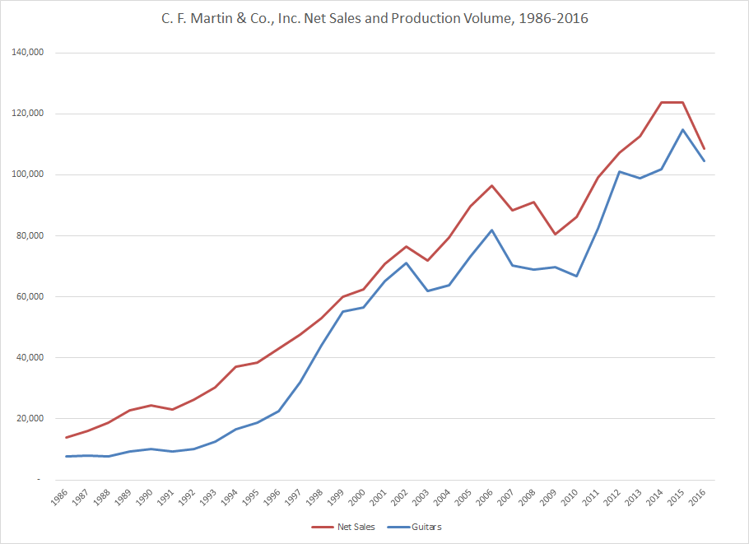

Net Sales provided by Martin Guitar
Volume estimated from data at https://www.martinguitar.com/about/martin-story/serial-number-lookup/

Exhibit 2 Workforce count, 1986-2016
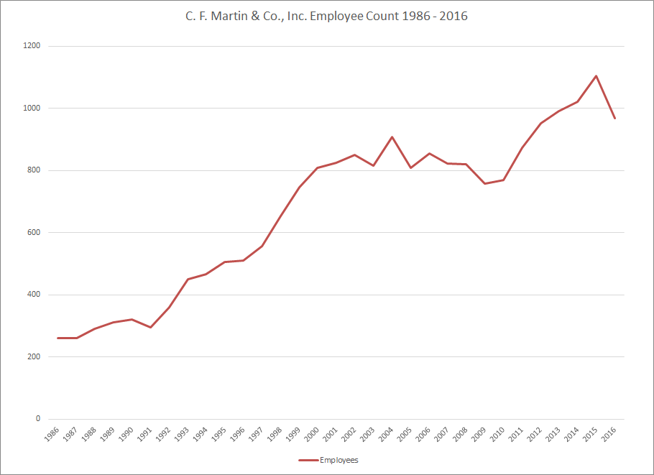

Source – Workforce count provided by Martin Guitar

Exhibit 3- Still Handmade Posters

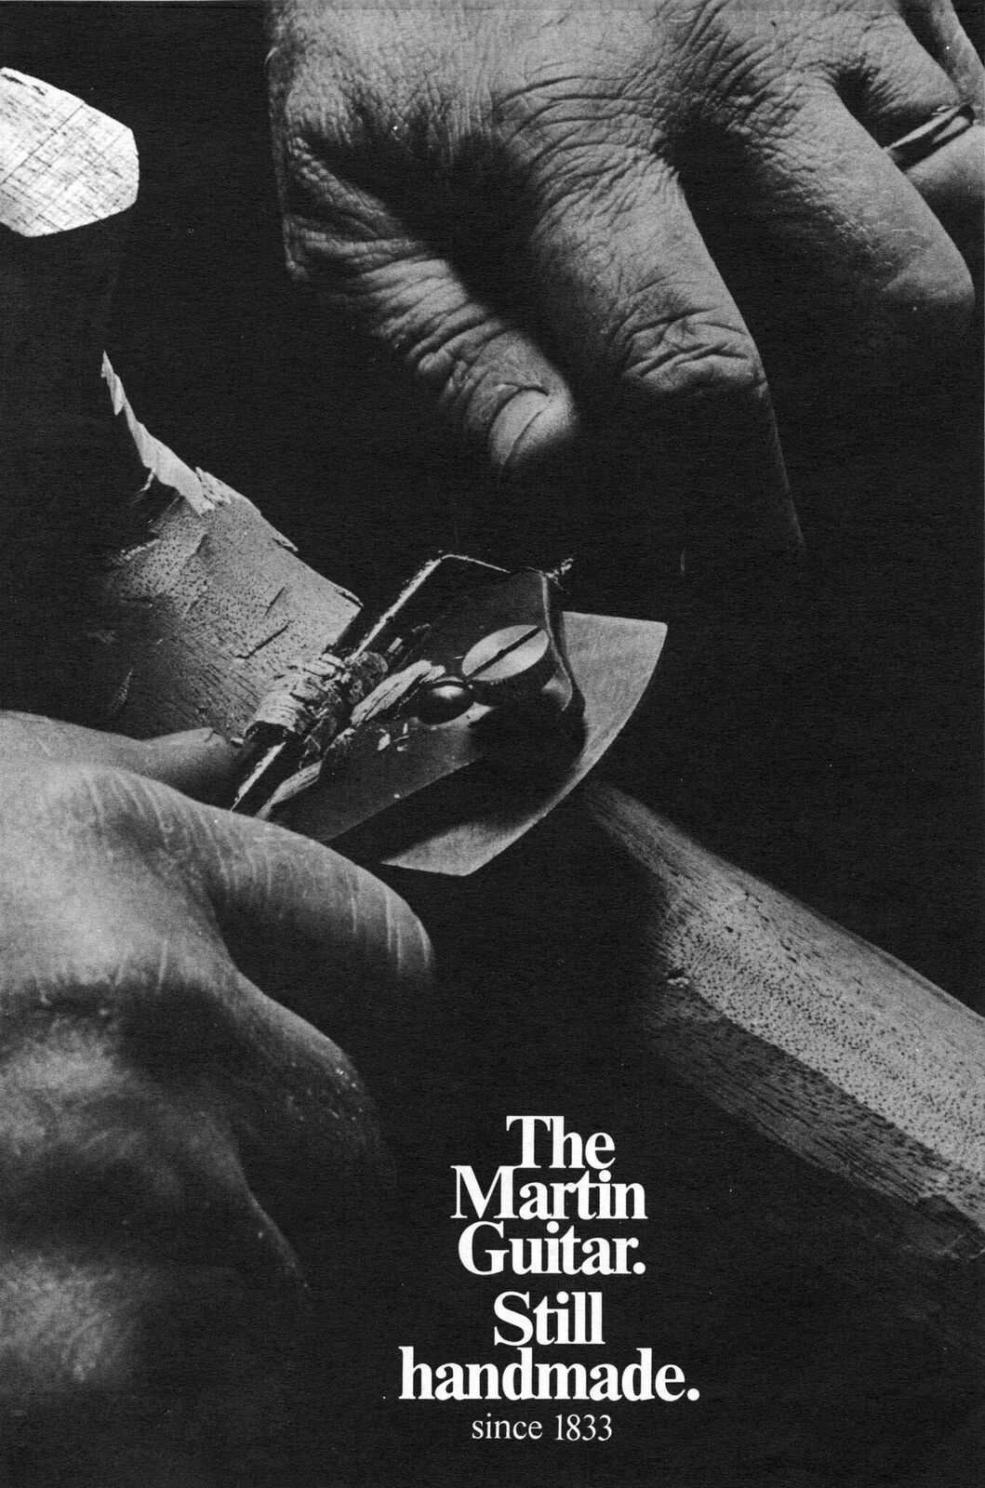

Exhibit 4- Notable Martin Ambassadors: Johnny Cash, Ed Sheeran, Eric Clapton

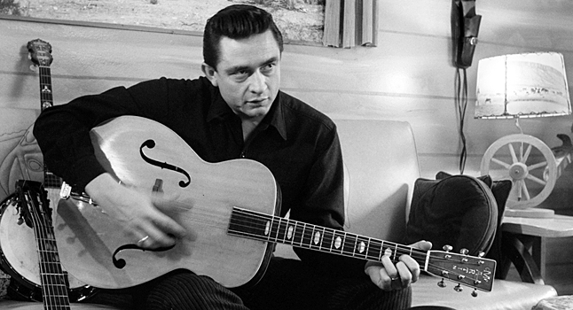
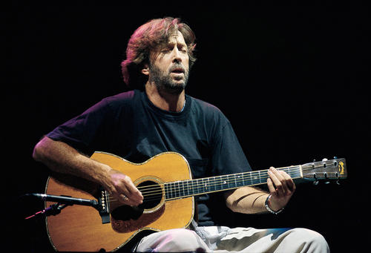
Exhibit 5- Old vs. New Factory (Technology)

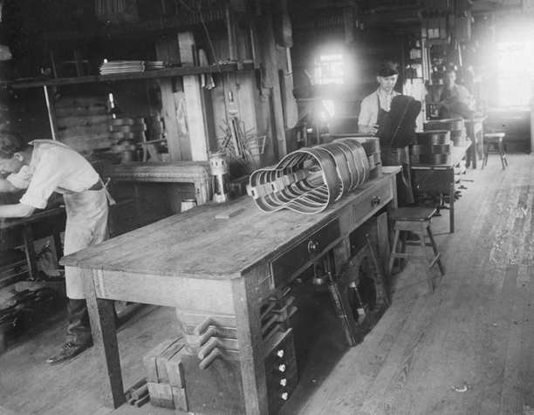
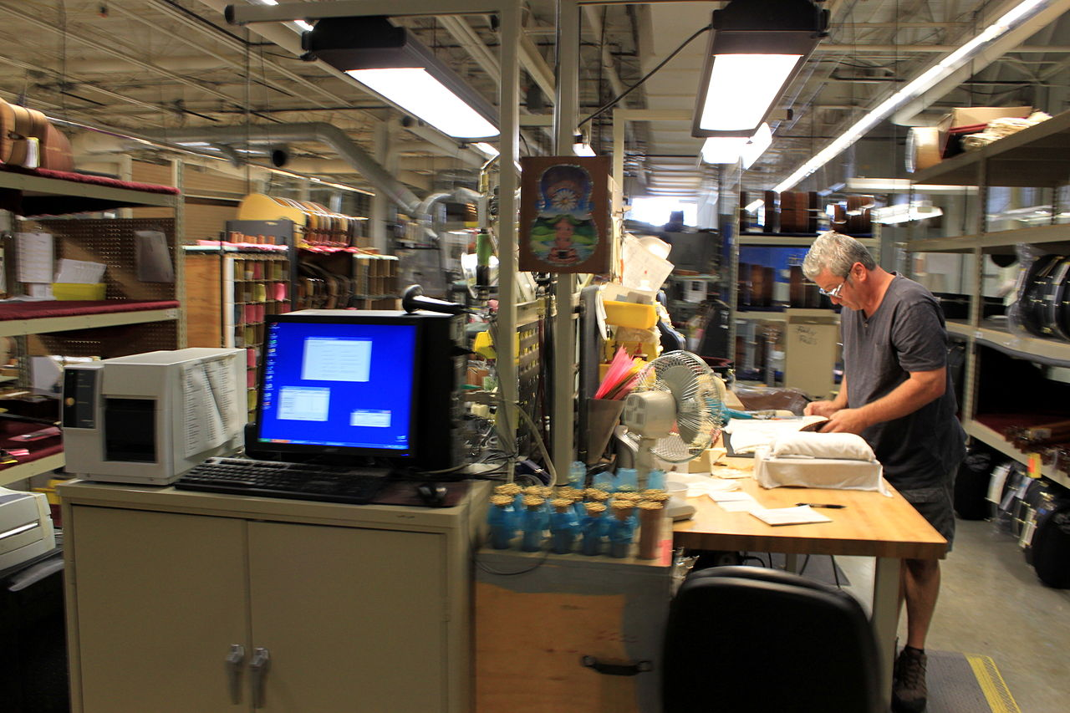
Exhibit 6- North Street Plant vs Current Plant

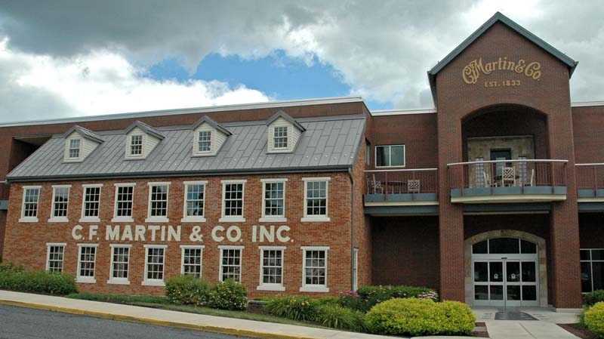
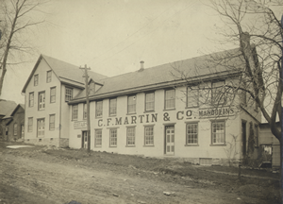

Exhibit 7 – 2017 Executive leadership team structure

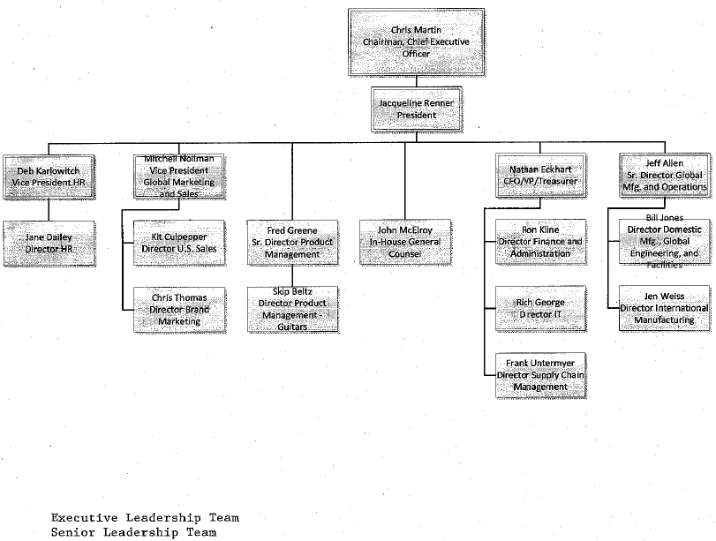

Source: Provided by Martin Guitar

Exhibit 8- Mission Statement

To be an organization of dedicated co-workers committed to exceptional leadership and innovation in the fretted instrument and string manufacturing industries, while celebrating our heritage and traditions as a family-owned company.

Source: https://www.martinguitar.com/about/mission-statement/

Instructors Manual: Building and Leading a Cultural Enterprise. Martin Guitar and C. F. Martin IV in 2018

Draft version of Jan 16, 2018

Manual sections:
Synopsis
Case Objectives and Use
Learning Objectives
Linkage to Concepts and Theories
Research Methdology
Links to Concepts and Theories
Discussion Questions
Teaching Suggestions
Epilogue
Exhibits, Appendices
References

Note to EAM reviewers. The above list is the intent for the full Instructors Manual to be available to workshop participants in coming weeks. Not all of the sections are completed for this submission to the case workshop but will be in ample time to send to conference workshop readers. .

Synopsis
In 2018, C. F. Martin IV is in his fourth decade leading one of America’s oldest family-owned companies, C. F. Martin & Co., Inc. of Nazareth, Pennsylvania. Martin Guitar is a globally-known maker of fine guitars that are prized by collectors, working musicians, and amateur musicians. Chris Martin was raised in the family business but was thrust into the CEO’s position at the age of 30. This took place in 1986 after Chris’ father’s term as CEO was unsuccessful; his grandfather came out of retirement to lead the company for a few years until his death, setting the stage for Chris Martin to lead the company. Though Martin Guitar was very fragile financially and operationally in the mid-1980s, the company retained a loyal following for its products. Over more than 30 years that Chris Martin has led Martin Guitar, the company has achieved aggregate sales of over $2 billion, with revenue growing 7.1 percent per year on average. The background for this has been the very dynamic music marketplace with its changes in tastes and technology, and the evolving role of the acoustic guitar in popular culture. In response, the product line has grown in depth and breadth, and the company sells globally. Success in the market has been supported by a manufacturing operation in the company’s home plant in Nazareth and, for some products, in Navajoa, Mexico. Chris has been a successful manager of operations and of people. Manufacturing operations have improved with new infusions of capital mainly generated from operations, and product quality and design remain strong.

The case describes how much of the company’s success comes from its cultural practices, in three related ways. The first is via the importance of the company’s product as a cultural artifact with a strong impact on American and global music. Secondly, there is a very strong bond of loyalty from Martin Guitar’s customers and channel partners to Martin that span multiple decades. Third, the internal culture of the company reflects the family heritage of the company, through a set of policies to foster and support worker engagement. In 2018, Chris Martin faces the latest episode of strategic opportunity and challenge.

Case Objectives and Use
The case is targeted to an undergraduate management or strategy course. In a management course organized around a “Planning-Organizing-Leading-Controlling” or skills-based structure, it could fit in and around topics of culture or leadership practice. In a strategy course, this could be used to illustrate a contrast between internal structural capacity and strength vis-a-vis external volatility, as well as strategic management for a product with a long life cycle. A main premise of the case is that the success of Martin Guitar during Chris Martin’s leadership has stemmed in large measure from his management policies and practices, and how they have sustained the company given multiple dynamic environments facing Martin Guitar. The case can be used to show how an organization can be transformed from having dysfunctional cultural values and expectations into a healthy work environment that is prized by its most important internal and external stakeholders.
- Other areas of interest explored in Learning Objectives

Learning Objectives
While the case is focused on one company and one individual, the objectives of the case relate to how it can be used to foster student learning that can be applied more generally. That is, what is the external validity of the case? And in particular, what is the applicability of the case lessons to organizations at different life stages. Students will examine how management and leadership practices associated with a particular individual can be retained within an organization, by considering a situation Martin Guitar might face if and when Chris leaves the post of CEO. Because the case is set in a manufacturing environment, albeit one with a highly-regarded and differentiated product, 21st century students can be asked to address how Martin Guitar’s management practices may apply in service design, service delivery, and other kinds of work that are more current now. In an era of increasing retail change, Guitar Center’s substantial share of Martin Guitar’s business can be used to consider the risks, costs, and benefits of heavy reliance on single external channel partners. Because the case spans a long period of time, Martin Guitar’s growth has spanned multiple shifts in the popular music styles that drive demand for guitars. From a strategy perspective, students can learn from considering Martin Guitar’s position relative to contemporary music styles. Four discussion questions are used to facilitate student attainment of these objectives:

- In 2018, Chris and Martin Guitar’s Board have to consider the long-term future of the company, including the possibility that Chris will retire from leadership. How can Martin Guitar sustain the cultural and family business practices in Chris Martin’s leadership style?
- Martin Guitar’s culture and its management practices are partly characteristic of its being (principally) a manufacturing business. Which elements of that culture and which of those practices are likely to successful if applied in service and other kinds of industries?
- After 2000, Martin Guitar became more dependent on Guitar Center as that particular retailer’s share of the company’s output grew. What are some of the potential benefits and challenges associated with having one channel partner having a dominating market share?
- Martin Guitar’s fortunes have always been affected how popular music has pushed demand for acoustic guitars, sometimes up but occasionally down. What are some of strengths and weaknesses of Martin Guitar’s market position based on current popular music trends? How should the company respond to improve its position?
- Other possible questions or inquiries
  - Contrast between management conditions he inherited and those he has initiated as they relate to performance
  - Governance focus – his use of his Board of Directors
  - Threat of losing access to woods

Linkage to Concepts and Theories
This case illustrates the experiences of one company that has adopted a particular set of cultural practices during an extended period of strong performance. The three cultural areas are support of the musical culture with product design and manufacture, a culture of customer relationships through sales and marketing, and Martin Guitar’s particular culture of workforce management and motivation practices. Given this scope of issues, a range of concepts and theories can be drawn on to support robust student learning.

Chris leads a company founded by his great-great-great grandfather, making Martin Guitar one of the oldest continuously-led family businesses in the U.S. Family businesses are generally recognized as having more participative, humane, and relationship-driven management practices [citations needed here]. The success during Chris’ position at the helm is notably different from performance during his father’s tenure. Family businesses may have more of a sense of stewardship and obligation to relatives, and concern for longer term results for descendants. It is noteworthy that Chris’ grandfather returned to lead the company after his own son retired. The case narrative notes how some of the workforce is multi-generational within the same family.

Other data also shows the nature of the company’s culture, such as how Martin Guitar changed its use of incentive payments, from an ESOP available to a small group to profit-sharing for all employees. Chris engages personally in this process, distributing the checks in person. Chris’ particular patterns of leadership are interwoven throughout the case. He engages with workers more than had his father, and has much more of a transformational than a transactional approach (ref: Bass). His Outward Bound trips with hundreds of Martin Guitar workers create a community even within such a large company. Employees participate in decision-making about company charitable giving. Another notable characteristic of the company’s internal culture is the proximity of front-line workers to the public tour.

This also relates to the second manifestation of culture, in customer and channel relationships. Fierce loyalty of customers. Company tries to promote

Also: strategic responsiveness to market, pursuit of global customers when American market falters.

Research Methodology
Some back-story is needed here. The first author has been a Martin user and owner since the 1970s, has provided consulting services to Martin Guitar in 1983 to Chris’ predecessor and in 2013 to Chris. Chris has been a guest in his management and strategy courses since the 1990s. In 2017 the author was added to the Board of Martin Guitar Charitable Foundation, after several years of making recommendations to the Foundations and requests on behalf of nonprofits.

In fall of 2017, Chris committed to participating in development of the case and asked several of his key lieutenants to collaborate. The company has often been featured in the news for its business practices, though this may be the first business education case written about the company. The case project and methodology were approved by the author’s Institutional Review Board. Interview subjects included Chris, VP of Human Resources Debra Karlowitch, Museum Director Dick Boak, President Jacqueline Renner, CFO Nathan Eckhart, and In-House Counsel John McElroy. All interviews were conducted after informants signed Informed Consent forms. Chris signed a release to enable development of the case for his initial review, and a second release to facilitate submitting it to the Case section of EAM in 2018. A third release is anticipated after hearing comments from Case Workshop reviewers, and before submitting for publication.

Much background information was available from secondary data. Martin Guitar is a visible brand that has received much coverage in global media for decades. Chris has been interviewed numerous times, and the company has a strong public and media relations culture. Several books have been published about Martin Guitar products, the evolution of the company’s leadership under different generations of Martin family members, and the importance of the guitar in American culture. A major exhibition at the Metropolitan Museum of Art in 2015 highlighted the history of the company’s products and their influence.

Besides participating in interviews, Martin Guitar was firm about what data could be provided to the case. The company has released its net sales data to the industry trade publication Music Trades, and made the same data available to the case authors, along with data on workforce levels and total tour visitation. However, no data was shared on profitability. The company provided total profit-sharing dollars. Information on Martin Guitar Charitable Organization came from the publicly disclosed information on the Foundation’s IRS Form 990.

Discussion Questions
- In 2018, Chris and Martin Guitar’s Board have to consider the long-term future of the company, including the possibility that Chris will retire from leadership. How can Martin Guitar sustain the cultural and family business practices in Chris Martin’s leadership style?
- Martin Guitar’s culture and its management practices are partly characteristic of its being (principally) a manufacturing business. Which elements of that culture and which of those practices are likely to successful if applied in service and other kinds of industries?
- After 2000, Martin Guitar became more dependent on Guitar Center as that particular retailer’s share of the company’s output grew. What are some of the potential benefits and challenges associated with having one channel partner having a dominating market share?
- Martin Guitar’s fortunes have always been affected how popular music has pushed demand for acoustic guitars, sometimes up but occasionally down. What are some of strengths and weaknesses of Martin Guitar’s market position based on current popular music trends? How should the company respond to improve its position?
Discussion

Teaching Suggestions
As of the EAM submission date, the case has not been used in the classroom. It is scheduled for a test run in an undergraduate management course in spring 2018, with the results expected to inform the presentation at the EAM Case workshop. Teaching will be structured as follows:
 | Question
 | 1 | 2 | 3 | 4
Learning objective
Curriculum / concept link
Decision / analytic tools
Key discussion points and times
Assignments / student work
Takeaways
Suggested discussion (minutes)

Epilogue (01/16/18)

Chris discussing B-Corp certification
Daughter Claire: too early to tell

References

Extra Exhibits

Students should be able to find many online illustrations of Martin Guitar’s production method including videos of factory tours and company histories, some of them guided by Chris or Dick Boak who are cited in the case.

The Martin Story | C.F. Martin & Co. (n.d.). Retrieved January 13, 2018, from https://www.martinguitar.com/about/martin-story/
Data provided by Martin Guitar
Data provided by Martin Guitar
Boak, R. (2017, October 26). Interview of Dick Boak [Personal interview].
Data provided by Martin Guitar
Martin, C. (2017, October 19). Interview of Chris Martin IV [Personal interview].
Data provided by Martin Guitar
Martin, Chris. (2017, October 19). Interview of Chris Martin IV [Personal interview].
(“The Martin Story | C.F. Martin & Co.,” n.d.)
(“2017 – Christian Frederick Martin, IV › Mipa Award,” n.d.)
Martin, Chris. (2017, October 19). Interview of Chris Martin IV [Personal interview].
Eckhart, Nathan. (2017, October 23). Interview of CFO, Nathan Eckhart [Personal interview].
Johnston, R., & Boak, D. (2008). Martin Guitars: A History. Hal Leonard.
Martin, Chris. (2017, October 19). Interview of Chris Martin IV [Personal interview].
Boak, R. (2017, October 26). Interview of Dick Boak [Personal interview].
Martin, C. (2017, October 19). Interview of Chris Martin IV [Personal interview].
Landesberg, P. (1999). In the Beginning, There Were Deming and Juran. Association for Quality and Participation.
Karlowitch, D. (2017, October 26). Interview of Deb Karlowitch [Personal interview].
Data provided by Martin Guitar
Martin, C. (2017, October 19). Interview of Chris Martin IV [Personal interview].
Martin, C. (2017, October 19). Interview of Chris Martin IV [Personal interview].
O’connor, J. J. (1992, June 3). Review/Television; With Paul Simon, MTV Slips Into Its Cardigan. The New York Times. Retrieved from http://www.nytimes.com/1992/06/03/news/review-television-with-paul-simon-mtv-slips-into-its-cardigan.html
Boak, R. (2017, October 26). Interview of Dick Boak [Personal interview].
Johnston, R., & Boak, D. (2008). Martin Guitars: A History. Hal Leonard.
Our History | Guitar Center. (n.d.). Retrieved January 13, 2018, from http://www.guitarcenter.com/pages/history
Martin Guitar’s Navojoa Factory Continues To Evolve And Grow As It Celebrates 25th Anniversary. (n.d.). Retrieved January 14, 2018, from https://www.prnewswire.com/news-releases/martin-guitars-navojoa-factory-continues-to-evolve-and-grow-as-it-celebrates-25th-anniversary-244707911.html
Karlowitch, D. (2017, October 26). Interview of VP of HR, Deb Karlowitch [Personal interview].
Karlowitch, D. (2017, October 26). Interview of VP of HR, Deb Karlowitch [Personal interview].
Martin, C. (2017, October 19). Interview of Chris Martin IV [Personal interview].
Karlowitch, D. (2017, October 26). Interview of VP of HR, Deb Karlowitch [Personal interview].
Martin, C. (2017, October 19). Interview of Chris Martin IV [Personal interview].
Martin, C. (2017, October 19). Interview of Chris Martin IV [Personal interview].
Data provided by Martin Guitar
Gerstenzang, P. (2008, February 22). A Journey to the Martin Guitar Factory in Nazareth, Pa. - Travel - Escapes. The New York Times. Retrieved from https://www.nytimes.com/2008/02/22/travel/escapes/22guitar.html
Data provided by Martin Guitar
About Taylor Guitars. (n.d.). Retrieved January 13, 2018, from https://www.taylorguitars.com/about
Data provided by Martin Guitar
https://www.namm.org/about. (n.d.). Retrieved January 13, 2018, from https://www.namm.org/about
Martin, C. (2017, October 19). Interview of Chris Martin IV [Personal interview].
Martin, C. (2017, October 19). Interview of Chris Martin IV [Personal interview].
Martin Guitar Charitable Foundation | C.F. Martin & Co. (n.d.). Retrieved January 13, 2018, from https://www.martinguitar.com/about/news/martin-guitar-charitable-foundation/
Martin, C. (2017, October 19). Interview of Chris Martin IV [Personal interview].
Data provided by Martin Guitar
Karlowitch, D. (2017, October 26). Interview of VP of HR, Deb Karlowitch [Personal interview].
McIlroy, J. (2017, October 26). Interview of In-house Counsel, John McIlroy [Personal interview].
Eckhart, Nathan. (2017, October 23). Interview of CFO, Nathan Eckhart [Personal interview].
Eckhart, Nathan. (2017, October 23). Interview of CFO, Nathan Eckhart [Personal interview].

