Beyond Entrepreneurship: Recognizing The Entrepreneurial Arc

ABSTRACT
Data gathered since 2008 points to a slowdown in business creation, leading to a nation-wide “startup deficit”: we need sustainable economic growth, but, although opportunities are there, concrete and predictable positive results have been increasingly elusive. Whose responsibility is it to address this problem? Suggestions for how to proceed include paying attention to demographic trends, recognizing that education can improve the rate and quality of new business creation, and therefore job creation, but each local ecosystem may need a unique approach, so how should this education be prepared and delivered, and to whom? What is the role of traditional higher education in this regard? Increasingly, universities may need to reexamine or expand their focus, and acknowledge their need to lobby for a renewed perception of their usefulness, perhaps changing role they play in evolving entrepreneurial ecosystems. Not only universities, but all of us should pay attention to the entrepreneurial arc.

Keywords: entrepreneurship, economic ecosystems, higher education, business creation, life-cycle development

PRELUDE AS CONTEXT: UNDERSTANDING THE STATE OF THE ENTREPRENEURIAL ECONOMY

The assumption is that we all want to live in an environment where we have a sense of security, an opportunity to pursue pleasurable activities, to exercise our skills and feel good about it, and to have the resources, financial and otherwise, in order to do so. We need physical, social, and economic security, and that, mostly, means we need a job, hopefully one we like and are good at, and that provides us a living wage. So where do these jobs come from, and how can we get them? According to the Kauffman Foundation, “…in any given year, new and young businesses create nearly all net new jobs in the U.S. economy. Put more starkly: if you want new jobs, then you want new and young firms. Older, established companies tend, on balance, to be net destroyers of jobs”(Kauffman, 2016).
This suggests that if a region wants to employ its inhabitants, it must encourage entrepreneurial activity. However, many new businesses do not produce jobs beyond their initial founding. They do not grow. Either they choose to stay small, or fail to adopt business models or market strategies that lead to a long-term positive economic impact. Many business startups are also in industries where there is little opportunity to “scale”, or grow significantly beyond startup, and this may be a conscious choice of the founder, most appropriate when this business serves a specific community need (Assenza, 2016; Hurst & Pugsley, 2015).
Even in the high tech sector, where there is potentially significant opportunity for a new venture to scale, data gathered since 2008 points to a slowdown in business creation, leading to a nation-wide “startup deficit”. Job creation or innovative risk-taking behaviors may be necessary to invigorate a regional or national economy, but the number of companies engaging in these behaviors, either young, high-growth or older innovative enterprises, may be small, and, at least in the U.S., getting smaller. There is, in fact, a “long-term decline in entrepreneurial dynamism in the United States” (Kauffman, 2017).
There are many reasons for this, not the least of which are demographic and historical economic trends, as well as advances in technology that can increase productivity and operational efficiency without the need for human capital. Although the Kauffman analysis of entrepreneurship business dynamics does report uneven activity on many metrics, one area, the health of established Main Street businesses – those with fewer than 50 employees located in a given geographic area – has seen a real increase in five-year survival rates and overall economic activity (Kauffman, 2017). In addition, those technological shifts that can hinder job growth can also lower barriers to entry for truly innovative companies – barriers to entry not only in initial startup mode, but also in product or market development for established enterprises.
So another reason for the reduction in solo entrepreneurial activity might be that existing firms are encouraging the development of intra-preneurs, hiring, training, and incentivizing employees to engage in research, exploration, and creation of innovative new products and ideas within an existing, sometimes very large, enterprise (Kauffman, 2016, NEG Introduction). For those individuals who don’t mind working for someone else, this access to perhaps significantly valuable enterprise resources can satisfy the urge to be creative, turning an innovative idea into an economically valuable product or service – which is essentially what entrepreneurship is. Regardless of how entrepreneurship is activated and expressed, there are still opportunities available.
Although there may be fewer startups, it seems the quality of these startups might be higher than previously realized. If a startup anticipates certain obstacles such as intellectual property protections, market acceptance, and regulatory hurdles, the potential for scaling, or expansive growth, is greatly improved (Guzman & Stern, 2016). Of course, this requires that the founders of these new firms are educated about the need for this analysis and prepared to take appropriate action.
So there’s a problem: we need jobs, and we need sustainable economic growth, but it seems, although opportunities are there, concrete and predictable positive results have been increasingly elusive. Whose responsibility is it to address this problem?
Local and regional economic development offices have taken notice – for instance regional entities have been gathering data to assess issues and opportunities, and city resources have developed business advocacy services to make startup and support easier, hoping to stimulate business and community development. Independent research can create suggestions for regional planning and provide regional data for municipal marketing and economic development efforts. These efforts provide a baseline, and offer help, but is this enough to make a difference? There may be various institutions and agencies working to address these issues, but have there been sufficient coordinated efforts that include all stakeholders?
Suggestions for a building startup community include the need for entrepreneurial leadership, an entity that can engage the entire entrepreneurial “stack” from first-time entrepreneurs through seasoned serial entrepreneurs, mentors, and small business service providers (Feld, 2012), yet also allows for full participation by those “feeder” entities, those that do not actually create the startups but provide inputs into the entrepreneurial community such as government, lawyers, financial advisors, and institutionally-based educators (Bautista, 2015). All need to work together.
The 2017 report by the Kauffman Foundation on the State of Entrepreneurship calls for action to identify the barriers to business creation, to engage entrepreneurs and policymakers, develop solutions and empower more entrepreneurs to “pursue their ambitions”, thereby reversing the long-term decline in entrepreneurial activity. Some suggestions for doing this include
- Addressing demographic trends, systemic challenges that lead to inequalities faced by a growing group of women and minority entrepreneurs as they seek out business resources, especially financial ones; facing the fact that young people, specifically millennials, are starting businesses at lower rates than previous cohorts (Ozkal, 2016) for reasons that may include financial insecurity, pragmatism and an increase in risk-aversion; and acknowledging the aging of the small business owners, especially on Main Street, with implications for unexpected business closure – what some have been calling the “silver tsunami”, identifying the concern that up to 85 percent of small and medium sized businesses may not have a solid succession plan (Kane, 2015);
- Recognizing that much of entrepreneurship “happens at the local level” and therefore requires a whole system approach where an understanding of the local ecosystem, including not only the nature of local resources but the quality and culture of the community, is critical to building local opportunities for sustainable growth – witness the challenge given by one state legislature to create “Innovation Places” where communities can become “magnets for talent” that drive innovation and result in economic output (CTNext, 2017), and to require institutions of higher education to work together to foster and support a strong culture of entrepreneurship and innovation, in part “catalyzing entrepreneurship skills and mindsets at the ‘academy’ for the benefit of local and regional communities” (Working Group, 2017, see CT Higher Ed Working Group Final Report, p. 8);
- Acknowledging that the pace of change, and resulting development of new technologies and business models (e.g. Uber and Etsy) requires new skill sets among workers who want to join the “gig” economy or take advantage of technological opportunities in previously inaccessible industries, therefore new educational models are needed in order to “help prepare entrepreneurs for the opportunities the new nature of entrepreneurship opens up” (Kauffman, 2017) – for example some Chambers of Commerce are sponsoring the Young Entrepreneurs Academy, which, along with Junior Achievement and DECA can bring entrepreneurial education to middle and high school students, while the SBDC is piloting the Ice House Entrepreneurship Program with youth programs and offering the GrowthWheel tool for both startup and growth company clients.
So if the assumption is that the overall goal is sustainable growth, that demographic trends demand attention, that education can improve the rate and quality of new business creation, and therefore job creation, but each local ecosystem may need a unique approach, how should this education be prepared and delivered, and to whom? And what is the role of traditional higher education in this regard?

NEED FOR ENTREPRENEURIAL EDUCATION
As awareness of the concept of “entrepreneurialism” has grown, more people may be interested in learning about this. As one consultant pointed out, people may not necessarily want to be entrepreneurs, but they want to know how to think like one. Currently, although entities such as SCORE, the SBA via its Small Business Development Centers (SBDC), Women’s Business Development Centers (WBDC), Chambers of Commerce and other community groups, including libraries and local “maker” spaces, do deliver education and training to community members, most formal entrepreneurial education is directed at college students. If this is meant to truly prepare people to take advantage of entrepreneurial opportunities, this focus might be more aspirational than actual – higher education can encourage entrepreneurial intentions but there’s no guarantee that actual entrepreneurial activity will occur. Those recently educated graduates may not wish to actually engage in startup activity after leaving school, at least not for many years. (Bogatyreva, Shirokova, & Osiyevskyy, 2016).
For instance, regarding the readiness of average age college students to engage in entrepreneurial activity, data indicates the “peak age” for starting a business is “closer to 40 than 20” (Ozkal, 2016), and both anecdotal evidence and surveys show less than 30% of students in one university’s entrepreneurship classes intend to become an entrepreneur, and less than 2% intend to do this directly out of college. That said, over 80% can see themselves engaging in innovative or entrepreneurially/intrapreneurially-minded work, and many say they are interested in working for a small, startup business just to see what it’s like. This is not inconsistent with data from other U.S. universities: “we believe the actual percentage of students in entrepreneurship programs starting a business immediately upon graduation is less than 10 percent” (Morris, Kuratko, & Cornwall, 2013, p. 45).
Regardless of their initial intentions or final outcome, students do sign up for classes in entrepreneurship, so universities have to be prepared to teach this content. Current educational trends suggest curriculum meant to prepare students and other nascent entrepreneurs for entrepreneurial activity should not only address the common and basic business skills such as how to do competitive strategy and market analysis, setting up operations, creating and monitoring control functions such as cash flow, financing, and human resource utilization and performance, but also include knowledge of entrepreneurial topics such as franchising, venture capital, intellectual property, and the need for alternate business models. More importantly, students should have an opportunity to experience the entrepreneurial leadership requirements of vision, passion, creative problem-solving, learning from failure, and resilience (Adapted from Morris et al., 2013).
Whatever the shape of programmatic elements in the curriculum, increasingly universities need to acknowledge their role as part of a larger economic community, the overall “ecosystem” – not only do students want to learn skills that they can use to get a job, but the business community wants the university to align its curriculum “more closely with the needs of the workforce” (Welsh, 2014, pg 14). In addition, it appears the workplace need for a combination of hard (technical knowledge) and soft (interpersonal creativity) skills can be best be met by a cross-disciplinary educational curriculum (Kauffman, 2016, from http://www.kauffman.org/neg/section-5#), underscoring the plea to fully incorporate “general education”, including the liberal arts, throughout the academy. In support of this focus, arguments have been made that “entrepreneurship should not be equated with new venture creation or small business management, but with creativity and change” (Kirby, 2005), recognizing that opportunities to exercise creativity in pursuit of something, solving a problem, hoping for change to occur, can be experienced in almost every discipline, every endeavor.
Also, increasingly, students seem to want to experience what it’s like to work in multiple scenarios, preparing themselves for a “multidisciplinary world” whether they work for themselves, for a startup, an established company, profit or non-profit, government or global enterprise (Welsh, 2014, p. 9). This implies that higher education faculty, whether using a “flipped classroom” pedagogy (Khan, 2011) or a traditional delivery model, need to also partner with career development and provide opportunities for internships, practicums, job shadowing, mentoring and other exposure to real world environments. Students need to be prepared not only with knowledge, but with actionable skills, and have at least some initial experience in what it feels like to work for a living. And an entrepreneurial mindset helps.
The challenge for entrepreneurship educators is that, in order to meet the evolving needs of students and the business community, the University must continue to evolve as well. Those with responsibility for entrepreneurship education must approach their role as one of a “founder” in a startup, in a disruptive industry environment, where creative problem solving is critical – where research must be done to uncover best practices, hypotheses must be tested, innovation must become the goal, and the resulting innovative product or service must become the essence of an entrepreneurial venture, be transformed “into a sustainable enterprise that generates value” (Kauffman, 2008, Chapter 2).
This may be difficult to do. Higher education exists in a highly institutionalized environment, where the expectations of society constrain entrepreneurial creativity and innovation (Aldrich & Martinez, 2015). Parent, students, teachers, administrators and employers all have an expectation of “appropriate” activity, activity that conforms to established norms or ways of doing things, which may be why existing entrepreneurial education tends to look and feel the same across the U.S. It may be easier to fall back on “habitual ways of responding”, and stay on the current “bandwagon” rather than risk anything truly new. However, increasing complexity and concurrent uncertainty in the context of higher education and economic development means there may be key stakeholders with “divergent expectations” such that the right mix of players might create conditions ripe for change (Aldrich & Martinez, 2015, p. 453).
John Dewey (1916) was famous for exhorting educators to “give pupils something to do, not something to learn,” and the current imperative to educate any willing stakeholder in how to engage in entrepreneurial endeavors seems so compelling… So what’s a University to do?

THE UNIVERSITY’S ROLE IN AN ENTREPRENEURIAL ECOSYSTEM
Although now “over 3000 institutions across the globe offer multiple courses, degree programs and/or concentrations in entrepreneurship” (Morris et al., 2013, p. xi), there’s still no consensus on what pedagogical model is best for what purpose, or how to assess the results. These institutions will offer education via certificate programs, courses, undergraduate minors/majors, graduate programs; experiential opportunities via business plan competitions, entrepreneur-of-the-year awards, virtual enterprise simulations, incubators or accelerators; create entrepreneurship “centers” that aggregate activities and sometimes focus on specific community niches where needs are evident, such as small, family businesses or social enterprises. However, if universities want to play a meaningful role in creating a community where economic growth is assured, there may be need for an even more integrative framework.
Too often entrepreneurship “programs” place “far too much weight on evaluating how many businesses are being started by students, while too little attention is given to assessment of changes in students attitudes, knowledge and capabilities” (Morris et al., 2013, p. xii). Students need to be able to do more than just start businesses. They need to develop what has been called the “entrepreneurial mindset”, variously defined as the ability to identify opportunities, act on those opportunities by engaging in critical thinking and problem solving, being creative, flexible and adaptive in developing innovative solutions, ultimately marshalling resources that result in products or services that are part of a sustainable enterprise that generates value for key stakeholders (see the discussion at VentureWell, 2017, https://venturewell.org/determining-entrepreneurial-mindset/).
The University not only needs to provide education and develop useful skills, but also instill confidence in students to act to support their own needs and therefore contribute to the needs of the larger economic environment, and, in order to do this, the University must act as a coordinated system, where all student touch points speak the same language, support the same goal. This requires a campus-wide cross-disciplinary approach to entrepreneurship education. Students need to see opportunities for innovation and creative problem-solving everywhere they look, and be skilled in the research methods and practices needed to investigate these opportunities and decide when and where to act (Assenza, 2017). The mindset, the discipline, the skills needed to do this can be developed in a nurse, a poet, a historian, a musician, an accountant, a lawyer, a psychologist or a management major. All can be innovators, creative problem-solvers, and act entrepreneurially in support of not only economic goals, but self-satisfaction!
In terms of the larger role universities can play in economic development, not only do universities have a responsibility as educators, and as researchers or creators of new knowledge, they also need to engage in knowledge sharing around innovative discoveries via technology generation and transfer, cooperating with industry and government as well as entrepreneurial ventures, so all parties can contribute to economic growth and job creation (Ranga & Etzkowski, 2013). In addition, universities might want to reevaluate their identity, examine how they’re being perceived by other stakeholders in an increasingly networked environment. For instance, a legacy of the “town/gown” disconnect between university and community has prompted successful serial entrepreneurs such as Brad Feld to allocate the role of “feeder”, not leader, to the university – feeders support the efforts of the entrepreneurial ecosystem, they do not lead the effort (Feld & Kaplan, 2012). This implies that universities may need to reexamine or expand their focus, and acknowledge their need to lobby for a renewed perception of their usefulness, perhaps changing role they play in evolving entrepreneurial ecosystems.
That said, there is increasing evidence that universities can not only influence entrepreneurial activity through the education of future players in this ecosystem, but can also “play a pivotal role in developing the regional entrepreneurial ecosystem” through the actions of “entrepreneurial champions within the university community” (Hechavarria, Ingram, & Heacock, 2016, p. 314). This requires identifying entrepreneurial leaders from within the University ranks who can use pilot programs to build community awareness, identify key regional entities who might be unaware of each other, and attract resources and sponsors from local businesses and government agencies, therefore connecting like-minded entities both within and external to the University in pursuit of a common agenda. In addition, although institutional forces do exist, each university also exists in a unique environment with “different resource bundles” or competencies and local conditions that can “drive differentiation” (Hechavarria et al., 2016, p. 315). It’s up to each University to identify and exploit both internal and external conditions that can be leveraged in support of success, however it may be defined.
As Hechavarria et al point out (2016), “in essence, entrepreneurship is about a proactive mindset that takes ownership of surrounding problems in society, sees them as opportunities, and embraces the risks and failures involved in finding a solution” (p. 317). Understanding the current need for job creation and economic growth, a University could identify itself as an entity that provides information about entrepreneurial education – to students, faculty, staff, alumni, and the greater community – and aspires to personify the role a University can play in developing a regional economic and entrepreneurial ecosystem. The University, perhaps through a Center or Institute that administers such activities, can understand the need to support entrepreneurial activity wherever it may exist, and set itself to research the issues, identify opportunities for creative problem-solving, and propose innovative solutions that activate stakeholders’ talents, competencies and resources, facilitating collaboration in pursuit of sustainable growth.
Incorporating the previously mentioned needs, the strategic purpose of the University could be to achieve strategic objectives: student attraction – create a value proposition that gets students to enroll because they see the University as a way to identify, learn, and advance their personal goals; student success – graduate more students with the skills to achieve a fulfilling and profitable life/career, in doing so, supporting connections between curriculum, community and careers that provide innovative solutions for a diverse community of learners; and innovation and economic growth – to create educational environments that cultivate innovation and prepare students for successful careers in a fast-changing world, hopefully instilling in them the gratitude for this learning experience such that they are willing to become benefactors of the University later in life.
What’s needed is a system-wide agreement on how to proceed, an innovative delivery system for services, and a communication system to gain and build support, and to report on opportunities and obstacles as they emerge (Hamilton-Pennell, 2010). It appears there may be fertile ground where “economic gardening” can take place. It is in this context that a University may be able to play a leadership role as convenor, connector and custodian of the entrepreneurial resource network.

SUGGESTION: UTILIZE THE ENTREPRENEURIAL ARC
Everyone will need to be the entrepreneur of their own life.
- Roy Carriker, Drexel University, 2018

As has been stated, there is still a lot we don’t know about how to create jobs and grow a regional economy, and there are both “leaders” and “feeders” in an entrepreneurial ecology whose roles need to be further defined. As has been said, what’s needed is a system-wide agreement on how to proceed, an innovative delivery system for services, and a communication system to gain and build support, and to report on opportunities and obstacles as they emerge (Hamilton-Pennell, 2010). It may be helpful to refer to a model of development, a graphical depiction of a process that has checkpoints along the way, so progress can be noted, adjustments made as necessary, and all can learn and grow.
Everyone is on a journey. Individuals and organizations both follow an organic developmental cycle that proceeds from birth through growth to maturity and eventually decline and death (Hanks, 1990; Quinn & Cameron, 1983). In the case of organizations, a “rebirth” is possible, a reversion to an earlier stage of development, so the process can begin again, hopefully having integrated what’s been learned, and the organization can achieve different outcomes, at greater levels of effectiveness.
As Quinn and Cameron (1983) note, evaluation of organizational success in one stage of development may require different criteria than that used at another stage, and the transitions from one stage to the next may encounter resistance, requiring intervention in order to make the process less “painful”. In addition, the resources and processes needed to facilitate these transitions and address challenges as they occur may not exist within the organization, necessitating external support or other facilitative mechanisms that can best help the organization reconfigure itself and continue to grow.
This need to seek help may cause an early decline and death if the organization’s leadership does not recognize or accept the reality of life stage transitions. Successful entrepreneurs are especially vulnerable to this “trap”, for to them the organization’s current success belies the need to think in terms of stages, and they may fail to see the need for reconfiguration, even as the organization grows in size and complexity (Galbraith, 1982). Both organizations (or institutions) and individuals are prone to this blind spot – we don’t know what we don’t know – so appropriate and timely help may be needed as decision points are reached and transitions need to be made.
INSERT FIGURE 1: The Entrepreneurial Arc

A University is an entity that could aspire to provide support and resource help for all the decision or inflection points along the entrepreneurial “arc”, going beyond the business launch to help with stage two business development, and the challenges faced by companies deciding on whether to grow, or how to handle the inevitable disruption in their industry – the choice to reconfigure or maintain, and the eventual decision of when to exit, or harvest assets to start again. These events in a given life cycle are inevitable regardless of how one defines the “life”, and developing the skills to navigate these transitions is essential to long-term success, however it is defined. There’s an opportunity to provide resources along the entire entrepreneurial “arc”, utilizing those assets unique to universities, the research strengths and knowledge gained through deep preparation in a discipline, to have a truly innovative impact in the both regional entrepreneurial ecosystem and beyond.
In this context, many colleges and universities have created programs, including majors, co-curricular and extra-curricular activities, to help students acquire an entrepreneurial or innovative “mindset” meant to aid these individuals along the path from the triggering event (pre-intention) through ideation and prototyping to piloting and perhaps launching of a new venture. Educators are excited if at least one or two students make it this far before they graduate (remember the 10% student startup rate?), but then what? Even the lean startup champion, Steve Blank has noticed there’s something possibly wrong here: Blank recounts a story of when a very successful former student, who had grown his startup to 70 people and $40 million, came to him for advice, saying “There were plenty of books for what to do as a startup, and lots of advice of what to do if I was running a large public company, but there’s nothing that describes how to deal with the issues of growing a company. I feel like I’m just driving without a roadmap…I wish someone had a methodology … for how to scale my company” (Blank, 2017).
This comment points out how educators may have to move beyond the existing focus, and extend help to organizations, entrepreneurs and other individuals who are ready to move to the next stage, providing assistance by providing referrals to other entities such as SBDC or other community resources to help with transitions to future growth stages as needed. Educators have a responsibility to their constituents within the entire community to help, as best they can, and also realize that they, the educators, may need to consider their own stage of development as well. Another story may be useful here.
At one University, when setting up a new center for entrepreneurship, the name, created in response to comments from a multitude of stakeholders, became E.R.I.C. the Center for Entrepreneurship, Research, Innovation, and Creativity. Why include Entrepreneurship, Research, Innovation, and Creativity as part of the Center name? The intent of this Center was to spread a “mindset” through the University community. In an attempt to be inclusive of multiple disciplines, the initial discussion among faculty revealed that some thought the use of the word “entrepreneurship” implied too much of a focus on revenue generating activities, on the end-stage of a process that began elsewhere and did not have to have profit as its goal.
A computer science faculty member argued that, yes, it all starts with an idea, but that RESEARCH was crucial to any further development. During this research into the components of any idea, figuring out if it would work, using hypotheses, designing experiments to test various configurations, basically using the scientific method to evaluate the initial feasibility of any design, this is where it all begins. Only when the research reveals that there’s a possibility for further development is it necessary to look at the external market and figure out where INNOVATION in design features might increase opportunity for the adoption of the designed product or service. It’s usually necessary to do further research to evaluate the innovation as it develops, so these processes do occur in tandem.
There’s also no doubt that CREATIVITY is necessary at every step, and the artist, or creative professional would argue that this is where it may start, with the need to express something, to create something that causes someone to “experience or feel something deep or unexpected.” Again, the act of creation is what may initially be most important to some, but, in the end, this creation works best if it can find a market. In fact, one definition of creativity addresses the need for something “novel” that is also appropriate for a specific use, but that, ultimately, “evokes people’s intention to purchase, adopt, use, and appreciate it,” implying that the product or service must be brought to market.
Here is where ENTREPRENEURSHIP comes in. At its essence, entrepreneurship is about pursuing opportunities, creating something out of something else that results in something different, and verifying, through research, that this innovative approach is solving a problem or fulfilling a need that people are willing to pay for. And it’s in this payment, or economic exchange of value, where the business piece comes in. No activity will be sustainable without the circular flow of economic activity that keeps things moving from supplier to consumer…
So the Entrepreneurial ARC describes a life-cycle approach to this whole process, and it’s called “entrepreneurial” because it takes action on an identified opportunity and assumes the risk of developing an organization or identifying resources that can be used to grow or profit from this activity. However, just like any organic or growth activity, there is also inevitable decline and death, which must be anticipated in the beginning, so it can be planned for, and an intervention can be activated at the appropriate time to re-configure or re-vitalize things. At that point, the activity or enterprise can begin again, but is now informed by what it learned, so the subsequent “arc” continues its upward spiral.
Entrepreneurship is not a bad word, but some disciplines still find it distasteful because of the presumed business or profit motive. In these cases, it might be best to speak of innovation, or innovative approaches to problem solving that inspire growth and accumulation of something of value, whether that be money, or learning, or a new process or mechanism for needed change. Whatever that is, it’s important that the outcome be sustainable or, at the very least, provide a foundation for further development.
For students, it’s important for them to have opportunities to explore, to evaluate what they’re learning in the context of what the future might bring, and then “see the pivot points” where they can make changes if needed. As previously said, the entrepreneurial mindset helps students navigate these transitions, regardless of whether they’re in a startup or a corporate environment. Especially around career choices it helps them to:
- Think strategically about how their actions might affect events in the future, so they can plan ahead
- Think holistically about how their job might fit into a larger picture, how their skills might need to mesh with skills at the department or organizational level
- Develop intellectual honesty in their decisions, being able to edit their own thought processes and realize when things just aren’t “right”
- Know where to look for the specialized knowledge they need in order to move from plan to action – as Dr. Saras Sarasvathy says, sometimes you have to just start with what you have, identify existing resources, then ask three questions: who am I (what are my values, what do I care about), what do I know (what am I good at, and what am I not so good at), and WHO do I know (can I find a partner who values what I value and has skills that complement mine). This gets you on your way.
But then it’s important to recognize how basic management works, that one starts with a plan, a goal, then organizes the resources necessary to achieve that goal, starts operating, but then immediately activates a control function to monitor performance toward the goal. It’s very unlikely that one will achieve that goal completely, which is where the “pivot” comes in. Adjustments are always necessary. Once you’ve done something, you’re never completely done doing it! But the idea is to achieve progress never the less. It should be an upward spiral, continuous improvement, and this applies almost everywhere, which is why the entrepreneurial arc should be able to appeal to almost all stakeholders.
INSERT FIGURE 2: Plan, Organize, Lead, Control

SUGGESTION: SUMMARY
This paper has made some assumptions, as follows:
- Everyone desires personal and economic growth, and is willing to work to attain and sustain it.
- Innovation and entrepreneurial activity is not limited to business or venture creation – it can apply to societal needs, individual or personal development and growth as well.
- The entrepreneurial process follows an “arc” of development, with key decision or inflection points where action is required.
- All purposeful activity takes place in a dynamic system, so awareness of the interactions, the components of this “ecosystem”, and understanding where levers for change can be deployed, is essential to long-term success.
And recognizes the following:
The Issue = we need resources to create successful graduates who can find meaningful work; Identify and develop local job opportunities, including startups; Build a local entrepreneurial/innovation ecosystem that sustains overall growth.
An Opportunity = Connect entrepreneurs, innovators and other creative talent with the resources needed for launch and growth, either on or off campus; Support existing businesses in transition, family businesses, service organizations, and corporate entities as they deal with the challenges of innovation.
The Goal = Provide information about entrepreneurial education, supporting entrepreneurial and innovation activity along the entire “arc”; Facilitate collaboration on and off campus, in pursuit of sustainable growth, personifying the role a University can play in developing a regional economic and entrepreneurial ecosystem.
Therefore, the proposal is for the following vision:
The University will provide resources and facilitate interaction and growth among all relevant stakeholders, becoming a key player in the innovation/entrepreneurial ecosystem of the greater community and region, fostering collaboration, encouraging all to work together to identify problems, then design and implement creative solutions that lead to sustainable growth and success for all, however that may be defined.
What do you think?

REFERENCES
Aldrich, H. E., & Martinez, M. A. 2015. Why Aren't Entrepreneurs More Creative? Conditions Affecting Creativity and Innovation in Entrepreneurial Activity. In C. E. Shalley, M. A. Hitt, & J. Zhou (Eds.), The Oxford Handbook of Creativity, Innovation, and Entrepreneurship: 445-456. New York, NY: Oxford University Press.

Assenza, P. 2016. Identifying Fertile Ground: Peripheral Stakeholder Contribution to a Healthy Entrepreneurial Ecosystem. Journal of Business & Entrepreneurship, 28(1): 31-54.

Assenza, P. 2017. Inspiring Innovation and Creativity: An Example of Effectuation in the Entrepreneurial Classroom. Global Journal of Entrepreneurship, 1(1): 43-56.

Bautista, K. 2015. Feeding the Full-Stack Entrepreneurial Community. Medium.com, January 25, 2015, https://medium.com/@kenbautista/feeding-the-full-stack-entrepreneurial-community-c9e9c5dd2252

Blank, S. 2017. Why Successful Startups Stumble at 40+ Employees, thinkgrowth.org: thinkgrowth.

Bogatyreva, K., Shirokova, G., & Osiyevskyy, O. 2016. Intention-Behavior Translation in Student Entrepreneurship: An Institutional Perspective. St. Petersburg, Russia, St. Petersburg State University Graduate School of Management. Working Paper. 2016, 21(E).

CTNext. 2017. Innovation Places. Hartford. 2017, August 5. http://ctnext.com/innovation-places/.

Dewey, J. 1916. Democracy and Education. New York, NY: Macmillan Company.

Feld, B. 2012. Entrepreneurs Take Lead in Building Vibrant Startup Communities. Entrepreneur.com, October 26, 2012, https://www.entrepreneur.com/article/224783

Feld, B., & Kaplan, D. 2012. Startup Communities: Building an Entrepreneurial Ecosystem in Your City. Hoboken, NJ: Wiley.

Galbraith, J. 1982. The Stages of Growth. Journal of Business Strategy, 3(1): 70-79.

Guzman, J., & Stern, S. 2016. The State of American Entrepreneurship: New Estimates of the Quantity and Quality of Entrepreneurship for 15 U.S. States, 1988-2014. MIT Innovation Initiative Laboratory for Innovation Science and Policy, Working Paper.

Hamilton-Pennell, C. 2010. Seven Steps to Developing an Economic Gardening Implementation Strategy. ICMA.org InFocus, September 16, 2010, https://icma.org/articles/seven-steps-developing-economic-gardening-implementation-strategy.

Hanks, S. H. 1990. The Organizational Life Cycle: Integrating Content and Process. Journal of Small Business Strategy, 1(1): 1-12.

Hechavarria, D. M., Ingram, A., & Heacock, J. 2016. Entrepreneurial ecosystems and entrepreneurship eudcation: The role of universities in fostering ecosystem development. In M. H. Morris, & E. Liguori (Eds.), Annals of Entrepreneurship and Pedagogy - 2016: 305-324. Northampton, MA: Edward Elgar Publishing.

Hurst, E. G., & Pugsley, B. W. 2015. Wealth, Tastes, and Entrepreneurial Choice. National Bureau of Economic Research, Working Paper 21644.

Kane, B. 2015. Silver Tsunami: CT biz unprepared for succession. Hartford Courant, August 8, 2015, http://www.hartfordbusiness.com/article/20150817/PRINTEDITION/308139949/1004?utm_source=enews&utm_medium=HBJ%2BToday&utm_campaign=Monday.

Kauffman. 2008. Entrepreneurship in American Higher Education: Kauffman Panel on Entrepreneurship Curriculum in Higher Education. St Louis, Ewing Marion Kauffman Foundation, October Chapter 2,

Kauffman. 2016. Kauffman Foundation’s Annual State of Entrepreneurship Address: America’s New Entrepreneurial Growth Agenda. St Louis, Ewing Marion Kauffman Foundation, February 15, 2016, http://www.kauffman.org/neg/neg-intro#theloomingentrepreneurialboomhowpolicymakerscanrenewstartupgrowth.

Kauffman. 2017. Kauffman Foundation's Annual State of Entrepreneurship Address: Zero Barriers. St Louis, Ewing Marion Kauffman Foundation, February 16, 2017, http://www.kauffman.org/what-we-do/resources/state-of-entrepreneurship-addresses/2017-state-of-entrepreneurship-address.

Khan, S. 2011. Turning the Classroom Upside Down. The Wall Street Journal, April 9, 2011, https://www.wsj.com/articles/SB10001424052748704101604576248713420747884.

Kirby, D. A. 2005. Entrepreneurship Education: Can Business Schools Meet the Challenge? Education and Training, 46(8/9).

Morris, M. H., Kuratko, D. F., & Cornwall, J. R. 2013. Entrepreneurship Programs and the Modern University. Northampton, MA: Edward Elgar Publishing, Inc.

Ozkal, D. 2016. Millennials can’t keep up with boomer entrepreneurs. Kauffman Blog: Growthology, Ewing Marion Kauffman Foundation, July 19, 2016, http://www.kauffman.org/blogs/growthology/2016/07/age-and-entrepreneurship.

Quinn, R. E., & Cameron, K. 1983. Organizational Life Cycles and Shifting Criteria of Effectiveness: Some Preliminary Evidence. Management Science, 29(1): 33-51.

Ranga, M., & Etzkowski, H. 2013. Triple Helix systems: an analytical framework for innovation policy and practice in the Knowledge Society. Industry & Higher Education, 27(3): 237-262.

VentureWell. 2017. Determining the What, Why, and How of Entrepreneurial Mindset. VentureWell.org, March 21, 2017, https://venturewell.org/determining-entrepreneurial-mindset/.

Welsh, D. H. B. 2014. Creative Cross-Disciplinary Entrepreneurship: A Practical Guide for a Campus-Wide Program. New York, NY: Palgrave Macmillan.

Working Group, C. H. E. I. E. 2017. Entrepreneurship & Innovation in Connecticut’s Higher Education System Final Report. CCIC.org, May 1, 2017, http://www.theccic.org/Customer-Content/www/CMS/files/Higher_Ed_Working_Group/Final_Report_with_ES_May5.pdf.

Figure 1: The Entrepreneurial Arc
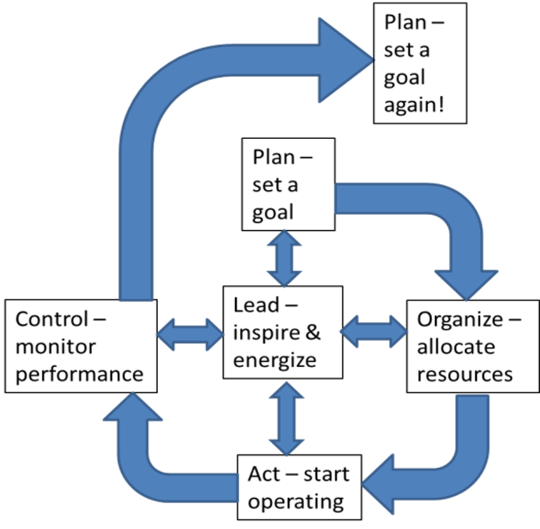
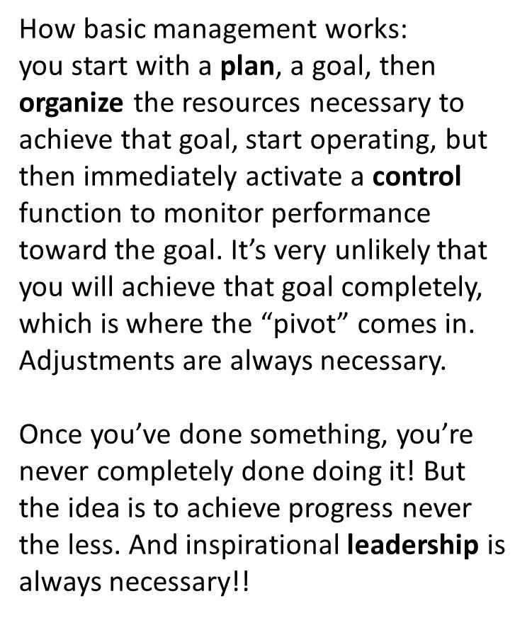
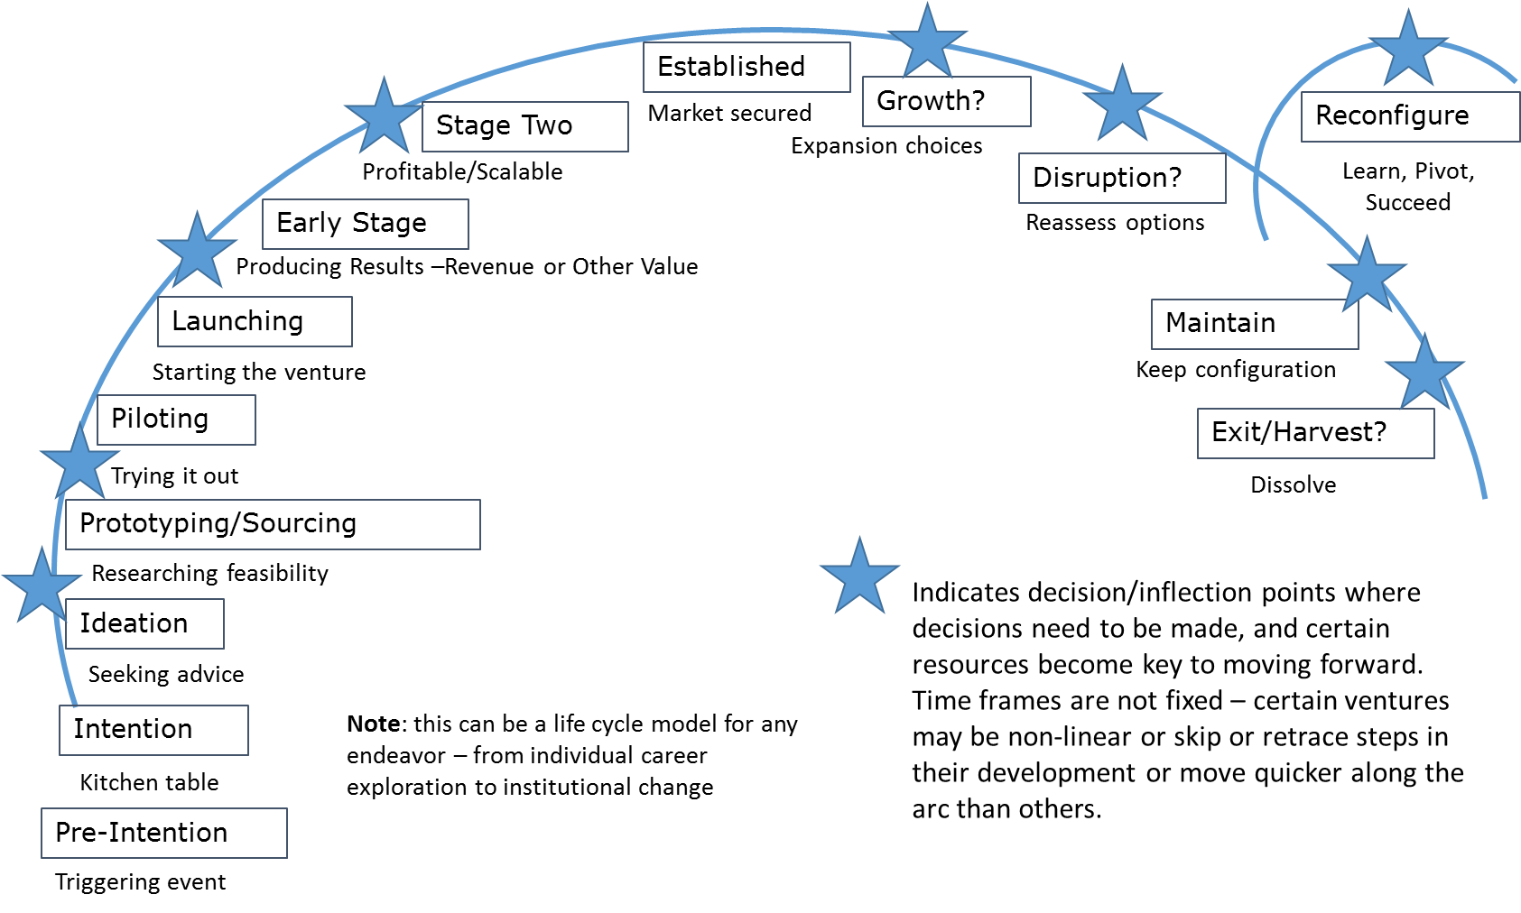
Figure 2: Plan, Organize, Lead, Control

See http://yeausa.org/about/introduction/
See https://elimindset.com/entrepreneurship-programs/
See http://ctsbdc.com/software-tools/growthwheel/
The “flip” is that students first “learn” at home, from lectures, sometimes delivered online, then do “homework” at school so teachers can mentor – students can learn at their own pace, “mastering” the concepts more effectively. https://www.ted.com/talks/salman_khan_let_s_use_video_to_reinvent_education)
See the Global Consortium of Entrepreneurship Centers (GCEC), an organization with over 200 members worldwide formed to “to collaborate, communicate, and jointly advance excellence in entrepreneurship through the unique role and position of the centers in the academic and business communities” (http://www.globalentrepreneurshipconsortium.org/mission/)
See the Triple Helix System of Innovation: “the potential for innovation and economic development in a Knowledge Society lies in a more prominent role for the university and in the hybridisation of elements from university, industry and government to generate new institutional and social formats for the production, transfer and application of knowledge.” http://triplehelix.stanford.edu/3helix_concept
Feld has said “the biggest most useful role of a university is fresh meat. And universities hate to hear that… But every year, a whole bunch of new, young smart people come to town to be Freshmen, and a whole bunch not-as-young but still relatively new people exit into the community as either entrepreneurs or employees or whatever.” https://www.geekwire.com/2012/vc-brad-feld-startup-hubs-led-entrepreneurs/
It’s said a healthy entrepreneurial ecosystem is like a permaculture garden: one that is designed to be sustainable, where resources flow into the system and are transformed into useful output that is then reintroduced and re-integrated, increasing the entity’s value over time. Also see how the economic gardening approach differs from a straightforward economic development plan: https://icma.org/articles/seven-steps-developing-economic-gardening-implementation-strategy
From Amanda Palmer, The Art of Asking: How I Learned to Stop Worrying and Let People Help, Grand Central Publishing, 2015, and her TED talk, https://www.ted.com/talks/amanda_palmer_the_art_of_asking/up-next
Zeng, L., Proctor, R. W., & Salvendy, G. 2011. Can traditional divergent thinking tests be trusted in measuring and predicting real-world creativity? Creativity Research Journal, 23(1): 24-37, p. 25.
See http://www.academicimpressions.com/news/what-you-need-know-pursuing-center-innovation
See Read, S., Sarasvathy, S., Dew, N., Wiltbank, R., & Ohlsson, A.-V. 2011. Effectual Entrepreneurship. New York, NY: Routledge.

