Organization Alumni Endorsement of their Former Employer:
“I like you. Do you (still) like me?”

ABSTRACT

This study investigates the quality of social exchange relationships of former employees, or organizational alumni (OA), with their former employer. An OA’s ‘willingness to endorse’ (OAE) their former organization as proxy for the OA-Organization relationship quality is examined at the organizational, supervisor, and team level. The effect of the OA’s assessment of Perceived Organizational Support (POS), Leader-Member Exchange (LMX), and Team-Member Exchange (TMX) on OAE are examined. Outcomes from current company ratings as well as the type of termination (voluntary or involuntary) from their former employer are considered in order to further contrast differences in the OA’s willingness to endorse. Findings from this study provide insights in to the OA-Organization relationship as a source of sustainable value for the former and current organization.

Organization Alumni Endorsement of their Former Employer:
“I like you. Do you (still) like me?”

“Our lives are connected by a thousand invisible threads, and along these sympathetic fibers, our actions run as causes and return to us as results.”
~ Herman Melville
“Working is an inherently relational act” (Blustein, 2011: 1). In the management literature, employment relationships are commonly researched through the lens of Social Exchange Theory (SET) (Blau, 1964). Indeed, work itself is characterized as and exchange, or the “trade of effort and loyalty for tangible benefits and social rewards” (Bateman & Organ, 1983; Rhoades & Eisenberger, 2002: 698). SET posits that individuals engage in beneficial actions directed toward one another, and that these actions generate an expectation of perceived obligation and reciprocity (Blau, 1964; Cropanzano & Mitchell, 2005), are guided by a sense of trust and good faith (Graham & Dienesch, 1995; Organ, 1988), and continuously evolve through ongoing contact and shared experiences (Rousseau & Parks, 1993). Social exchange relationships also foster heightened identification with an exchange counterpart (Rupp & Cropanzano, 2002) through which the individuals may see the well-being of an exchange counterparts as their own (Kim, Eisenberger, & Baik, 2016).
Social exchange relationships exist at multiple levels with an organization (Lavelle, Rupp, & Brockner, 2007) including with co-workers (Sherony & Green, 2002), teams and groups (Seers, Petty, & Cashman, 1995), supervisors (Liden, Sparrowe, & Wayne, 1997; Wayne, Shore, & Liden, 1997), and the organization itself (Cropanzano & Mitchell, 2005; Lavelle et al., 2007; Wayne et al., 1997). While the majority of the research is conducted within the boundaries of the current employment relationship, research on the persistency and benefits of social exchange relationships post-employment is modest.
Extant literature addressing post-employment relationships between organizations and their former employees, or organization alumni (OA), developed around two areas of relevant to the post-employment relationship. The first emerged in the wake of corporate downsizing in the 1980’s and 1990’s as layoffs became an accepted management tool to cut costs and boost earnings (Trevor & Nyberg, 2008). Downsizing, or involuntary termination, served as the impetus for post-employment studies and were most commonly grounded in procedural and distributive organizational justice (Bies, Martin, & Brockner, 1993; Brockner, Tyler, & Cooper-Schneider, 1992; Iyer, Bamber, & Barefield, 1997; Konovsky & Folger, 1991; Naumann, Bennett, Bies, & Martin, 1998; Wanberg, Gavin, & Bunce, 1999). In contrast to the studies centered around layoffs (involuntarily termination), the second body of research is focused on former employees who intentionally leave an organization (voluntarily termination) and later join alumni groups (local groups or through social media platforms) in which members maintain identification and relationships with their former employer (Herda & Lavelle, 2011; Iyer, 1998; Iyer et al., 1997; Raghuram, Gajendran, Liu, & Somaya, 2017). These studies are frequently grounded in Social Exchange Theory (SET). A common thread that running through both areas of study is OA Endorsement (OAE) of their former organization.
OAE has been characterized as a “willingness to endorse” (Wanberg et al., 1999), the “inclination to benefit” (Iyer et al., 1997), and “post-employment citizenship” (PEC) (Herda & Lavelle, 2011). More recently, endorsement has been referred to as organizational alumni goodwill (OAG) (Raghuram, Gajendron, Liu, & Somaya, 2017). Endorsements from OA provides value to their former organizations through indirect channels such as word-of-mouth or social media endorsements can influence the former company’s employment brand and reputation (Cable & Graham, 2016) as well as direct methods such as employment referrals (e.g. promoting a job opening) or product and service-based referrals from an OA’s position within a buyer or vendor organization (Carnahan & Somaya, 2013).
The OAE literature specific to the quality of exchange relationships and how those relationships accrue value to a former organization are limited. Raghuram et al.’s (2017) study of post-employment LMX and organizational alumni goodwill provides essential insight in to relationship salience at the supervisory level, but leaves organization- and team-level relationships unexplored. Drawing on insights from both areas of OA literature, this research offers three primary contributions to the SET and management literature. First, the design of this study contributes to our understanding of SET by examining OA’s relationships at the organization, supervisor, and team levels. Second, this research provides an informative comparison of OA endorsement of former and current employer. Third, it explores the influence of the termination type on OA endorsement of their former and current company. A post hoc analysis provides insight into the differences between voluntary and involuntary termination. Findings provide useful insights in to the OA–Organization relationship and the importance of sustaining post-employment relationships as a source of value for organizations.
LITERATURE REVIEW
Endorsement is defined as the expression of “support or approval of publicly and definitely” or the intent “to recommend (something, such as a product or service) usually for financial compensation” (Merriam Webster). Raghuram, et al. (2017: 9) study “organizational alumni goodwill” as the willingness to speak favorably about an organization and the employment experience. Because endorsement may provide tangible value and ‘exchange’ is embedded in the definition, OA endorsement (OAE) is used throughout this study.
A review of the post-employment and alumni literature reveals two primary channels through which the value of OAE accrues to an organization. I describe the first as the human capital channel. For example, when an OA endorses their former (or current) organization as an attractive employer. OAE through the human capital channel has been operationalized as a “willingness to recommend their former company to a friend or colleague,” “encourage someone to accept a job there,” or the OA’s “willingness to return” to work for their former employer” (Konovsky & Folger, 1991; Wanberg et al., 1999: 69). A second, enterprise channel is concerned with the endorsement or recommendations of an organization’s products or services and has been described as an “inclination to benefit” their former organization (Iyer et al., 1997). This ‘inclination’ has be operationalized by statements such as “would like to see their former firm as auditors,” “would like their former firm to provide additional services,” and “would recommend their former firm” (Iyer, 1998: 324).
Endorsement by Organizational Alumni. OA provide a potential source of value to their former organization through attraction and recruitment (human capital), and products and services (enterprise). OA can also have an influence on a company’s reputation (Cable & Graham, 2016) through membership in an alumni group, the listing on individual’s LinkedIn profile, or the ‘liking’ of organization-related posts on social media. Other OA studies have explored the benefits from knowledge flows within the alumni community (McNamara & McLoughlin, 2009), knowledge transfer in retirement (Koc-Menard, 2009), and the relational advantage competing firms possess when an OA works for the customer or vendor (Carnahan & Somaya, 2013). The aggregated benefits of OAE can therefore affect the organization’s economic performance as well as its ability to attract and retain talented employees.
Endorsement as Organizational Citizenship Behavior. Organizational Citizenship Behavior (OCB) is defined as “individual behavior that is discretionary, not directly or explicitly recognized by the formal reward system, and in the aggregate promotes the efficient and effective functioning of the organization” (Organ, 1988: 4). Organ (1977) believed that OCBs have a greater value to managers than traditional performance or ability. Ashforth and Mael (1989) suggest that membership in a group is not associated with any specific behavior or attitude, as is the case in formal employment relationship, but rather only their perception that they contribute to the future well-being of the organization. Because OAs are no longer ‘formal’ members of an organization, OA may have been largely overlooked for their role in creating value for the organization through citizenship behaviors. Therefore, I posit that OA who continue to identify as members of an organization and draw elements of their professional identify from membership (Mael & Ashforth, 1992), act as stakeholders in the future of the organization (Raghuram et al., 2017), enjoy the organization success as their own (Ashforth, Harrison, & Corley, 2008; Ashforth & Mael, 2016), and are invested in the long-term well-being of the organization (Sison, 2011) are indeed ‘members’ of the organization.
Social Exchange Relationships. Humans share a propensity to be in relationships (Karriker & Williams, 2009). SET acknowledges relationships as key to effective organizational functioning (Bateman & Organ, 1983) and positive work behaviors (Seers et al., 1995). SET also posits that individuals engage in actions that generate an expectation of perceived obligation in another (Cropanzano & Mitchell, 2005). Lavelle, et al. (2007: 845) suggest that social exchange may be more accurately understood as “﻿subjective, relationship-oriented interactions between employers and employees characterized by an exchange of socio-emotional benefits such as mutual trust and commitment, a long-term focus, and unspecified, open-ended commitments.” Importantly, Social Exchange Theory (SET) tells us that people develop numerous social exchange relationships with a variety of distinct exchange counterparts including co-workers (Sherony & Green, 2002), teams and groups (Seers et al., 1995), supervisors (Liden et al., 1997; Wayne et al., 1997), and the organization itself (Cropanzano & Mitchell, 2005; Lavelle et al., 2007; Wayne et al., 1997).
Perceived Organizational Support (POS) is a measure of the individual’s assessment of how well they are treated and supported by an organization. Leader-Member Exchange (LMX) captures the trust and commitment to a supervisor, and Team-Member Exchange (TMX) address the level of shared commitment and trust among members of the same group. POS, LMX, and TMX are commonly used proxies for an individual’s evaluation of exchange relationship quality (Shore, Tetrick, Taylor, Shapiro, & Liden, 2004) and are representative of the “actual state” of the relationship at the three levels (Shore et al., 2004: 19).
Organizational Alumni. A review of OA literature reveals two broad areas of research delineated by the manner in which an individual leaves the organization – as the individual’s decision (voluntary termination) or as the organization’s decision (involuntary termination) as in the case of downsizing or reduction-in-force. Research involving involuntarily terminating OA examines individual’s attitudes and experience prior to and immediately following the time of separation (Brockner et al., 1992; Herda & Lavelle, 2011), as well as their retrospective assessment and future outlook immediately after their exit (Wanberg et al., 1999). Pugh, Skarlicki, & Passell (2003) examine the persistent effect of involuntary termination on an OA’s trust in a new organization and find that involuntary termination may have lasting effects on relationships at the new organization. Research on voluntarily terminating individuals predominately views OA as members of formal or informal “groups” in which individuals maintain identification and relationships with their former employer while subsequently employed or otherwise engaged with a new organization (Herda & Lavelle, 2011; Iyer, 1998; Iyer et al., 1997; Naumann et al., 1998; Raghuram et al., 2017).
OA Relationships with Former and Current Employers. Employees form an overall assessment about their contributions to the organization and how much the organization cares about their well-being (Eisenberger et al. 1986). Importantly, individuals engage with multiple levels of relationships within an organization (Lavelle et al., 2007). However, given the passing of time and reduced interaction (Cropanzano & Mitchell, 2005), the expectation is that the exchange relationships post-employment would weaken over time, or at least in how they are remembered. Exceptions would likely occur when a new position places the individual in contact or close proximity to the former organization such as when OA work for vendors or customers (Carnahan & Somaya, 2013), maintain relationships with supervisors or colleagues as mentors (Iyer, 1998; Mael & Ashforth, 1992), retain high levels of organizational identification (Bardon, Josserand, & Villesèche, 2014; Iyer et al., 1997), or hold a strong value for firm reputation or pride of membership (Cable & Turban, 2003).
Individuals leaving an organization due to involuntary termination (downsizing) would likely exhibit different attitudes and behaviors toward their former employer, and perhaps toward their current or future employer (Pugh et al., 2003). Involuntary termination has been linked to negative effects on mental and physical health (Eliason & Storrie, 2009) and a loss of work-related identity (Conroy, Becker, & Menges, 2017). Therefore, we would expect time since leaving and involuntary termination to adversely affect the individual’s rating of social exchange relationships with their former organization.
HYPOTHESES DEVELOPMENT
Perceived Organizational Support and Endorsement. Perceived Organizational Support (POS) is described as an employee’s “global beliefs concerning the extent to which the organization values contributions and cares about their well-being” (Eisenberger, Huntington, Hitchinson, & Sowa, 1986). POS may be understood as an amalgam of various types of support from the organization which includes economic benefits such as compensation, training, promotional opportunities, as well as socioemotional benefits such as endorsement, loyalty, and support (Morrison & Robinson,1997; Rousseau & McLean Parks, 1993). In a social exchange model, “actions generate an expectation of perceived obligation in another” (Cropanzano & Mitchell, 2005). When an employee perceives that they have received high levels of organizational support, they are likely to report a “felt obligation” to return the commitment (Eisenberg et al., 2001; Wayne et al., 1997).
This quid pro quo nature of social exchange relationships means that as employees perceive commitment on behalf of the organization, their affective commitment toward the organization grows (Eisenberger, Huntington, Hitchinson, and Sowa, 1986). How an employee perceives being cared about and supported can lead to increased trust that the organization will respond to fulfill the exchange relationship (Wayne et al., 1997). If POS is perceived as low, employees may compensate by changing work output, perhaps in an effort to encourage the organization to recognize changes and reciprocate (Wayne et al., 1997), or alternatively to search for a new employment situation (Guzzo, Noonan, & Elron, 1994). This equilibrium-seeking behavior is consistent with Blau’s (1964) supposition that the parties of exchange will seek fairness in the relationship over time, which suggest that a decline in the quality of the exchange relationship would lead to a decrease in endorsement behavior.
Hypothesis 1a – Perceived Organizational Support (POS) will be positively related to OAE toward an OA’s former organization, but less than their current POS.
Hypothesis #1b – Perceived Organizational Support (POS) will be positively related to OAE toward an OA’s current organization.
Leader-Member Exchange and Endorsement. Leader-member exchange (LMX) is grounded in social exchange theory, wherein "each party must offer something the other party sees as valuable and each party must see the exchange as reasonably equitable or fair" (Graen & Scandura, 1987: 182). LMX suggest that the relationship between supervisor and employee develops overtime and higher levels of POS are associated with the perception that the individual’s supervisor cares about their well-being and value their efforts (Kottke & Sharafinski, 1988).
For current employees, LMX has been shown to be positively related to job performance (Gerstner & Day, 1997), job satisfaction (Porter & Steers, 1973; Graen, Novak, & Sommerkamp, 1982), organizational justice (Griffeth, Hom, & Gaertner, 2000), and negatively related to turnover intent (Bolino & Turnley, 2009). Settoon et al., (1996) found that a subordinate’s citizenship behaviors are affected by the mutual trust and loyalty between the employee and supervisor. LMX is more correlated to citizenship, while POS engenders stronger levels of organizational commitment (Settoon et al., 1996). Examining the POS-LMX relationship, Eisenberger et al. (2002) finds that supervisor support effects POS, but that POS does not necessarily relate to supervisor support. However, Wayne et al. (1997) suggest that the supervisor’s role in disseminating information increases influence of LMX on POS.
Wayne et al. (1997) also suggest that future studies would be well-served to incorporate both POS and LMX to enhance the predictive ability of the models. They further note that the past treatment of an employee (e.g. promotion and developmental experiences) is more strongly associated with POS than LMX (Wayne et al., 1997), but it is the supervisor who may be the gatekeeper for such opportunities as LMX is more closely aligned with interpersonal liking and increased expectations, which may lead to better performance from the employee. LMX had a greater influence on in-role behaviors, including creating feelings of obligation (Shore & Wayne, 1993; Wayne & Green, 1993). The strength of LMX should then increase feelings of obligation and therefore positively influence OA Endorsement, but with lesser effect size than POS.
Hypothesis #2a – Leader-Member Exchange (LMX) will be positively related to OAE of an OA’s former organization, but less than POS, and less than the current LMX.
Hypothesis #2b – Leader-Member Exchange (LMX) will be positively related to OAE of an OA’s current organization, but less than the effect of current POS.
Team-Member Exchange and Endorsement. Team-Member Exchange (TMX) shares the same SET foundations as LMX and POS and captures the quality of team-level relationships. LMX is a measure of the trust and perceived reciprocity held between members of the same organizational unit and is specific to exchange relationships between a target role and other “key members of the role set” (Seers, 1989: 118). While the majority of management research has focused on the employee-manager and the employee-organization relationship, peers and immediate work groups have significant effect on the interdependent working relationships with their closest colleagues (Seers, 1989; Seers et al., 1995). Farmer, Van Dyne, & Kamdar (2015) find that high TMX helps increase group levels of TMX as well as higher OCB directed at group members. With OCBs as an initial action or repayment within the exchange relationship, it follows that TMX should be self-reinforcing as these actions-reactions further develop TMX relationships (Homans, 1958; Rousseau & Parks, 1993) and evolve in to mutual and loyal commitments that would be indicative of exchange relationships (Cropanzano & Mitchell, 2016).
While LMX and TMX share characteristics, the two constructs are distinguished by the level of positional resources held by each party of the relationship, holding that team members are similar in nature and in their access to organizational resources (Graen & Cashman, 1975). Seers (1989) found that TMX was positively related to job satisfaction, and notably distinct beyond the influence of LMX. TMX is the product of multiple, concurrent relationships such that it is difficult to distinguish between the influence of individual members. However, higher TMX at a former company should have positive correlations with OAE of the former company, but with a lesser effect size than POS and LMX. Higher TMX at the current company should also positively influence the willingness to endorse, but may also hold less sway than POS or LMX as friends and colleagues leave to join new organizations.
Hypothesis #3a – Leader-Member Exchange (LMX) will be positively related to OAE of a former organization, but less than POS or LMX, and less than current TMX.
Hypothesis #3b – Leader-Member Exchange (LMX) will be positively related to OAE of an OA’s current organization, but less than current POS and TMX.
METHODS
This study employs a survey distributed to respondents through Amazon’s MTurk (MTurk). As a sampling tool, MTurk shares similar psychometric properties as other sampling techniques and reports similar results and validity as other data collection methods (Behrend, Sharek, Meade, & Wiebe, 2011). The survey was distributed to HIT workers (survey respondents) currently working 35-hours or more per week and classified as Master HIT workers as qualified by high approval ratings. No additional worker specifications were used to encourage responses from a broad range of industries, position types, and experience levels.
The survey was distributed in three waves over a 2-week time frame and collected 149 respondents and resulted in 146 usable surveys. Participants were informed that their responses were confidential and that no personally identifiable information would be collected. The research design and all materials were approved by the University of Massachusetts Lowell Institutional Review Board prior to distribution. Questions about former and current organizations were included in the same survey with questions about their former company first. The remaining two sections of the survey included work history and demographic questions.
Of the 146 survey respondents, 56% were male and averaged 37 years of age, with an average of $51,270 in annual income. Average tenure was 4 years and 10 months at their former company and 5 years and 7 months for their current company, with an average of 17-years of total work experience. Individuals who voluntarily left their former organization made up 84% of the respondents while the remaining 16% reported being involuntarily terminated (downsized).
The survey consisted of 102 items including duplicate items for OA Endorsement, perceived organizational support (POS), leader-member exchange (LMX), and team-member exchange (TMX) for former and current organizations. A seven-point Likert-type scale with “1” as “strongly disagree” and “7” as “strongly agree” were utilized for the primary scales (OA Endorsement, POS, LMX, and TMX). The wording of the scale items was modified to accommodate current and former companies.
MEASURES & ANALYSIS
Organizational Alumni Endorsement. OA endorsement was measured as a 4-item scale based on Konovsky & Folger's (1991) 3-item scale and Herda & Lavelle's (2011) 3-item scale. These two scales overlapped on two items and each included an additional item of interest. The two core items included “recommending former (current) company to others” (Herda & Lavelle, 2011; Raghuram et al., 2017; Wanberg et al., 1999) and “encourage anyone to accept a job there” (Konovsky & Folger, 1991; Wanberg et al., 1999). The third item was the willingness to “return to work at my former company” (Konovsky & Folger, 1991; Wanberg et al., 1999). The fourth item addressed the participants “willingness to help former/current company get more business” (Herda & Lavelle, 2011). Given the overlap and the differences in the third and fourth items, an exploratory factor analysis was completed with the first two-items alone, then alternating with the third and fourth items, and finally all four-items. The alphas for all of the combinations exceeded 0.96. In the final analysis, willingness to return to work was not included in OAE.
Perceived Organizational Support. POS measures of former and current employers were adapted from an 8-item scale (Eisenberger, R., Huntington, R., Hitchinson, S., Sowa, 1986). Examples of items include: “cared about my well-being,” “strongly considered my goals and values,” and “showed little concern for me” (reverse coded). The full scale is listed in Appendix A. The alphas for POS (former/current) were 0.97 and 0.96 respectively.
Leader-Member Exchange. LMX was measured using the Graen & Uhl-Bien (1995) 7-item scale. Like the other scales, respondents selected their level of agreement on a 7-point Likert-type scale. Items included responses about how both former and current supervisor “recognized my potential,” “would have likely used his/her power to help me solve problems in my work, regardless of their amount of formal authority,” and “I had a working relationship I would characterize as "extremely ineffective" (reverse coded).” The alphas for LMX (former/current) were 0.96 and 0.91 respectively.
Team-Member Exchange. Seers et al. (1995) 10-item scale was used for both former and current organizations. For consistency, a 7-point Likert-type scale was used to record participant ratings. Participant were prompted with “thinking about the people (your team or work group) with whom you worked most closely, my former colleagues.” Response items included “recognized my potential,” “were people for whom I would have been willing to help finish work that had been assigned to them,” “would have been willing to help finish work that was assigned to me,” “understood my problems and needs,” and “did not listen to the suggestions I made about better work methods (reverse coded).” The alphas for TMX(former/current) were 0.91 and 0.94 respectively.
Control Variables. A variety of work history and demographic items were collected. Five measures were selected as control for their theorized influence on attitude toward their former employer. These included the tenure with their former and current organization, the time in between former and current as a measure of unemployment, total years working, and educational level. (Note: All scales can be found in the appendix).
Analysis. Before beginning the analysis, I examined the primary and control variables for normality using the Shaprio-Wilk test. Only total tenure was found to have a normal distribution, therefore robust standard errors were used in the regressions. Although the primary measures were from validated scales, I conducted an exploratory factor analysis and found all alphas in excess of 0.90, Multiple items within a construct were averaged into a single variable rating (Blau, Petrucci, & McClendon, 2012: 502; Konovosky and Folger, 1991; Wanberg et al., 1999). As the survey methodology required self-ratings, a Harman Single Factor test was run for all individual items for former and current organization variables to test for common method bias. For former organizational variables, no one variable accounted for more than 0.50 of variance while current variables exceeded the 0.50 level suggesting that common method bias may be a concern that will need to be addressed in future data collection. For the full analysis, OLS regression was used. Additional regressions and a MANOVA were run post hoc to distinguish the effect of voluntarily and involuntarily termination. Means and descriptive statistics are provided for former and current organizations in Table 1.
________ ______
Insert Table 1 about here
RESULTS
For the original models testing OAE of both former and current organizations, POS was found to be significant at p<0.01 level. POS for was found to have a stronger effect on OAE for current (0.8275) than the former organization (0.9153). Therefore, I find support for hypotheses 1a and 1b predicting a positive effect of POS on OAE and that the effect would be greater for the current organization. For hypotheses 2a and 2b, only the coefficient for LMX’s effect on OAE of the former organization was significant (0.1954, p<0.05). Thus, I find support for hypothesis 2a (former), but not 2b (current). The effect of POS on OAE on the former company was significantly higher than the comparable LMX. TMX was also found to be significant (0.1999, p<0.05) for OAE of their former company, but was not significant for the current organization. Hypothesis 3a is then supported, however, 3b is not.
________ ______
Insert Table 2 about here

Post hoc analysis. In order to examine the effect of the termination type on OA endorsement, I conducted a post hoc analysis of the differences in effect between voluntary and involuntary termination through additional regression models and MANOVAs. Examining voluntary termination (those making the decision to leave their former company), the data shows that the effect size of POS on OAE is almost equal for former (0.7892, p<0.01) and current organizations (0.7780, p<0.01). However, when the same analysis is run for individuals leaving involuntarily (through layoff or termination for cause), the effect of POS on OAE was stronger for the current (1.4828, p<0.01) organization than it was for the former (1.0504, p<0.01) organization. Both of the coefficients for those involuntarily terminated were stronger than those who were voluntarily terminated (0.7892, p<0.01 vs. 1.504, p<0.01) and current voluntary vs. involuntary (0.7780, p<0.01 vs. 1.4828, p<0.01). Table 2 shows the comparisons for voluntary and involuntary terminations.
The first set of graphs in table 3 displays the relationships between the former and current organizations by termination type for each variable individually. The second set examines all variables by termination type for both former and current organizations. All statistics were significant at the p<0.05 level with the exception of OAE former which was significant at p<0.10. These results confirm the relative higher ratings for OA endorsement of the current organization. TMX, although not significant in the regressions, is distinct from the remaining variables, but interpretation is difficult and will require further examination with a larger sample.
_________ ______
Insert Table 3 about here
DISCUSSION
The results of this study support prior research in finding that POS is most strongly correlated to OAE. When individuals voluntarily leave their former employer, OAE is similar for both former and current organizations. But when compared with involuntarily terminated employees, the effect of POS on OAE is much greater for the current organization than the former. Importantly, the effects of POS on OAE for involuntarily terminated employees are higher for both former and current organizations than their voluntarily terminated counterparts. This suggest that OA, whether voluntarily or involuntarily terminated, continue to endorse both their former and current organization. More interestingly, this suggests that downsized employees may place a higher premium on POS than their voluntarily terminated counterparts. This is supported by Frazier et al. (2013) in their findings that individuals with greater lifetime trauma engage in higher levels of prosocial behavior. Thus involuntarily terminated employees be an underrecognized source of endorsements of the former company.
While both LMX and TMX show moderate effect size on OA endorsement of the former organization, LMX and TMX are not significant for the current organization. This may be a function of the limited sample size. However, when the variables are compared via MANOVA, POS, LMX and TMX are demonstrably stronger for the current company than the former across all measures. From the regression analysis, LMX has a smaller effect on OA Endorsement of the former organization for those voluntarily terminating (but is insignificant for current organizations. This may indicate that those relationships stay intact, while a downsizing may alter the quality of the LMX relationship. Interestingly, the temporal qualities (measured in this study as the number of months with the former employer and the number of months since leaving the former company) that would be predicted to reduce the strength of the exchange relationships have an extremely small effect in this study. It’s unclear from the results the relative effects of LMX and TMX across the former and current organizations.
Although none of the time-related variables were significant, OA endorsement of their former company seems to persist over time and at levels comparable to their current organizations. Perhaps one explanation of this is that ‘endorsement’ may be dispositionally as well experientially influenced. While the question remains, the results offer organizations a reason to further explore post-employment relationships and develop alumni networks as a sustainable source of value.
Limitations. This study highlights potential relational and experiential differences that we may consider to be intuitive, but have not been explicitly explored. However, a relatively small sample size (n=146) diminishes the statistical power and ability to make strong causal inferences. The study also draws on a cross-sectional sample, which may limit its generalizability. Additionally, insights from this research rely on self-report responses and collects data on former and current organizations concurrently. While future efforts will address the survey design and data collection, common method bias may have affected respondent ratings. However, Van Dyne & LePine (1998) acknowledge the appropriateness of self-report methodology for self-representative measurements. Conway & Lance (2010) argue that our alarms around common method bias are perhaps overstated. These authors suggest systematic and design antidotes may be a better strategy, rather than statistical controls that come with their own downsides. Additionally, as full scales were used and the survey contained 102 items, the completion time averaged 18-20 minutes, there is a possibility that any increase in statistical reliability may have been in part off-set by some level of survey fatigue (Hinkin, 1998).
Managerial Implications. Few organizations have invested in developing post-employment relationships. Framing the employment relationship to include OA allows organizations to consider the possible ROI from establishing and maintaining OA-Organization relationships. Former organization may establish regular communications or facilitate networking activities. Current organizations may want to emphasize resources that enhance POS beginning in early employment (e.g. recruitment and onboarding). For current companies, employee referral programs (ERPs) are an effective endorsement channels. But for former organizations, OA lack a clear ‘channel’ and endorsement occurring outside formal channels may get lost, and lead to a loss of goodwill for all involved.
Future Study. OAE may be the action that begins the cycle of reciprocity (Cropanzano & Mitchell, 2005). However, while endorsements benefit organizations, the motivation for the endorsement may be more driven by personal relationships than benefice toward a former organization. Furthermore, the object of exchange may be unequal in value (e.g. a job referral for a cup of coffee). Foa and Foa (1974) offer insight into these inequities suggesting potential “currencies” of exchange may include love, status, information, money, goods, and services. Further research can offer insight into how imbalances in reciprocity affect OAE over time.
Understanding of the discrete types of behavior benefitting the organizations would add to the understanding of the sources of value latent within the OA-Organization relationship. Carnahan and Somaya (2013) explore “relational advantages” associated with organizational alumni working with buyers (customers) positively influence purchase decisions toward the organization. Interestingly, the authors noted an “alumni effect” was acknowledged by most of the study participants, but also reported that the was no planned or systematic approach to benefitting from these connections (Carnahan & Somaya, 2013: 36) – suggesting a more inclusive understanding of OAE is needed.
Lastly, Rousseau (1989: 121) defined a psychological contract as an “individual's belief regarding the terms and conditions of a reciprocal exchange agreement between that focal person and another party.” Downsizing “victims” often perceive the layoff as a psychological contract breach and would likely adversely affect OAE (Brockner et al., 1994, 1992; Konovsky & Folger, 1991; Kulik, Rae, Sardeshmukh, & Perera, 2015; Naumann et al., 1998; Raghuram et al., 2017). Understanding the differences in OA experiences in leaving an may lead to improved human resource practices during voluntary and involuntary terminations.
CONCLUSION
An argument could be made that a former employee offers little in the way of measurable benefit to an organization’s bottom-line. However, a shift in our thinking about the boundaries of the employment relationship can help us reframe the post-employment relationship as a continuation of the formal employment relationship and a source of multiple channels of value to the organization. By integrating SET and examining relationships at the organization, supervisor, and team level, this research adds insight in to the attitudes and behaviors of organizational alumni toward their former and current organization. The significant effect of POS on OA Endorsement across all models evaluated in this research suggest the primacy of the OA-organization relationship. However, the more surprising finding of the differential in OA endorsement between involuntarily and voluntarily terminated employees as well as the persistency of OA endorsement regardless of termination type suggests that there are underexplored opportunities within the post-employment relationship. Therefore, organizations, as former and current employers, would be well advised to invest in and develop rich and sustainable relationships.

~ END ~
REFERENCES

Ashforth, B. E., Harrison, S. H., & Corley, K. G. 2008. Identification in organizations: An examination of four fundamental questions. Journal of Management, 34(3): 325–374.
Ashforth, B. E., & Mael, F. 2016. Social identity theory and the organization. The Academy of Management Review, 14(1): 20–39.
Bardon, T., Josserand, E., & Villesèche, F. 2014. Beyond nostalgia: Identity work in corporate alumni networks. Human Relations, 68(4): 583–606.
Bateman, T. S., & Organ, D. W. 1983. Job satisfaction and the good soldier: The relationship between affect and employee “citizenship.” Academy of Management Journal, 26(4): 587–595.
Behrend, T. S., Sharek, D. J., Meade, A. W., & Wiebe, E. N. 2011. The viability of crowdsourcing for survey research. Behavior Research Methods, 43(3): 800–813.
Bies, R. J., Martin, C. L., & Brockner, J. 1993. Just laid off, but still a “good citizen?” Only if the process is fair. Employee Responsibilities and Rights Journal, 6(3): 227–238.
Blau, P. M. 1964. Justice in social exchange. Sociological Inquiry, 34(2): 193–206.
Blustein, D. L. 2011. A relational theory of working. Journal of Vocational Behavior, 79(1): 1–17.
Bolino, M. C., & Turnley, W. H. 2009. Relative deprivation among employees in lower-quality leader-member exchange relationships. Leadership Quarterly, 20(3): 276–286.
Brockner, J., Konovsky, M., Cooper-Schneider, R., Folger, R., Martin, C., et al. 1994. Interactive effects of procedural justice and outcome negativity on victims and survivors of job loss. Academy of Management Journal, 37(2): 397–409.
Brockner, J., Tyler, T. R., & Cooper-Schneider, R. 1992. The influence of prior commitment to an institution on reactions to perceived unfairness: The higher they are, the harder they fall. Administrative Science Quarterly, 37(2): 241.
Cable, D. M., & Graham, M. E. 2016. The determinants of job seekers’ reputation perceptions. Journal of Organizational Behavior, 21(8): 929–947.
Cable, D. M., & Turban, D. B. 2003. The value of organizational reputation in the recruitment context: A brand-equity perspective. Journal of Applied Social Psychology, 33(11): 2244–2266.
Carnahan, S., & Somaya, D. 2013. Alumni effects and relational advantage: The impact on outsourcing when a buyer hires employees from a supplier’s competitors. Academy of Management Journal, 56(6): 1578–1600.
Conroy, S. A., Becker, W. J., & Menges, J. I. 2017. The meaning of my feelings depends on who I am: Work-related identifications shape emotion effects in organizations. Academy of Management Journal, 60(3): 1071–1093.
Conway, J. M., & Lance, C. E. 2010. What reviewers should expect from authors regarding common method bias in organizational research. Journal of Business and Psychology, 25(3): 325–334.
Cropanzano, R., & Mitchell, M. S. 2005. Social exchange theory : An interdisciplinary review, 31(6). https://doi.org/10.1177/0149206305279602.
Cropanzano, R., & Mitchell, M. S. 2016. Social Exchange Theory: An Interdisciplinary Review. Journal of Management, 31(6): 874–900.
Eisenberg, R., Armeli, S., Rexwinkel, B., Lynch, P. D., Rhoades, L., et al. 2001. Reciprocation of perceived organizational support. Journal of Applied Psychology.
Eisenberger, R., Huntington, R., Hitchinson, S., Sowa, D. 1986. Perceived organizational support. Journal of Applied Psychology, 71(3): 500–507.
Eisenberger, R., Stinglhamber, F., Vandenberghe, C., Sucharski, I. L., & Rhoades, L. 2002. Perceived supervisor support: Contributions to perceived organizational support and employee retention. Journal of Applied Psychology, 87(3): 565–573.
Eliason, M., & Storrie, D. 2009. Does job loss shorten life? Journal of Human Resources, 44(2): 277–302.
Farmer, S. M., Van Dyne, L., & Kamdar, D. 2015. The contextualized self: How team-member exchange leads to coworker identification and helping OCB. Journal of Applied Psychology, 100(2): 583–595.
Frazier, P., Greer, C., Gabrielsen, S., Tennen, H., Park, C., et al. 2013. The relation between trauma exposure and prosocial behavior. Psychological Trauma: Theory, Research, Practice, and Policy, 5(3): 286–294.
Gerstner, C. R., & Day, D. V. 1997. Meta-analytic review of leader-member exchange theory: Correlares and construct issues. Journal of Applied Psychology, 82(6): 827–844.
Graen, G. B., & Uhl-Bien, M. 1995. Relationship-based approach to leadership: Development of leader-member exchange (LMX) theory of leadership over 25 years: Applying a multi-level multa-domain perspective. Leadership Quarterly, 6(2): 219–247.
Graen, G., & Cashman, J. F. 1975. A role-making model of leadership in formal organizations - a developmental approach. Organization and Administrative Sciences, 6(2–3): 143.
Graen, G., Novak, M. A., & Sommerkamp, P. 1982. The effects of leader-member exchange and job design on productivity and satisfaction: Testing a dual attachment model. Organizational Behavior and Human Performance, 30(1): 109–131.
Graham, J. W., & Dienesch, R. M. 1995. Organizational citizenship behavior : Construct redefinition, measurement, and validation. Academy of Management Journal, 37(4): 765–802.
Griffeth, R. W., Hom, P. W., & Gaertner, S. 2000. A meta-analysis of antecedents and correlates of employee turnover: Update, moderator tests, and research implications for the next millennium. Journal of Management, 26(3): 463–488.
Guzzo, R. A., Noonan, K. A., & Elron, E. 1994. Expatriate managers and the psychological contract. Journal of Applied Psychology, 79(4): 617.
Herda, D. N., & Lavelle, J. J. 2011. The effects of organizational fairness and commitment on the extent of benefits big four alumni provide their former firm. Accounting, Organizations and Society, 36(3): 156–166.
Hinkin, T. R. 1998. A Brief Tutorial on the Development of Measures for Use in Survey Questionnaires. Cornell University, School of Hotel Administration. https://doi.org/10.1177/109442819800100106.
Homans, G. C. 1958. Social behavior as exchange. American Journal of Sociology, 63(6): 597–606.
Iyer, V. M. 1998. Characteristics of accounting firm alumni who benefit their former firm. Accounting Horizons, 12(1): 18.
Iyer, V. M., Bamber, E. M., & Barefield, R. M. 1997. Identification of accounting firm alumni with their former firm: Antecedents and outcomes. Accounting, Organizations and Society, 22(3–4): 315–336.
Karriker, J. H., & Williams, M. L. 2009. Organizational justice and organizational citizenship behavior: A mediated multifoci model. Journal of Management, 35(1): 112–135.
Kim, K. Y., Eisenberger, R., & Baik, K. 2016. Perceived organizational support and affective organizational commitment: Moderating influence of perceived organizational competence. Journal of Organizational Behavior, 37: 558–583.
Koc-Menard, S. 2009. Knowledge transfer after retirement: the role of corporate alumni networks. Development and Learning in Organizations: An International Journal, 23(2): 9–11.
Konovsky, M. A., & Folger, R. 1991. The effects of procedures, social accounts, and benefits level on victims’ layoff reactions. Journal of Applied Social Psychology, 21(8): 630–650.
Kottke, J. L., & Sharafinski, C. E. 1988. Measuring perceived supervisory and organizational support. Educational and Psychological Measurement, 48(4): 1075–1079.
Kulik, C. T., Rae, B., Sardeshmukh, S. R., & Perera, S. 2015. Can we still be friends? The role of exit conversations in facilitating post‐exit relationships. Human Resource Management, 54(6): 893–912.
Lavelle, J. J., Rupp, D. E., & Brockner, J. 2007. Taking a multifoci approach to the study of justice, social exchange, and citizenship behavior: The target similarity model. Journal of Management, 33(6): 841–866.
Liden, R. C., Sparrowe, R. T., & Wayne, S. J. 1997. Leader–member exchange theory- The past and potential for the future. Research in Personnel and Human Resources Management, 15(January 1997): 47–120.
Mael, F., & Ashforth, B. E. 1992. Alumni and their alma mater: A partial test of the reformulated model of organizational identification. Journal of Organizational Behavior, 13(13): 103–123.
McNamara, Y., & McLoughlin, D. P. 2009. Corporate alumni networks and knowledge flows.
Naumann, S. E., Bennett, N., Bies, R. J., & Martin, C. L. 1998. Laid off, but still loyal: The influence of perceived justice and organizational support. International Journal of Conflict Management, 9(4): 356–368.
Organ, D. W. 1988. Organizational citizenship behavior: The good soldier syndrome. Lexington Books.
Porter, L. W., & Steers, R. M. 1973. Organizational, work, and personal factors in employee turnover and absenteeism. Psychological Bulletin, 80(2): 151–176.
Pugh, S. D., Skarlicki, D. P., & Passell, B. S. 2003. After the fall: Layoff victims’ trust and cynicism in re‐employment. Journal of Occupational and Organizational Psychology, 76(2): 201–212.
Raghuram, S., Gajendran, R. S., Liu, X., & Somaya, D. 2017. Boundaryless LMX: Examining LMX’s impact on external career outcomes and alumni goodwill. Personnel Psychology, 70(2): 399–428.
Rhoades, L., & Eisenberger, R. 2002. Perceived organizational support: A review of the literature. Journal of Applied Psychology, 87(4): 698–714.
Rousseau, D. M., & Parks, J. 1993. The contracts of individuals and organizations. Research in organizational behavior.
Rupp, D. E., & Cropanzano, R. 2002. The mediating effects of social exchange relationships in predicting workplace outcomes from multifoci organizational justice. Organizational Behavior and Human Decision Processes, 89(1): 925–946.
Seers, A. 1989. Team-member exchange quality: A new construct for role-making research. Organizational Behavior and Human Decision Process, 43(1): 118–135.
Seers, A., Petty, M. M., & Cashman, J. F. 1995. Team-member exchange under team and traditional management: A naturally occurring quasi-experiment. Group & Organization Management, 20(1): 18–38.
Settoon, R. P., Bennett, N., & Liden, R. C. 1996. Social exchange in organizations: Perceived organizational support, leader–member ex- change, and employee reciprocity. Journal of Applied Psychology, 81(3): 219–227.
Sherony, K. M., & Green, S. G. 2002. Coworker exchange : Relationships between coworkers, leader-member exchange, and work. Journal of Applied Psychology, 87(3): 542–548.
Shore, L. M., Tetrick, L. E., Taylor, M. S., Shapiro, J. A.-M. C., & Liden, R. C. 2004. The employee-organization relationship: A timely concept in a period of transition. Research in personnel and human resources management: 291–370. Emerald Group Publishing Limited.
Trevor, C. O., & Nyberg, A. J. 2008. Keeping your headcount when all about you are losing theirs: Downsizing, voluntary turnover rates, and the moderating role of HR practices. Academy of Management Journal, 51(2): 259–276.
Van Dyne, L., & LePine, J. 1998. Helping and voice extra-role behaviors : evidence of construct and predictive validity. Academy of Management Journal, 41(1): 108–119.
Wanberg, C. R., Gavin, M. B., & Bunce, L. W. 1999. Perceived fairness of layoffs among individuals who have been laid off: A longitudinal study. Personnel Psychology, 52(1): 59–84.
Wayne, S. J., Shore, L. M., & Liden, R. C. 1997. Perceived organizational support and leader-member exchange : A social exchange perspective. Academy of Management Journal, 40(1): 82–111.

TABLE 1
Descriptive Statistics – Means, S.E. and Correlations.
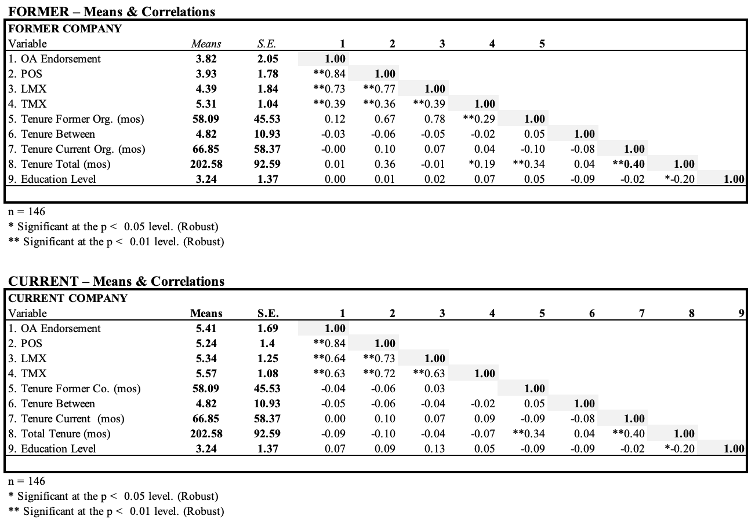

TABLE 2
Regression Results – All, Voluntary and Involuntary Termination.
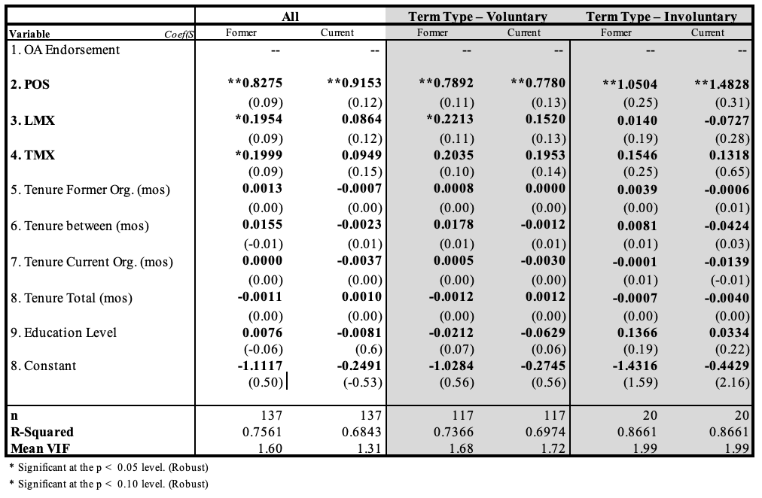

TABLE 3
MANOVA, By Variable and Former and Current

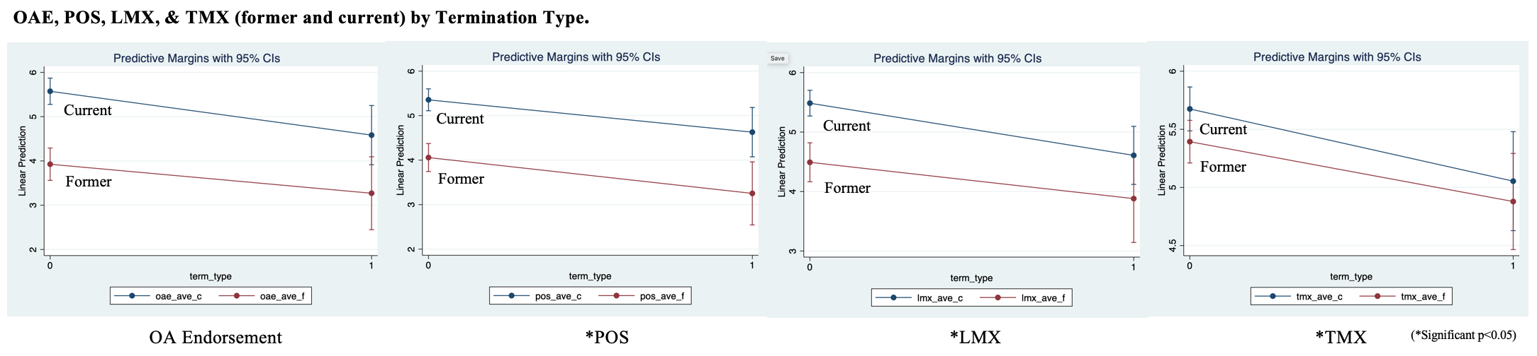
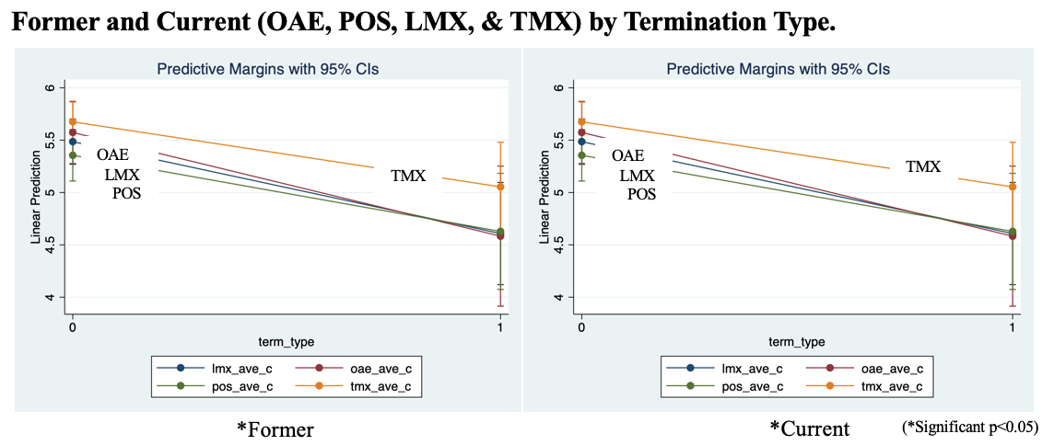

APPENDIX A.
Research Measures

Description
OA Endorsement | Konovsky and Folger (1991)
Reflecting on your experience at your FORMER (CURRENT) COMPANY: | Herda & Lavelle (2011)
_I would encourage anyone interested in working for FORMER COMPANY to accept a job there.
_I would have no problem at all in recommending FORMER COMPANY to others.
_I would be willing to recommend my FORMER COMPANY to get more business.
_I would return to work for my FORMER COMPANY if a job were available.
Perceived Organizational Support | Eisenberger, et al., (1986)
My 'most recent' FORMER (Current) COMPANY:
_cared about my well-being.
_strongly considered my goals and values.
_showed little concern for me. [R]
_cared about my opinions.
_was willing to help me if I needed a special favor.
_was available to help when I had a problem.
_would forgive an honest mistake on my part.
_would have taken advantage of me if given the opportunity. [R]
Leader-member Exchange | Graen & Uhl-Bien (1995)
My 'most recent' FORMER (Current) SUPERVISOR:
_was someone who usually let me know where I stood with my work.
_understood my problems and needs related to my job.
_recognized my potential.
_would have likely used his/her power to help me solve problems in my work, regardless of their amount of formal authority.
_would have likely "bailed me out" at his/her expense, regardless of his/her amount of formal authority.
_was someone I had enough confidence in that I would have defended and justified his/her decision even if he/she were not present to do so.
_and I had a working relationship I would characterize as "extremely ineffective." [R] (extremely effective').
Team-member Exchange | Seers, Petty, & Cashman (1995)
My 'most recent' FORMER (Current) COLLEAGUES:
_recognized my potential.
_were people for whom I would have been willing to help finish work that had been assigned to them.
_would have been willing to help finish work that was assigned to me.
_understood my problems and needs.
_did not listen to the suggestions I made about better work methods. [R]
_usually let me know when I did something that made their job easier. (or harder)
_heard from me when they did something that made my job easier. (or harder)
_are people with whom I would have been flexible and willing to switch job responsibilities to make things easier for everyone.
_often asked me to help out.
_are people I often volunteered to help.

